**MINISTRY OF EDUCATION AND TRAINING**

**FPT UNIVERSITY**

Capstone Project Document

**School Feedback Management System**

|  |  |
| --- | --- |
| **Group 11** | |
| **Group members** | SE61897 - Nguyễn Việt Tú (Leader)  SE61882 - Trần Hồ Minh Thuấn  SE61745 - Hoàng Quốc Việt |
| **Supervisor** | Nguyễn Huy Hùng |
| **Ext. Supervisor** | N/A |
| **Capstone Project**  **code** | SFMS |

-Ho Chi Minh City, ***8th January, 2018***-

**

**CAPSTONE PROJECT REGISTER**

Class: Duration time: from 8/1/2018 to 29/4/2018

(*) Profession: <Software Engineer> Specialty: <ES> <IS>

x

(*) Kinds of person make registers: Lecturer Students

x

1. Register information for supervisor (if have)

|  |  |  |  |  |
| --- | --- | --- | --- | --- |
|  | **Full name** | **Phone** | **E-Mail** | **Title** |
| Supervisor 1 | Nguyễn Huy Hùng |  | hungnh@fpt.edu.vn | Mr. |

2. Register information for students (if have)

|  |  |  |  |  |  |
| --- | --- | --- | --- | --- | --- |
|  | **Full name** | **Student code** | **Phone** | **E-mail** | **Role in Group** |
| Student 1 | Nguyễn Việt Tú | SE61897 | 0903123324 | Tu.nguyen1110@gmail.com | Leader |
| Student 2 | Hoàng Quốc Việt | SE61745 |  | viethqse61745@fpt.edu.vn | Member |
| Student 3 | Trần Hồ Minh Thuấn | SE61882 |  | thuanthmse61882@fpt.edu.vn | Member |

3. Register content of Capstone Project

(*) 3.1. Capstone Project name:

English: School Feedback Management System

Vietnamese: Hệ Thống Quản Lý Feedback Trường Học

Abbreviation: SFMS

(*) 3.2. Main proposal content (including result and product)

1. Theory and practice (document):
   * Student should apply the software development process and the UML 2.0 in modeling the system
   * Software artifacts include User Requirement, Software Requirement Specification, Architecture Design, Detail Design, System Implementation and Testing Document, Installation Guide, sources code, and deployable software packages
   * Server side technique:
     + Database design, OOA, OOD, OOP, MVC, Java or .Net technology, …
     + Apache Lucene, Elastic Search
   * Client side technique
     + HTML5, CSS, JavaScript, JQuery, Ajax
     + Mobile Platform (iOS, Android)
2. Program:

Building web application that allows school to create and manage feedbacks. Feedbacks may be used to evaluate staff, teachers, and other departments. Therefore, the system should support flexible templates that can be customized for each department, each course, each major, and even for each lecture. The following main features should be implemented:

- Support different roles

- Support default templates as well provide a way to customize template for each object

- Support create template by drag-n-drop feedback elements

- Generate reports from feedback results

- Analyze and give suggested improvement based on generated reports

- Set interval time for each feedback

- Remind users to conduct feedbacks

1. Other products:

* All of management functions of the system must be implemented to support the operating system.

4. Other comment (propose all relative thing if have)

N/A

|  |  |
| --- | --- |
| **Supervisor (If have)**  *(Sign and full name)* | HCM city, date 18/04/2018  **On behalf of Registers**  *(Sign and full name)* |

Nguyễn Huy Hùng

**Table of Contents**

**A. Introduction** 1

1. Project Information 1

2. Introduction 1

3. Current Situation 1

4. Problem Definition 1

5. Proposed Solution 2

5.1. Feature functions 2

**5.2. Advantages and disadvantages** 2

6. Functional Requirement 3

7. Role and Responsibilities 4

**B. Software Project Management Plan** 5

**1. Problem Definition** 5

1.1. Name of this Capstone Project 5

**1.2. Problem Abstract** 5

1.3. Project Overview 5

**2. Project organization** 9

**2.1. Software Process Model** 9

2.2. Roles and responsibilities 9

2.3. Tools and Techniques 10

3. Project Management Plan 10

3.1. Product Backlog 10

3.2. Sprint Backlog 10

3.3. Deliverables 10

3.4. All Meeting Minutes 11

4. Coding Convention 11

**C.** **Software Requirement Specification** 12

**1. User Requirement Specification** 12

**1.1. Guest Requirement** 12

**1.2. Student Requirement** 12

**1.3. Lecturer Requirement** 12

**1.4. Staff Requirement** 12

**1.5. Head-of-Academic Requirement** 13

1.6. System Requirement 14

**1.7. System Requirement Specification** 14

**2. Software System Attribute** 55

**2.1. Usability** 55

**2.2. Availability** 55

**2.3. Security** 55

**2.4. Maintainability** 55

2.5. Portability 56

2.6. Performance 56

**3. Conceptual Diagram** 57

D. Software Design Description 59

1. Design Overview 59

**2. System Architectural Design** 59

**3. Component Diagram** 60

4. Detailed Description 61

4.1. Class Diagram 61

4.2. Class Diagram Explanation 63

**5. Interaction Diagram** 67

***Create new Feedback*** 67

***Conduct Feedback*** 69

***View Feedback Report*** 69

***Alert Undone Feedback*** 70

***Create User*** 70

***Create criteria*** 71

**6. Interface** 71

**6.1.** **Component interface** 72

6.2. User Interface Design 75

**7.** **Database Design** 110

**7.1. Entity relationship diagram (ERD)** 110

**7.2. Data Dictionary** 111

**7.3. Algorithms** 112

**E. System Implementation & Test** 117

**1. Introduction** 117

**1.1. Overview** 117

1.2. Test Approach 117

**2. Database Relationship Diagram** 117

**2.1. Physical Diagram** 117

**2.2. Data Dictionary** 119

**3. Test Plan** 121

3.1. Features to be tested 121

**3.2. Features not to be tested** 122

**4. System Testing Test Case** 123

**4.1. Communication Diagram** 123

**4.2. Test Case** 125

**F.** **Software User’s Manual** 133

**1.** **Installation Guide** 133

**1.1.** **Setting up environment at server side** 133

**1.2.** **Deployment at server side** 133

**1.3.** **Setting up the environment at client side** 134

**2.** **User Guide** 134

*2.1.* *Web application for all users* 134

2.2. Web application for staffs 136

2.3. Web application for Head of Academic 144

4.3. Mobile application for all users 146

**List of Tables**

**List of Figures**

**Definitions, Acronyms, and Abbreviations**

Miêu tả từ viết tắt hay các term dùng trong tài liệu thuyết minh bên dưới

|  |  |
| --- | --- |
| **Name** | **Definition** |
| SFMS | School Feedback Management System |

1. **Introduction**

## Project Information

* + - * Project name: School Feedback Management System
      * Project Code: SFMS
      * Product Type: **Web app, Mobile App**
      * Start Date: **08/01/2018**
      * End Date: **29/04/2018**

## Introduction

In this document, we introduce a solution for School Feedback System. Current feedback systems have some problems like impossible to design and customize feedback form that suitable for each major, lecture, course, or inconvenient in analyzing results. Base on our reaserches and analysis, we proposed a solution for university in Vietnam and other developed countries.

We build a system, which helps the universities solve current problems. In the process of analysis, we believe our system is capable to resolve the problem by let users create, design, and customize feedback form through dragging and dropping items. Besides that, we also analyze feedback results and provide reports and suggested improvements, based on the results.

This document also describes our working process in 4 months includes our perspective in the system, component designs and detailed core workflows. We hope the system and our solution will help resolve the problems from universities in Vietnam and other developed countries.

## Current Situation

Currently, in university, we use the same feedback form for every courses and major. So we can just gain feedback of some general information like: if lecturer is on time, if the students can understand the lecture, how skillful the lecturer is... When feedback period’s over, the results will send to lecturer without analysing or providing suggested improvement.

## Problem Definition

* **Customize Feedback form:**

- Use same questions set for all lectures, courses, majors

- Can’t question unique aspect of each course (For example: Can’t question about accent of English lecturer)

- Lack of usefulness and practicality (Can only ask same general questions that used for all courses)

- Hardly use for personal improvement

- Can’t modify targets or conductors of Feedback

- Can’t choose type of feedback survey (Feedback for lecture, course, major, or for department)

* **Analyze results and Report**

- Can’t generate graphical charts of statistical results from feedback answers

- Can’t compare results in the past to current

- Don’t provide suggested improvement to lecturers

* **Conduct Feedback**

- Edit answers

## Proposed Solution

Our proposed solution is to build a system named School Feedback Manage System can drag-n-drop feedback items to create new feedback form to resolve those problems of current situations.

SFMS includes a web application to manage and create feedback, and mobile app to conduct feedback, with following functions:

### Feature functions

* **Web Application:**

- Create new Feedback form: choose existed template or customize by dragging and dropping items to the form

- Save created feedback template

- Choose scope of Feedback: Feedback for a lecture, a major, a course or a department

- Set suggested improvement based on avaerage points of each feedback

- Set interval time for each Feedback

- Remind users to conduct Feedback

- Search and Filter feedback

- Conduct Feedback

- Edit Answers

- Search and Filter reports

- Compare points in the past to current through semester

- View report in details

* **Mobile Application:**

**-** View list Feedback

- Conduct Feedback

- Edit answer

* 1. **Advantages and disadvantages**
* **Advantages**:

**-** Make realistic improvement from feedback

- Help Head of Academic follows real performance of lecturers

- Feedback can use in different subjects, courses, majors, lecturer, departments

- Represent results as graphical charts

- Save created feedback form to

* **Disadvantages**:

- Staffs have to spend time to design feedback form

- Input suggested improvement manually

## Functional Requirement

**Base component**

* Login
* Logout

**• Student component**

* View list of feedbacks
* Filter feedbacks
* Conduct Feedback
* Be alerted of undone feedback

**• Lecturer component**

* View list of feedbacks
* Filter feedbacks
* Conduct Feedback
* Be alerted of undone feedback
* View list of Report for that relates to their classes
* Filter Reports
* View Report comparisions through semesters
* View Report details

**• Staff component**

* View list of feedbacks
* Filter feedbacks
* Conduct Feedback
* Be alerted of undone feedback
* View list of Report for that relates to their departments
* Filter Reports
* View Report comparisions through semesters
* View Report details
* Create blank new feedback form:

+ Create blank new feedabck

+ Drag-n-drop feedback items to create content

+ Edit feedback content

+ Set suggested improvement

+ Set name and description for feedback

+ Set interval time for feedback

+ Set semester for feedback

+ Choose scope (lecture, major, course, department)

+ Choose and modify feedback target

* Create new feedback from template
* Save Feedback:

+ Save and publish feedback

+ Save feedback as a new template

+ Update current template

* Manage Users:

+ View list users

+ Add users

+ Update users

**• Head-of-Academic component**

* View list of feedbacks
* Filter feedbacks
* Conduct Feedback
* Be alerted of undone feedback
* View list of all Reports
* Filter Reports
* View Report comparisions through semesters
* View Report details
* Create blank new feedback form:

+ Create blank new feedabck

+ Drag-n-drop feedback items to create content

+ Edit feedback content

+ Set suggested improvement

+ Set name and description for feedback

+ Set interval time for feedback

+ Set semester for feedback

+ Choose scope (lecture, major, course, department)

+ Choose and modify feedback target

* Create new feedback from template
* Save Feedback:

+ Save and publish feedback

+ Save feedback as a new template

+ Update current template

* Manage Users:

+ View list users

+ Add users

+ Update users

+ Deactive users

* Manage Criterias:

+ View list criterias

+ Add criterias

+ Update criterias

+ Deactive criterias

## Role and Responsibilities

|  |  |  |  |  |
| --- | --- | --- | --- | --- |
| *No* | *Full Name* | *Role* | *Position* | *Contact* |
| *1* | *Nguyễn Huy Hùng* | *Project Manager* | *Supervisor* | [*hungng@fpt.edu.vn*](mailto:hungng@fpt.edu.vn) |
| *2* | *Nguyễn Việt Tú* | *Developer* | *Leader* | [*tunvse61897@fpt.edu.vn*](mailto:tunvse61897@fpt.edu.vn) |
| *4* | *Hoàng Quốc Việt* | *Developer* | *Member* | [*viethqse61745@fpt.edu.vn*](mailto:viethqse61745@fpt.edu.vn) |
| *5* | *Trần Hồ Minh Thuấn* | *Developer* | *Member* | [*thuanthmse61882@fpt.edu.vn*](mailto:thuanthmse61882@fpt.edu.vn) |

***Table 1: Roles and Responsibilities***

1. **Software Project Management Plan**
2. **Problem Definition**

### Name of this Capstone Project

* + 1. Official name: School Feedback Management System
    2. Vietnamese name: Hệ Thống Quản Lý Feedback Trường Học
    3. Abbreviation: SFMS
  1. **Problem Abstract**

This project is our exertion about School Feedback System in Viet Nam. We called it is School Feedback Management System (SFMS). SFMS will provide users a user-friendly interface to create and conduct feedback.

Organizing a feedback survey in an effectively way is always a problem to improve quality. With the current Feedback system, users use the same feedback for all department, majors and course. Therefore, it’s hard to evaluate the true quality while each department, major and course has its unique aspects.

SFMS will provide a system where users can create several Feedback forms easily by dragging and dropping Feedback items and save them as templates to reuse later.

To qualify the results, SFMS uses a new critical points-counting system for each question, provides suggested improvement when critical points is low.

Finally, SFMS analyzed results and presents as charts, help users to review and compare the results through semesters.

### Project Overview

#### Current Situation

Below are the problems encountered in this project:

* Lack of the amount of necessary data: students, lecturers, staffs… data
* Limit in human resources and time: Team has only 4 members and time for all project is about 13 weeks for writing document, implementing the products and testing
* Lack of UI, UX (user experience) design skill: Our team members all study IS major and no one has studied UI, UX design.
* Lack of knowledge about back-office business: How point is counted in survey, how feedback results are treated…
* New technique: Some team members are new to the techniques used in the project. The team needs an amount of time to get familiar with those techniques.

#### The Proposed System

The system will have three sub-systems:

* An API application to serve API for mobile application and web application.
* A web application for staffs, lecturers, head of academic and students. Head of Academic can manage users, majors, courses, departments. Staffs and head of academic can create new feedback or choose existed template. Staff, Head of academic and lecturers can view reports when feedback period finishes. All users can conduct feedback.
* A mobile application for students conduct feedback

Task will be assigned vertically to team members, so that if one member quits, the team will be not lack of resources.

##### **Web Site**

**• Base component**

* Login
* Logout

**• Student component**

* View list of feedbacks
* Filter feedbacks
* Conduct Feedback
* Be alerted of undone feedback

**• Lecturer component**

* View list of feedbacks
* Filter feedbacks
* Conduct Feedback
* Be alerted of undone feedback
* View list of Report for that relates to their classes
* Filter Reports
* View Report comparisions through semesters
* View Report details

**• Staff component**

* View list of feedbacks
* Filter feedbacks
* Conduct Feedback
* Be alerted of undone feedback
* View list of Report for that relates to their departments
* Filter Reports
* View Report comparisions through semesters
* View Report details
* Create blank new feedback form:

+ Create blank new feedabck

+ Drag-n-drop feedback items to create content

+ Edit feedback content

+ Set suggested improvement

+ Set name and description for feedback

+ Set interval time for feedback

+ Set semester for feedback

+ Choose scope (lecture, major, course, department)

+ Choose and modify feedback target

* Create new feedback from template
* Save Feedback:

+ Save and publish feedback

+ Save feedback as a new template

+ Update current template

* Manage Users:

+ View list users

+ Add users

+ Update users

**• Head-of-Academic component**

* View list of feedbacks
* Filter feedbacks
* Conduct Feedback
* Be alerted of undone feedback
* View list of all Reports
* Filter Reports
* View Report comparisions through semesters
* View Report details
* Create blank new feedback form:

+ Create blank new feedabck

+ Drag-n-drop feedback items to create content

+ Edit feedback content

+ Set suggested improvement

+ Set name and description for feedback

+ Set interval time for feedback

+ Set semester for feedback

+ Choose scope (lecture, major, course, department)

+ Choose and modify feedback target

* Create new feedback from template
* Save Feedback:

+ Save and publish feedback

+ Save feedback as a new template

+ Update current template

* Manage Users:

+ View list users

+ Add users

+ Update users

+ Deactive users

* Manage Criterias:

+ View list criterias

+ Add criterias

+ Update criterias

+ Deactive criterias

##### **Mobile Application**

* View list of feedbacks
* Filter feedbacks
* Conduct Feedback

##### **API Application**

The server system takes responsibility to respond all the requests and also manages and processes data.

* Provide
* APIs for Mobile Application, Web Application

#### Boundaries of the System

The system can:

* Allow Head of academic and Staff to manage users.
* Allow Head of academic to manage criteria.
* Allow create new feedbacks
* Allow save feedbacks as templates to reuse
* Allow conduct feedback
* Notify users when there is undone feedback
* Count feedback points based on result
* Suggest improvement based on Feedback result
* View feedback reports

#### Future Plans

Current system is concentrated on core business flow. Therefore, some supporting features are restricted for the development team. These features may be expanded in the future:

* Analyze if users really spend time to do feedback
* Analyze “Other comment” paragraph to see if it’s positive or negative comment and count point

#### Development enviroment

##### **Hardware requirements**

**For server**

|  |  |  |
| --- | --- | --- |
| **Windows** | **Minimum Requirements** | **Recommended** |
| **Internet Connection** | Cable, Wi-Fi (4 Mbps) | Cable, Wi-Fi (8 Mbps) |
| **Operating System** | Window Server 2008 | Window Server 2008 |
| **Computer Processor** | Intel® Xeon ® 1.4GHz | Intel® Xeon ® Quad Core  (12M Cache, 2.50 GHz) |
| **Computer Memory** | 1GB RAM | 2GB or more |

**Table 2: Hardware Requirement for Server**

**For PC**

|  |  |  |
| --- | --- | --- |
| **Windows** | **Minimum Requirements** | **Recommended** |
| **Internet Connection** | Cable, Wi-Fi (2 Mbps) | Cable, Wi-Fi (4 Mbps) |
| **Operating System** | Windows 7 or above | Window 7 or above |
| **Computer Processor** | Intel® Pentinum 4 1.60Ghz | Intel® Pentinum 4 2.00Ghz |
| **Computer Memory** | 1GB RAM | 2GB or more |

**Table 3: Hardware Requirement for PC**

**For mobile**

|  |  |  |
| --- | --- | --- |
| **Windows** | **Minimum Requirements** | **Recommended** |
| **Internet Connection** | Wi-Fi (2 Mbps) | Wi-Fi (4 Mbps) |
| **Operating System** | Android 4.4.2 or above | Android 6.0 or above |
| **Memory** | 1GB RAM | 2GB or more |

**Table 4: Hardware Requirement for Mobile**

##### **Software requirement**

|  |  |  |
| --- | --- | --- |
| Software | Name / Version | Description |
| Operating system | Window 7 or above | Operating system and platform for development |
| Environment | Java EE 8, Spring, Gradle | Specification for developing web application |
| Modeling tool | StarUML 2.8.0 | Use to draw model models and diagrams |
| IDE | NetBeans 8.2, IntelliJ IDEA  17.2, Android Studio 3.0 | Programming tools |
| DBMS | MySQL 5.7 | Used to create & manage the database for system |
| Source control | Github | Used for source control |
| Web browser | Chrome 42 or above | Testing browser |
| Application Server | Tomcat 8.0 | Server to deploy app |

1. **Project organization**
   1. **Software Process Model**

This project is developed using Scrum model – part of an agile framework for Software development project. Our team choose Scrum model because of the following reasons:

* Our team only has 4 members, and tasks are assigned vertically, do all steps from design, coding, testing and implementation. Scrum is the most suitable model for small and medium project.
* In the project there are many new technologies that need to be learned. With the Scrum model, the team can learn and develop in parallel to meet deadline.
* There is no leader, no hierarchy in team, so team members work cheerfully, stimulating the initiative and creativity of each member.
* Product owner can change requirement or extend scope. The team will adapt to change better.

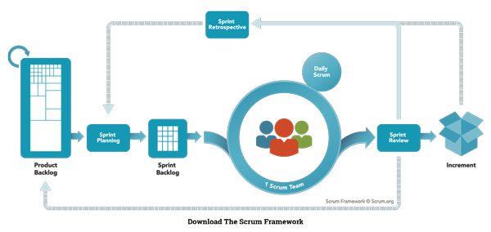

**Figure 1 Scrum model**

<https://www.scrum.org/resources/what-is-scrum>

### Roles and responsibilities

|  |  |  |  |
| --- | --- | --- | --- |
| ***No*** | ***Full name*** | ***Role in Group*** | ***Responsibilities*** |
| **1** | Nguyễn Huy Hùng | Project manager | * Specify scope and user requirement * Control the development process * Give out technique and business analysis support |
| **2** | Nguyễn Việt Tú | Scrum master | * Create Sprint Backlog and Product Backlog. * Make sure the Scrum teams understand and follow the process. * Always be present to answer questions and give advice when product owner or scrum member needs. * Help the team master scrum artifacts such as: Sprint Backlog, Product Backlog, ... * Writing report |
| ***3*** | Nguyễn Việt Tú  Trần Hồ Minh Thuấn  Hoàng Quốc Việt | Scrum team members | * Designing database * Clarifying requirements * Prepare documents * GUI Design * Coding * Testing |

**Table 5: Roles and Responsibilities Details**

### Tools and Techniques

|  |  |
| --- | --- |
| Tool / Technique | Name / version |
| Frontend | HTML, CSS, JavaScript, Bootstrap, Thymeleaf |
| Backend | SpringBoot framework, Java |
| IDE | NetBeans 8.2, IntelliJ IDEA 17.2, Android Studio 3.0 |
| Database | MySQL 5.7 |
| Modelling tool | Star UML 2.8.0 |

## Project Management Plan

### Product Backlog

All product backlog could be found here

### Sprint Backlog

All sprint backlog could be found [here](https://docs.google.com/a/fpt.edu.vn/spreadsheets/d/1Tj9tsbnGwQrQiTGnWU0NW55C2mwtRrxtwqqfhS-2teA/edit?usp=drive_web)

### Deliverables

|  |  |  |  |  |
| --- | --- | --- | --- | --- |
| **No** | **Deliverable** | **Deliverable date** | **Deliverable location** | **Note** |
| 1 | Introduction, Project Management Plan, Concept Diagram, Class Diagram, Entity Relationship Diagram, Use Case Overview, Mock UI |  |  | Sprint 1 |
| 2 | Study Spring Boot Framework, Design User Interface for Web Application |  |  | Sprint 2 |
| 3 | Design User Interface for Web Application (continue), Web Service Architecture, Code core flow RESTful API Web services |  |  | Sprint 3 |
| 4 | Code core flow Web application and Mobile application; User Requirement Specification |  |  | Sprint 4 -> 8 |
| 5 | Code low priority functions, Conceptual Diagram, Design Overview, System Architectural Design, Component Diagram. |  |  | Sprint 9-10 |
| 6 | Testing, Entity Relationship Diagram, Database Diagram, Algorithms |  |  | Sprint 11-12 |
|  | | | | |
| Table 6: Deliverables | | | | |

* For each Sprint, deliverables are potentially shippable products, which can be a part of document or prototype implemented based on the project’s core flow.
* Each Sprint has a fixed duration of one week.

### All Meeting Minutes

All sprint meeting minutes could be found [here](https://drive.google.com/open?id=1uTbg15fL05aFUnV9TXOXZ4Vy-kl4HMBu)

## Coding Convention

* **Naming convention:**

- Variable and method names are in mixed case, with first letter of each internal word capitalized except first word.

* **Method names should be verbs.**

- Class names should be nouns, in mixed case with first letter of each internal word capitalized.

- Constant names should be all uppercase with words separated by underscore.

* **Comment**:

- Using /* */ for block comments.

- Using // for line comments.

Using Java coding convention from:

<http://www.oracle.com/technetwork/java/codeconvtoc-136057.html>

1. **Software Requirement Specification**
   1. **User Requirement Specification**
   2. **Guest Requirement**

Guest is a person who wants to create or conduct feedback. Guest can do the following functions:

* Login
  1. **Student Requirement**

Student is a person who attends in a class. Student conducts most of feedbacks. Student can do the following functions:

* Manage Feedbacks:

+ View list feedbacks

+ Filter feedbacks

* Conduct Feedback
* Be alerted of undone feedback
  1. **Lecturer Requirement**

Lecturer is a person who teach a class. Lecturer is the target of most of feedbacks. Teacher can do the following functions:

* Manage Feedbacks:

+ View list feedbacks

+ Filter feedbacks

* Conduct Feedback
* Be alerted of undone feedback
* Manage Reports:

+ View list reports that relates to their classes

+ Compare reports by semesters

+ View report details

+ Filter reports

* 1. **Staff Requirement**

Staff is a person who work for the school, but doesn’t have the highest role. Staff can do the following functions:

* Conduct Feedback
* Be alerted of undone feedback

- Create new feedback form:

+ Create blank new feedabck

+ Drag-n-drop feedback items to create content

+ Edit feedback content

+ Set suggested improvement

+ Set name and description for feedback

+ Set interval time for feedback

+ Set semester for feedback

+ Choose scope (lecture, major, course, department)

+ Choose and modify feedback target

+ Choose and modify feedback conductor

* Create new feedback from template
* Save Feedback:

+ Save and publish feedback

+ Save feedback as a new template

+ Update current template

* Manage Feedbacks:

+ View list feedbacks

+ Filter feedbacks

* Manage Reports:

+ View list reports that relates to their departments

+ Compare reports by semesters

+ View report details

+ Filter reports

* Manage Users:

+ View list users

+ Add users

+ Update users

* 1. **Head-of-Academic Requirement**

Head of Academic is a person manage everything and have the highest role. Head of Academic can manage criterias of feedbacks, deactive users and can view all reports. Head of Academic can do the following functions:

* Conduct Feedback
* Be alerted of undone feedback

- Create new feedback form:

+ Create blank new feedabck

+ Drag-n-drop feedback items to create content

+ Edit feedback content

+ Set suggested improvement

+ Set name and description for feedback

+ Set interval time for feedback

+ Set semester for feedback

+ Choose scope (lecture, major, course, department)

+ Choose and modify feedback target

+ Choose and modify feedback conductor

* Create new feedback from template
* Save Feedback:

+ Save and publish feedback

+ Save feedback as a new template

+ Update current template

* Manage Feedbacks:

+ View list feedbacks

+ Filter feedbacks

* Manage Reports:

+ View all reprots

+ Compare reports by semesters

+ View report details

+ Filter reports

* Manage Users:

+ View list users

+ Add users

+ Update users

+ Deactive users

* Manage Criterias:

+ View list criterias

+ Add criterias

+ Update criterias

+ Deactive criterias

### System Requirement

System performs functions that run underground and connects to external system (deposit money, notification system). System does following functions:

* Calculate stistic results for report
* Send notification when users have undone feedbacks

1. **System Requirement Specification**
   1. **External Interface Requirement**
      1. **User Interface**

* Mobile and Web application use Vietnamese interface, suitable for Vietnamese user.
  + 1. **Hardware Interface**
* N/A

#### Software Interface

* Web application: work with Firefox, Chromes, Internet Explorer browsers.
* Mobile application: Android operating system.

#### Communication Protocol

* Use HTTP protocol 1.1 for communication between the web browser and the web server, mobile application and the server.

### System Overview Use Case

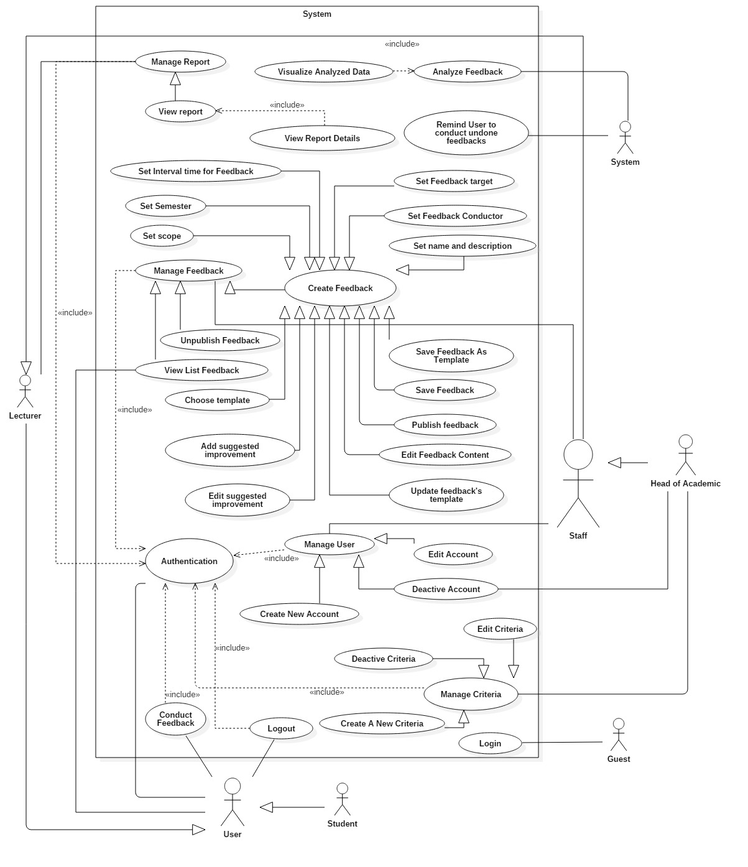

***Figure 2 System Overview Use Case***

### List of Use Case

* + 1. ***Guest Overview Use Case***

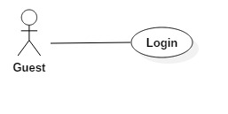

**Figure 3 Guest Overview Use Case**

* + - 1. ***Guest Login***



**Figure 4 <Guest>Login**

|  |  |  |  |
| --- | --- | --- | --- |
| **USE CASE – UC001** | | | |
| **Use Case No.** | 001 | **Use Case Version** | 1.0 |
| **Use Case Name** | Login | | |
| **Author** | TuNV | | |
| **Date** | 27/03/2018 | **Priority** | High |
| **Actor:**   * Guest   **Summary:**   * This use case allows Guest login to the system on website and mobile application.   **Goal:**   * Guest login successfully with the proper role.   **Triggers:**   * Guest sends the login command.   **Preconditions:**   * Guest has an account.   **Post Conditions:**   * **Success:** Guest accesses the system successfully. * **Fail:** System shows error message “Invalid username or password”.   **Main Success Scenario:**   |  |  |  | | --- | --- | --- | | Step | Actor Action | System Response | | 1 | Guest sends command to request login. | System requires identity information form Guest:   * Username: free text input. * Password: free text input. | | 2 | Guest inputs information |  | | 3 | Guest sends command to login to system.  [Alternative 1] | Guests will login system with their specific role. |   **Alternative Scenario:**   |  |  |  | | --- | --- | --- | | Step | Actor action | System Response | | 1 | Guest input invalid username or password. | System shows error message “Tên đăng nhập hoặc mật khẩu không đúng”. |   **Exceptions :** N/A  **Relationships:** N/A  **Business Rules:**  - After login to system, guest will be redirected to specific view based on their role on the system: student, lecturer, staff or head of academic.   * If role is “Student”, the system will display to Student view. * If role is “Lecturer”, the system will display to Lecturer view. * If role is “Staff”, the system will display to Staff view. * If role is “Head of Academic”, the system will display to Head of Academic view. | | | |

* + 1. ***Student Overview Use Case***

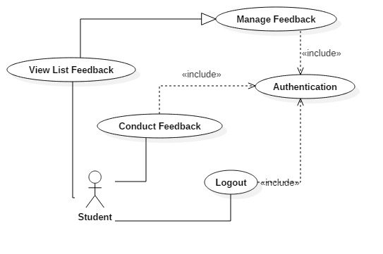

***Figure 5 <Student> Overview Use Case***

* + - 1. ***Student View List Feedback***

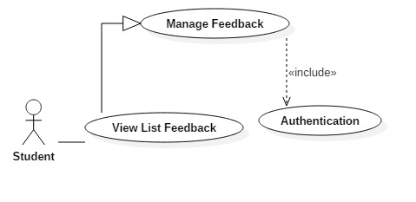

**Figure 6 <Student> View List Feedback**

|  |  |  |  |
| --- | --- | --- | --- |
| **USE CASE – UC002** | | | |
| **Use Case No.** | 002 | **Use Case Version** | 1.0 |
| **Use Case Name** | View List Feedback | | |
| **Author** | TuNV | | |
| **Date** | 27/03/2018 | **Priority** | High |
| **Actor:**   * Student * Staff * Lecturer * Head of Academic   **Summary:**   * This use case allows Actor to get feedback list.   **Goal:**   * System gets feedback list and display it to Actor.   **Triggers:**   * Actor sends get feedback list command.   **Preconditions:**   * Actor has been authorized and accessed the system.   **Post Conditions:**   * **Success:** Feedback list is displayed. * **Fail:** Show error messages.   **Main Success Scenario:**   |  |  |  | | --- | --- | --- | | Step | Actor Action | System Response | | 1 | Actor sends get feedback list command. | [Exception 1]  System displays feedback list to Actor. |   **Exceptions 1:**   |  |  |  | | --- | --- | --- | | Step | Cause | System Response | | 1 | Feedback list is empty | System shows error message “Không có Phản hồi”. |   **Relationships:** N/A  **Business Rules:**   * Actor can view list of feedbacks that they are in conductors list. * Actor can conduct feedbacks that are still in available time from this list. | | | |

* + - 1. ***Student Conduct Feedback***

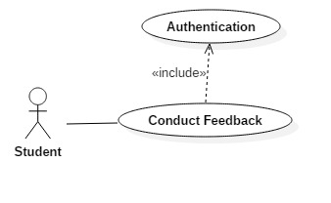

**Figure 7 <Student> Conduct Feedback**

|  |  |  |  |
| --- | --- | --- | --- |
| **USE CASE – UC003** | | | |
| **Use Case No.** | 003 | **Use Case Version** | 1.0 |
| **Use Case Name** | Conduct Feedback | | |
| **Author** | TuNV | | |
| **Date** | 27/03/2018 | **Priority** | High |
| **Actor:**   * Student * Staff * Lecturer * Head of Academic   **Summary:**   * This use case allows Actor to get conduct feedback.   **Goal:**   * Actor submits answers successfully.   **Triggers:**   * Actor clicks button “Hoàn thành ngay” from list feedback. * Actor clicks corresponding feedback from alert button.   **Preconditions:**   * Actor has been authorized and accessed the system. * Actor has feedback needed to conduct. * Feedback is still in available interval time.   **Post Conditions:**   * **Success:** Actor submits answers succesfully. * **Fail:** Show error messages.   **Main Success Scenario:**   |  |  |  | | --- | --- | --- | | Step | Actor Action | System Response | | 1 | Actor sends conduct feedback command. | System displays list of feedback questions to Actor. | | 2 | Actor chooses options |  | | 3 | Actor submits answers | System checks answers.  [Exception 1]  System directs to view list feedback screen and changes button “Hoàn Thành Ngay” to “Đã Hoàn Thành” |   **Exceptions 1:**   |  |  |  | | --- | --- | --- | | Step | Cause | System Response | | 1 | Actor doesn’t answer all required questions | System shows error message “Xin hoàn thành những câu hỏi bắt buộc. |   **Relationships:** N/A  **Business Rules:**   * Actor answers question of the feedbacks. * Actor has to answer all required questions. | | | |

##### ***Student******Logout***

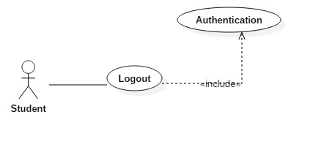

**Figure 8 <Student> Logout**

|  |  |  |  |
| --- | --- | --- | --- |
| **USE CASE – UC003** | | | |
| **Use Case No.** | 004 | **Use Case Version** | 1.0 |
| **Use Case Name** | Logout | | |
| **Author** | TuNV | | |
| **Date** | 27/03/2018 | **Priority** | High |
| **Actor:**   * Student * Staff * Lecturer * Head of Academic   **Summary:**   * This use case allows Actor to logout.   **Goal:**   * Actor logouts successfully.   **Triggers:**   * Actor clicks button “Logout”.   **Preconditions:**   * Actor has been authorized and accessed the system.   **Post Conditions:**   * **Success:** Actor logouts succesfully. * **Fail:** N/A   **Main Success Scenario:**   |  |  |  | | --- | --- | --- | | Step | Actor Action | System Response | | 1 | Actor sends command to Logout. | System clears session state if any, takes user out of the system.  System displays sign in view. |   **Exceptions 1:** N/A  **Relationships:** N/A  **Business Rules:**   * After logout, role “Authenticated User” will become “Guest”. | | | |

* + 1. ***Lecturer Overview Use Case***

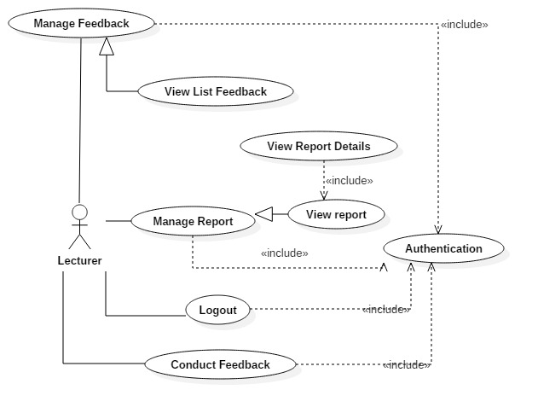

***Figure 8: <Lecturer> Overview Use Case***

* + - 1. ***Lecturer View List Report***

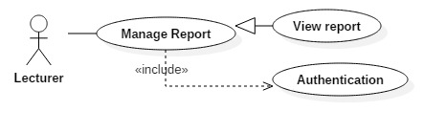

***Figure 9: <Lecturer> View List Report***

|  |  |  |  |
| --- | --- | --- | --- |
| **USE CASE – UC005** | | | |
| **Use Case No.** | 005 | **Use Case Version** | 1.0 |
| **Use Case Name** | View List Reprot | | |
| **Author** | TuNV | | |
| **Date** | 27/03/2018 | **Priority** | High |
| **Actor:**   * Staff * Lecturer * Head of Academic   **Summary:**   * This use case allows Actor to get report list.   **Goal:**   * System gets report list and display it to Actor.   **Triggers:**   * Actor sends get report list command.   **Preconditions:**   * Actor has been authorized and accessed the system.   **Post Conditions:**   * **Success:** Report list is displayed. * **Fail:** Show error messages.   **Main Success Scenario:**   |  |  |  | | --- | --- | --- | | Step | Actor Action | System Response | | 1 | Actor sends get report list command. | [Exception 1]  System displays report list to Actor. |   **Exceptions 1:**   |  |  |  | | --- | --- | --- | | Step | Cause | System Response | | 1 | Report list is empty | System shows error message “Không có Báo cáo”. |   **Relationships:** N/A  **Business Rules:**   * Actor can view list of report that corresponds to their roles. * Lecturer can view reports of their classes. * Staff can view reports of their departments. * Head of Academic can view all reports. | | | |

* + - 1. ***Lecturer View Report Details***

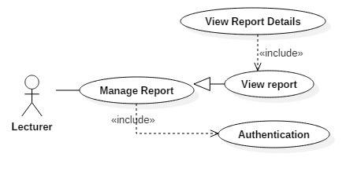

***Figure 10: <Lecturer> View Report Details***

|  |  |  |  |
| --- | --- | --- | --- |
| **USE CASE – UC006** | | | |
| **Use Case No.** | 006 | **Use Case Version** | 1.0 |
| **Use Case Name** | View List Reprot Details | | |
| **Author** | TuNV | | |
| **Date** | 27/03/2018 | **Priority** | High |
| **Actor:**   * Staff * Lecturer * Head of Academic   **Summary:**   * This use case allows Actor to view report details.   **Goal:**   * System gets details of a report and displays it to Actor.   **Triggers:**   * Actor sends get report details command.   **Preconditions:**   * Actor has been authorized and accessed the system.   **Post Conditions:**   * **Success:** Details of a report is displayed. * **Fail:** Show error messages.   **Main Success Scenario:**   |  |  |  | | --- | --- | --- | | Step | Actor Action | System Response | | 1 | Actor sends get report details command. | System calculates answer points, statistics and displays report list to Actor. |   **Relationships:** N/A  **Business Rules:**   * Actor can view details of a report. * Details of a report included: Statistic number of answers of each questions, proportions of answers, average point of each criteria, average point of the report. * Average point of each criteria is the average point of all questions belong to that criteria. * Average point of the report is the average point of all criteria belong to that report. | | | |

* + 1. ***Staff Overview Use Case***

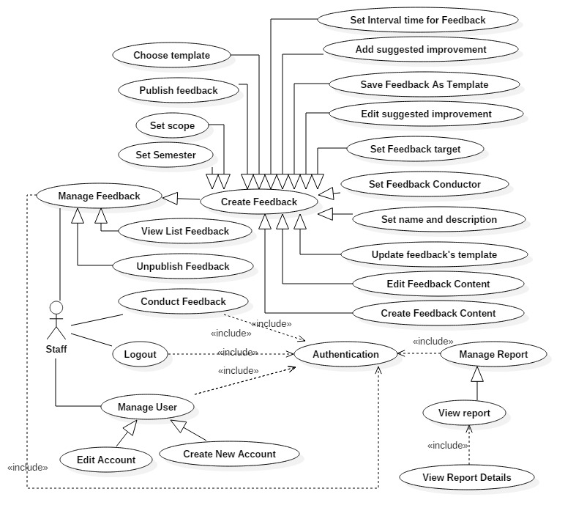

***Figure 11: <Staff> Overview Use Case***

* + - 1. ***Staff Create New Account***

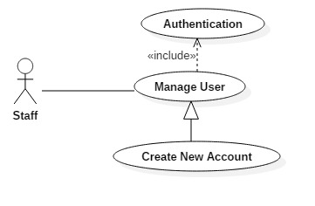

***Figure 12: <Staff> Create new account***

|  |  |  |  |
| --- | --- | --- | --- |
| **USE CASE – UC007** | | | |
| **Use Case No.** | 007 | **Use Case Version** | 1.0 |
| **Use Case Name** | Create new account | | |
| **Author** | TuNV | | |
| **Date** | 27/03/2018 | **Priority** | High |
| **Actor:**   * Staff * Head of Academic   **Summary:**   * This use case allows Actor to create new account.   **Goal:**   * Account is created successfully and store in database of the system.   **Triggers:**   * Actor clicks on create new account button.   **Preconditions:**   * Actor has been authorized and accessed the system with proper role.   **Post Conditions:**   * **Success:** New account is created. * **Fail:** Account is not created.   **Main Success Scenario:**   |  |  |  | | --- | --- | --- | | Step | Actor Action | System Response | | 1 | Actor sends create new account command. | System requires information:   * Username: free text input, required, length (9-20), unique * Password: free text input, required, length (9-20) * Full name: free text input, required, length (10-50) * Birthdate: date * Email: free text input, email format, unique * Sex: male or female * Role: Student, Lecturer, Staff, or Head of Academic * Major: Only for Lecturer and Student * Department: Only for Staff and Student * Status: Active or Deactive * Code | | 2 | Actor inputs information and sends command to “Save”.  [Alternative 1] | Account created.  [Exception 1]  [Exception 2]  [Exception 3]  [Exception 4] |   **Alternative Scenario 1:**   |  |  |  | | --- | --- | --- | | Step | Actor Action | System Response | |  | Actor sends command to reset. | System reset all field to blank. |   **Exceptions :**   |  |  |  | | --- | --- | --- | | No | Cause | System Response | | 1 | Actor inputs username already exist. | System show warning message “Tên đăng nhập này đã có người sử dụng”. | | 2 | Actor inputs email already exist. | System show warning message “Mail này đã được sử dụng”. | | 3 | Actor does not input required field. | System notices that actor need to input all these field:   * “Full name” * “Username” * “Password” * “Code” * “Email” | | 4 | Actor inputs wrong somefields with requirement. | System notices that actor need to re-input all those fields. |   **Relationships:** N/A  **Business Rules:**   * After creating new account and active, user can login with new account. * If choose role “Lecturer” or “Student”, actor can choose field “Major”, field “Department” will be disabled. * If choose role “Staff” or “Head of Academic”, actor can choose field “Department”, field “Major” will be disabled. | | | |

* + - 1. ***Staff Edit Account***

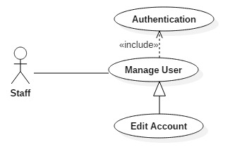

***Figure 13: <Staff> Edit account***

|  |  |  |  |
| --- | --- | --- | --- |
| **USE CASE – UC008** | | | |
| **Use Case No.** | 008 | **Use Case Version** | 1.0 |
| **Use Case Name** | Edit account | | |
| **Author** | TuNV | | |
| **Date** | 27/03/2018 | **Priority** | High |
| **Actor:**   * Staff * Head of Academic   **Summary:**   * This use case allows Actor to edit account.   **Goal:**   * Profile of account is updated.   **Triggers:**   * Actor clicks on edit account button.   **Preconditions:**   * Actor has been authorized and accessed the system with proper role.   **Post Conditions:**   * **Success:** Information of account is updated and display. * **Fail:** Information of account is not updated.   **Main Success Scenario:**   |  |  |  | | --- | --- | --- | | Step | Actor Action | System Response | | 1 | Actor sends edit account command. | System requires information:   * Username: free text input, required, length (9-20), unique * Password: free text input, required, length (9-20) * Full name: free text input, required, length (10-50) * Birthdate: date * Email: free text input, email format, unique * Sex: male or female * Role: Student, Lecturer, Staff, or Head of Academic * Major: Only for Lecturer and Student * Department: Only for Staff and Student * Status: Active or Deactive * Code | | 2 | Actor inputs information and sends command to “Save”.  [Alternative 1] | Account updated.  [Exception 1]  [Exception 2]  [Exception 3] |   **Alternative Scenario 1:**   |  |  |  | | --- | --- | --- | | Step | Actor Action | System Response | |  | Actor sends command to reset. | System reset all field to blank. |   **Exceptions :**   |  |  |  | | --- | --- | --- | | No | Cause | System Response | | 1 | Actor inputs email already exist. | System show warning message “Mail này đã được sử dụng”. | | 2 | Actor does not input required field. | System notices that actor need to input all these field:   * “Full name” * “Password” * “Email” | | 3 | Actor inputs wrong some fields with requirement. | System notices that actor need to re-input all those fields. |   **Relationships:** N/A  **Business Rules:**   * After edited, new information will be save to profile of account. * Actor can’t change Username, Code field. | | | |

* + - 1. ***Staff Create New Feedback Content***

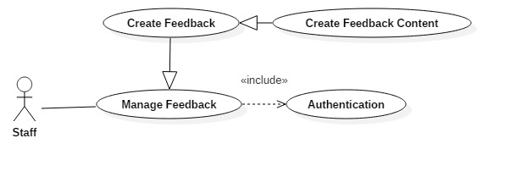

***Figure 14: <Staff> Create New Feedback Content***

|  |  |  |  |
| --- | --- | --- | --- |
| **USE CASE – UC009** | | | |
| **Use Case No.** | 009 | **Use Case Version** | 1.0 |
| **Use Case Name** | Create Feedback Content | | |
| **Author** | TuNV | | |
| **Date** | 27/03/2018 | **Priority** | High |
| **Actor:**   * Staff * Head of Academic   **Summary:**   * This use case allows Actor to create new feedback content.   **Goal:**   * Actor successfully creates new feedback content.   **Triggers:**   * Actor clicks on create new feedback button.   **Preconditions:**   * Actor has been authorized and accessed the system with proper role.   **Post Conditions:**   * **Success:** New Feedback with created content is stored in database. * **Fail:** New Feedback content cannot be created.   **Main Success Scenario:**   |  |  |  | | --- | --- | --- | | Step | Actor Action | System Response | | 1 | Actor sends create blank new feedback command.  [Alternative 1] | System displays create blank new feedback screen offering 4 types of feedback elements: radio, multiple choices, text or paragraph. | | 2 | Actor drags and drops suitable feedback elements to create content. | System requires information:   * Radio: Question, Options, “Other” or not, “Required” or not, Point of each Option, Criteria * Multiple Choices: Question, Options, “Other” or not, “Required” or not, Point of each Option, Criteria * Text: Question, Criteria * Paragraph: Question, Criteria | | 2 | Actor sends command to “Save”.  [Alternative 2]  [Alternative 3]  [Alternative 4] | Feedback created.  [Exception 1] |   **Alternative Scenario 1:**   |  |  |  | | --- | --- | --- | | Step | Actor Action | System Response | |  | Actor creates new feedback from an existed template. | System loads and displays questions and options from chosen template. |   **Alternative Scenario 2:**   |  |  |  | | --- | --- | --- | | Step | Actor Action | System Response | |  | Actor sends command to delete a created question. | System deletes chosen question. |   **Alternative Scenario 3:**   |  |  |  | | --- | --- | --- | | Step | Actor Action | System Response | |  | Actor sends command to delete a created option. | System deletes chosen option. |   **Alternative Scenario 4:**   |  |  |  | | --- | --- | --- | | Step | Actor Action | System Response | |  | Actor drags question to reorder. | System reorders chosen questions. |   **Exceptions :**   |  |  |  | | --- | --- | --- | | No | Cause | System Response | | 1 | Actor does not input required field. | System notices that actor need to input all these field:   * Question * Option * Point |   **Relationships:** N/A  **Business Rules:**   * After clicking save, all questions and options will be stored in database. * Point will be limit from 1 to 5 points. | | | |

* + - 1. ***Staff Edit Feedback Content***



***Figure 15: <Staff> Edit Feedback Content***

|  |  |  |  |
| --- | --- | --- | --- |
| **USE CASE – UC010** | | | |
| **Use Case No.** | 010 | **Use Case Version** | 1.0 |
| **Use Case Name** | Edit Feedback Content | | |
| **Author** | TuNV | | |
| **Date** | 27/03/2018 | **Priority** | High |
| **Actor:**   * Staff * Head of Academic   **Summary:**   * This use case allows Actor to edit feedback content.   **Goal:**   * Actor successfully edits feedback content.   **Triggers:**   * Actor clicks on edit feedback button.   **Preconditions:**   * Actor has been authorized and accessed the system with proper role.   **Post Conditions:**   * **Success:** New contents of feedback are stored in database. * **Fail:** New content cannot be edited.   **Main Success Scenario:**   |  |  |  | | --- | --- | --- | | Step | Actor Action | System Response | | 1 | Actor sends edit feedback command. | System displays edit feedback screen offering 4 types of feedback elements: radio, multiple choices, text or paragraph. | | 2 | Actor drags and drops suitable feedback elements to create content. | System requires information:   * Radio: Question, Options, “Other” or not, “Required” or not, Point of each Option, Criteria * Multiple Choices: Question, Options, “Other” or not, “Required” or not, Point of each Option, Criteria * Text: Question, Criteria * Paragraph: Question, Criteria | | 2 | Actor sends command to “Save”.  [Alternative 1]  [Alternative 2]  [Alternative 3] | Feedback updated.  [Exception 1] |   **Alternative Scenario 1:**   |  |  |  | | --- | --- | --- | | Step | Actor Action | System Response | |  | Actor sends command to delete a created question. | System deletes chosen question. |   **Alternative Scenario 2:**   |  |  |  | | --- | --- | --- | | Step | Actor Action | System Response | |  | Actor sends command to delete a created option. | System deletes chosen option. |   **Alternative Scenario 3:**   |  |  |  | | --- | --- | --- | | Step | Actor Action | System Response | |  | Actor drags question to reorder. | System reorders chosen questions. |   **Exceptions :**   |  |  |  | | --- | --- | --- | | No | Cause | System Response | | 1 | Actor does not input required field. | System notices that actor need to input all these field:   * Question * Option * Point |   **Relationships:** N/A  **Business Rules:**   * After clicking save, all questions and options will be updated in database. * Point will be limit from 1 to 5 points. * Edit Feedback screen contains all created questions and options before | | | |

* + - 1. ***Staff Choose Template***

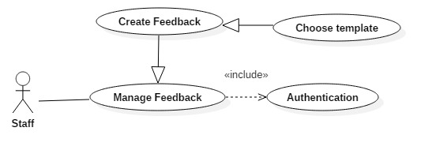

***Figure 16: <Staff> Choose Template***

|  |  |  |  |
| --- | --- | --- | --- |
| **USE CASE – UC011** | | | |
| **Use Case No.** | 011 | **Use Case Version** | 1.0 |
| **Use Case Name** | Choose Template | | |
| **Author** | TuNV | | |
| **Date** | 27/03/2018 | **Priority** | High |
| **Actor:**   * Staff * Head of Academic   **Summary:**   * This use case allows Actor to choose feedback template.   **Goal:**   * Actor successfully choose feedback template.   **Triggers:**   * Actor clicks on chosen template.   **Preconditions:**   * Actor has been authorized and accessed the system with proper role.   **Post Conditions:**   * **Success:** Chosen template has been successfully loaded. * **Fail:** Cannot choose template.   **Main Success Scenario:**   |  |  |  | | --- | --- | --- | | Step | Actor Action | System Response | | 1 | Actor sends choose template command.  [Alternative 1] | System chooses corresponding template and loads template content. |   **Alternative Scenario 1:**   |  |  |  | | --- | --- | --- | | Step | Actor Action | System Response | |  | Actor clicks on “Preview button” | System loads template content and display to actor. |   **Relationships:** N/A  **Business Rules:**   * System will display update template screen with all existed questions. | | | |

* + - 1. ***Staff Set Feedback Name and Description***

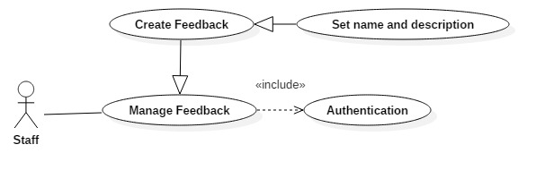

***Figure 17: <Staff> Set Feedback Name and Description***

|  |  |  |  |
| --- | --- | --- | --- |
| **USE CASE – UC012** | | | |
| **Use Case No.** | 012 | **Use Case Version** | 1.0 |
| **Use Case Name** | Set Feedback Name and Description | | |
| **Author** | TuNV | | |
| **Date** | 27/03/2018 | **Priority** | High |
| **Actor:**   * Staff * Head of Academic   **Summary:**   * This use case allows Actor to set Feedback name and description.   **Goal:**   * Actor successfully sets Feedback name and description.   **Triggers:**   * Actor sends set Feedback name and description command.   **Preconditions:**   * Actor has been authorized and accessed the system with proper role.   **Post Conditions:**   * **Success:** Feedback name and description are stored in database. * **Fail:** Feedback name and description cannot be set.   **Main Success Scenario:**   |  |  |  | | --- | --- | --- | | Step | Actor Action | System Response | | 1 | Actor sends set Feedback name and description command.  [Alternative 1] | System requires information:   * Title: free text input, required, length (9-20) * Description: free text input, required, length (9-150) | | 2 | Actor inputs information and sends command to “Save”. | Feedback Name and Description are saved.  [Exception 1]  [Exception 2] |   **Alternative Scenario 1:**   |  |  |  | | --- | --- | --- | | Step | Actor Action | System Response | |  | Actor uses existed name and description from template. | System loads existed name and description from template. |   **Exceptions :**   |  |  |  | | --- | --- | --- | | No | Cause | System Response | | 1 | Actor inputs wrong some fields with requirement. | System notices that actor need to re-input all those fields. | | 2 | Actor does not input required field. | System notices that actor need to input all these field:   * Title * Description |   **Relationships:** N/A  **Business Rules:**  N/A | | | |

* + - 1. ***Staff Add Suggested Improvement***

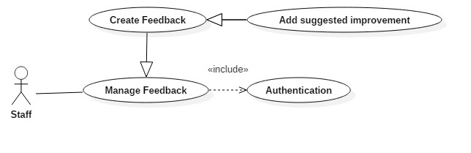

***Figure 18: <Staff> Add Suggested Improvement***

|  |  |  |  |
| --- | --- | --- | --- |
| **USE CASE – UC013** | | | |
| **Use Case No.** | 013 | **Use Case Version** | 1.0 |
| **Use Case Name** | Add suggested improvement | | |
| **Author** | TuNV | | |
| **Date** | 27/03/2018 | **Priority** | High |
| **Actor:**   * Staff * Head of Academic   **Summary:**   * This use case allows Actor to add suggested improvement.   **Goal:**   * Actor successfully adds suggested improvement.   **Triggers:**   * Actor clicks add suggested improvement button.   **Preconditions:**   * Actor has been authorized and accessed the system with proper role.   **Post Conditions:**   * **Success:** Suggested improvements are successfully stored in database. * **Fail:** Suggested improvement cannot be saved.   **Main Success Scenario:**   |  |  |  | | --- | --- | --- | | Step | Actor Action | System Response | | 1 | Actor sends add suggested improvement command.  [Alternative 1] | System loads all created questions and requires improvement for each question:   * Improvement: free text input, length (9-200) | | 2 | Actor inputs information and sends command to “Save”. | Feedback suggested improvements are saved.  [Exception 1]  [Exception 2] |   **Alternative Scenario 1:**   |  |  |  | | --- | --- | --- | | Step | Actor Action | System Response | |  | Actor chose an existed template and adds improvements. | System loads existed questions and improvements from chosen template. |   **Exceptions :**   |  |  |  | | --- | --- | --- | | No | Cause | System Response | | 1 | Feedback has no created questions. | System shows error questions “Không có câu hỏi nào” | | 2 | Actor inputs wrong some fields with requirement. | System notices that actor need to re-input all those fields. |   **Relationships:** N/A  **Business Rules:**   * Improvements will be displayed in report if point of question is lower than average point. | | | |

* + - 1. ***Staff Edit Suggested Improvement***

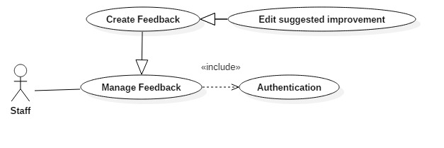

***Figure 19: <Staff> Edit Suggested Improvement***

|  |  |  |  |
| --- | --- | --- | --- |
| **USE CASE – UC014** | | | |
| **Use Case No.** | 014 | **Use Case Version** | 1.0 |
| **Use Case Name** | Edit suggested improvement | | |
| **Author** | TuNV | | |
| **Date** | 27/03/2018 | **Priority** | High |
| **Actor:**   * Staff * Head of Academic   **Summary:**   * This use case allows Actor to edit suggested improvement.   **Goal:**   * Actor successfully edits suggested improvement.   **Triggers:**   * Actor clicks edit suggested improvement button.   **Preconditions:**   * Actor has been authorized and accessed the system with proper role.   **Post Conditions:**   * **Success:** Suggested improvements are successfully updated in database. * **Fail:** Suggested improvement cannot be update.   **Main Success Scenario:**   |  |  |  | | --- | --- | --- | | Step | Actor Action | System Response | | 1 | Actor sends edit suggested improvement command. | System loads all created questions and improvements   * Improvement: free text input, length (9-200) | | 2 | Actor inputs information and sends command to “Save”. | Feedback suggested improvements are updated.  [Exception 1]  [Exception 2] |   **Exceptions :**   |  |  |  | | --- | --- | --- | | No | Cause | System Response | | 1 | Actor inputs wrong some fields with requirement. | System notices that actor need to re-input all those fields. | | 2 | Feedback has no created questions. | System shows error questions “Không có câu hỏi nào” |   **Relationships:** N/A  **Business Rules:**   * Improvements will be displayed in report if point of question is lower than average point. | | | |

* + - 1. ***Staff Set Feedback Semester***

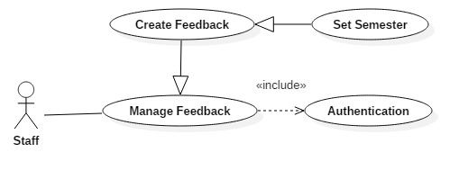

***Figure 20: <Staff> Set Feedback Semester***

|  |  |  |  |
| --- | --- | --- | --- |
| **USE CASE – UC015** | | | |
| **Use Case No.** | 015 | **Use Case Version** | 1.0 |
| **Use Case Name** | Set Feedback Semester | | |
| **Author** | TuNV | | |
| **Date** | 27/03/2018 | **Priority** | High |
| **Actor:**   * Staff * Head of Academic   **Summary:**   * This use case allows Actor to set Feedback semester.   **Goal:**   * Actor successfully sets Feedback semester.   **Triggers:**   * Actor clicks set Feedback semester button.   **Preconditions:**   * Actor has been authorized and accessed the system with proper role.   **Post Conditions:**   * **Success:** Feedback semester is successfully saved in database. * **Fail:** Feedback semester cannot be saved.   **Main Success Scenario:**   |  |  |  | | --- | --- | --- | | Step | Actor Action | System Response | | 1 | Actor sends feedback semester command. | System requires information:   * Semester: Dropdown list | | 2 | Actor inputs information and sends command to “Save”. | Feedback semester is saved.  [Exception 1] |   **Exceptions :**   |  |  |  | | --- | --- | --- | | No | Cause | System Response | | 1 | Actor does not input required field. | System notices that actor need to input semester field. |   **Relationships:** N/A  **Business Rules:**   * Feedback semester identifies the semester that feedback is available in. | | | |

* + - 1. ***Staff Set Feedback Interval Time***

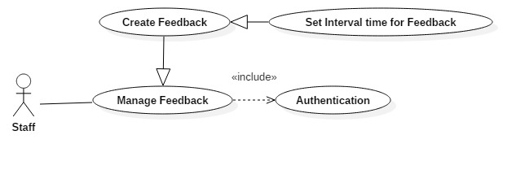

***Figure 21: <Staff> Set Feedback Interval Time***

|  |  |  |  |
| --- | --- | --- | --- |
| **USE CASE – UC016** | | | |
| **Use Case No.** | 016 | **Use Case Version** | 1.0 |
| **Use Case Name** | Set Feedback Interval Time | | |
| **Author** | TuNV | | |
| **Date** | 27/03/2018 | **Priority** | High |
| **Actor:**   * Staff * Head of Academic   **Summary:**   * This use case allows Actor to set Feedback Interval Time.   **Goal:**   * Actor successfully sets Feedback Interval Time.   **Triggers:**   * Actor clicks set Feedback Interval Time button.   **Preconditions:**   * Actor has been authorized and accessed the system with proper role.   **Post Conditions:**   * **Success:** Feedback Interval Time is successfully saved in database. * **Fail:** Feedback Interval Time cannot be saved.   **Main Success Scenario:**   |  |  |  | | --- | --- | --- | | Step | Actor Action | System Response | | 1 | Actor sends Feedback Interval Time command. | System requires information:   * From: Date picker * To: Date picker | | 2 | Actor inputs information and sends command to “Save”. | Feedback Interval Time is saved.  [Exception 1]  [Exception 2] |   **Exceptions :**   |  |  |  | | --- | --- | --- | | No | Cause | System Response | | 1 | Actor inputs wrong some fields with requirement. | System notices that actor need to re-input all those fields. | | 2 | Actor does not input required field. | System notices that actor need to input semester field. |   **Relationships:** N/A  **Business Rules:**   * Interval time is the period of time that Feedback is available to conduct. * Interval time must be between start and end date of chosen semester. | | | |

* + - 1. ***Staff Set Feedback Scope***

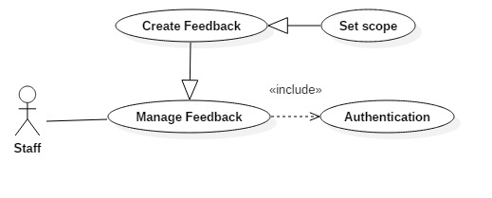

***Figure 22: <Staff> Set Feedback Scope***

|  |  |  |  |
| --- | --- | --- | --- |
| **USE CASE – UC017** | | | |
| **Use Case No.** | 017 | **Use Case Version** | 1.0 |
| **Use Case Name** | Set Feedback Scope | | |
| **Author** | TuNV | | |
| **Date** | 27/03/2018 | **Priority** | High |
| **Actor:**   * Staff * Head of Academic   **Summary:**   * This use case allows Actor to set Feedback Scope.   **Goal:**   * Actor successfully sets Feedback Scope.   **Triggers:**   * Actor clicks set Feedback Scope button.   **Preconditions:**   * Actor has been authorized and accessed the system with proper role.   **Post Conditions:**   * **Success:** Feedback Scope is successfully saved in database. * **Fail:** Feedback Scope cannot be saved.   **Main Success Scenario:**   |  |  |  | | --- | --- | --- | | Step | Actor Action | System Response | | 1 | Actor sends Feedback Scope command. | System requires information:   * Scope: Dropdown list | | 2 | Actor inputs information and sends command to “Save”. | Feedback Scope is saved.  [Exception 1]  [Exception 2] |   **Exceptions :**   |  |  |  | | --- | --- | --- | | No | Cause | System Response | | 2 | Actor does not input required field. | System notices that actor need to input semester field. |   **Relationships:** N/A  **Business Rules:**   * Feedback Scope can be Major, Course, Department, Class. * Each Feedback can only have one scope. | | | |

* + - 1. ***Staff Set Feedback Target***

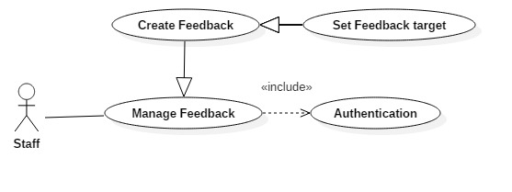

***Figure 23: <Staff> Set Feedback Target***

|  |  |  |  |
| --- | --- | --- | --- |
| **USE CASE – UC018** | | | |
| **Use Case No.** | 018 | **Use Case Version** | 1.0 |
| **Use Case Name** | Set Feedback Target | | |
| **Author** | TuNV | | |
| **Date** | 27/03/2018 | **Priority** | High |
| **Actor:**   * Staff * Head of Academic   **Summary:**   * This use case allows Actor to set Feedback Target.   **Goal:**   * Actor successfully sets Feedback Target.   **Triggers:**   * Actor clicks set Feedback Target button.   **Preconditions:**   * Actor has been authorized and accessed the system with proper role.   **Post Conditions:**   * **Success:** Feedback Target is successfully saved in database. * **Fail:** Feedback Target cannot be saved.   **Main Success Scenario:**   |  |  |  | | --- | --- | --- | | Step | Actor Action | System Response | | 1 | Actor sends Feedback Target command. | System displays list Feedback target that suitable to existed scope.  [Exception 1] | | 2 | Actor choose Target and sends command to “Save”.  [Alternative 1]  [Alternative 2]  [Alternative 3] | Feedback target is saved.  [Exception 2] |   **Alternative Scenario 1:**   |  |  |  | | --- | --- | --- | | Step | Actor Action | System Response | |  | Actor clicks on button “Deselect” target. | System deselects that target |   **Alternative Scenario 2:**   |  |  |  | | --- | --- | --- | | Step | Actor Action | System Response | |  | Actor clicks on “Delete” button. | System deletes that chosen target |   **Alternative Scenario 3:**   |  |  |  | | --- | --- | --- | | Step | Actor Action | System Response | |  | Actor chooses another scope | System removes all selected targets in previous scope |   **Exceptions :**   |  |  |  | | --- | --- | --- | | No | Cause | System Response | | 1 | There is no suitable target for chosen scope | System shows error message “Không có đối tượng nào” | | 2 | Actor does not choose any target. | System notices that actor need to choose at least one target. |   **Relationships:** N/A  **Business Rules:**   * Actor can choose multiple targets for one feedback. * All targets that are chosen for a feedback must be in the same Scope. | | | |

* + - 1. ***Staff Set Feedback Conductor***

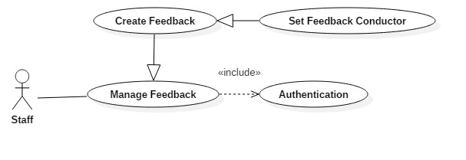

***Figure 24: <Staff> Set Feedback Conductor***

|  |  |  |  |
| --- | --- | --- | --- |
| **USE CASE – UC019** | | | |
| **Use Case No.** | 019 | **Use Case Version** | 1.0 |
| **Use Case Name** | Set Feedback Conductor | | |
| **Author** | TuNV | | |
| **Date** | 27/03/2018 | **Priority** | High |
| **Actor:**   * Staff * Head of Academic   **Summary:**   * This use case allows Actor to set Feedback Conductor.   **Goal:**   * Actor successfully sets Feedback Conductor.   **Triggers:**   * Actor clicks set Feedback Conductor button.   **Preconditions:**   * Actor has been authorized and accessed the system with proper role.   **Post Conditions:**   * **Success:** Feedback Conductor is successfully saved in database. * **Fail:** Feedback Conductor cannot be saved.   **Main Success Scenario:**   |  |  |  | | --- | --- | --- | | Step | Actor Action | System Response | | 1 | Actor sends Feedback Conductor command. | System displays list Feedback Conductor that suitable to existed target.  [Exception 1] | | 2 | Actor choose Conductor and sends command to “Save”.  [Alternative 1]  [Alternative 2] | Feedback Conductor is saved.  [Exception 2] |   **Alternative Scenario 1:**   |  |  |  | | --- | --- | --- | | Step | Actor Action | System Response | |  | Actor clicks on button “Deselect” conductor. | System deselects that conductor |   **Alternative Scenario 2:**   |  |  |  | | --- | --- | --- | | Step | Actor Action | System Response | |  | Actor clicks on “Delete” target button. | System deletes that all selected conductors for that target. |   **Exceptions :**   |  |  |  | | --- | --- | --- | | No | Cause | System Response | | 1 | There is no suitable conductors for chosen target | System shows error message “Không có người thực hiện nào” | | 2 | Actor does not choose any conductor. | System notices that actor need to choose at least one conductor. |   **Relationships:** N/A  **Business Rules:**   * Actor can choose multiple conductors for one target. * All corresponding conductors for that target must be auto selected. | | | |

* + - 1. ***Staff Publish Feedback***

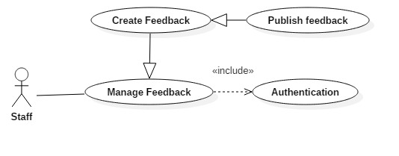

***Figure 25: <Staff> Publish Feedback***

|  |  |  |  |
| --- | --- | --- | --- |
| **USE CASE – UC020** | | | |
| **Use Case No.** | 020 | **Use Case Version** | 1.0 |
| **Use Case Name** | Publish Feedback | | |
| **Author** | TuNV | | |
| **Date** | 27/03/2018 | **Priority** | High |
| **Actor:**   * Staff * Head of Academic   **Summary:**   * This use case allows Actor to publish Feedback.   **Goal:**   * Actor successfully publishes Feedback.   **Triggers:**   * Actor clicks Publish Feedback button.   **Preconditions:**   * Actor has been authorized and accessed the system with proper role.   **Post Conditions:**   * **Success:** Feedback is successfully saved in database and published. * **Fail:** Feedback cannot be saved and published.   **Main Success Scenario:**   |  |  |  | | --- | --- | --- | | Step | Actor Action | System Response | | 1 | Actor sends Publish Feedback command. | System saves all Feedback Information and publishes Feedback.  [Exception 1]  [Exception 2] |   **Exceptions :**   |  |  |  | | --- | --- | --- | | No | Cause | System Response | | 1 | Actor does not input required field. | System notices that actor need to input all these fields. | | 2 | Actor inputs wrong some fields with requirement. | System notices that actor need to re-input all those fields. |   **Relationships:** N/A  **Business Rules:**   * When Feedback is published, it will be available for corresponding conductors to do. * Once feedback is published, it cannot be edited anymore. | | | |

* + - 1. ***Staff Save Feedback as Template***

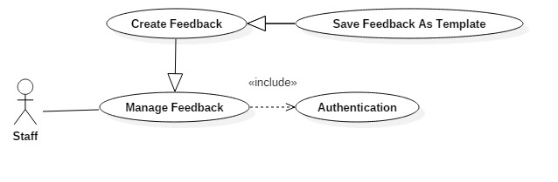

***Figure 26: <Staff> Save Feedback as Template***

|  |  |  |  |
| --- | --- | --- | --- |
| **USE CASE – UC021** | | | |
| **Use Case No.** | 021 | **Use Case Version** | 1.0 |
| **Use Case Name** | Save Feedback as Template | | |
| **Author** | TuNV | | |
| **Date** | 27/03/2018 | **Priority** | High |
| **Actor:**   * Staff * Head of Academic   **Summary:**   * This use case allows Actor to Save Feedback as Template.   **Goal:**   * Actor successfully Save Feedback as Template.   **Triggers:**   * Actor clicks Save Feedback as Template button.   **Preconditions:**   * Actor has been authorized and accessed the system with proper role.   **Post Conditions:**   * **Success:** Feedback is successfully saved as template in database. * **Fail:** Feedback cannot be saved as template.   **Main Success Scenario:**   |  |  |  | | --- | --- | --- | | Step | Actor Action | System Response | | 1 | Actor sends Save Feedback as Template command. | System saves all Feedback Information as new template Feedback.  [Exception 1]  [Exception 2] |   **Exceptions :**   |  |  |  | | --- | --- | --- | | No | Cause | System Response | | 1 | Actor does not input required field. | System notices that actor need to input all these fields. | | 2 | Actor inputs wrong some fields with requirement. | System notices that actor need to re-input all those fields. |   **Relationships:** N/A  **Business Rules:**   * When Feedback is saved as template, actor can choose it again in Select template screen | | | |

* + - 1. ***Staff Update Feedback Template***



***Figure 27: <Staff> Update Feedback Template***

|  |  |  |  |
| --- | --- | --- | --- |
| **USE CASE – UC022** | | | |
| **Use Case No.** | 022 | **Use Case Version** | 1.0 |
| **Use Case Name** | Update Feedback Template | | |
| **Author** | TuNV | | |
| **Date** | 27/03/2018 | **Priority** | High |
| **Actor:**   * Staff * Head of Academic   **Summary:**   * This use case allows Actor to Update Feedback Template.   **Goal:**   * Actor successfully Update Feedback Template.   **Triggers:**   * Actor clicks Update Feedback Template button.   **Preconditions:**   * Actor has been authorized and accessed the system with proper role.   **Post Conditions:**   * **Success:** Template is successfully updated in database. * **Fail:** Template cannot be updated.   **Main Success Scenario:**   |  |  |  | | --- | --- | --- | | Step | Actor Action | System Response | | 1 | Actor sends Update Feedback Template command. | System updates all Template Information.  [Exception 1]  [Exception 2] |   **Exceptions :**   |  |  |  | | --- | --- | --- | | No | Cause | System Response | | 1 | Actor does not input required field. | System notices that actor need to input all these fields. | | 2 | Actor inputs wrong some fields with requirement. | System notices that actor need to re-input all those fields. |   **Relationships:** N/A  **Business Rules:**   * Template is updated. Actor can chose template again in list template, customize and publish or save as another template. | | | |

* + - 1. ***Staff Unpublish Feedback***

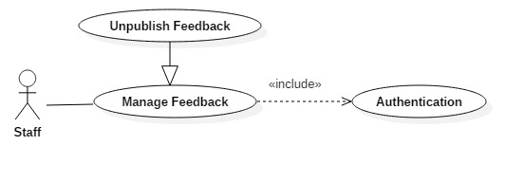

***Figure 28: <Staff> Unpublish Feedback***

|  |  |  |  |
| --- | --- | --- | --- |
| **USE CASE – UC023** | | | |
| **Use Case No.** | 023 | **Use Case Version** | 1.0 |
| **Use Case Name** | Update Feedback Template | | |
| **Author** | TuNV | | |
| **Date** | 27/03/2018 | **Priority** | High |
| **Actor:**   * Staff * Head of Academic   **Summary:**   * This use case allows Actor to Unpublish Feedback.   **Goal:**   * Actor successfully Unpublish Feedback.   **Triggers:**   * Actor clicks Unpublish Feedback button.   **Preconditions:**   * Actor has been authorized and accessed the system with proper role.   **Post Conditions:**   * **Success:** Feedback is successfully unpublished. * **Fail:** Feedback cannot be unpublished.   **Main Success Scenario:**   |  |  |  | | --- | --- | --- | | Step | Actor Action | System Response | | 1 | Actor sends Unpublish Feedback command. | System confirms actor command. | | 2 | Actor send confirm command.  [Alternative 1] | System changes selected Feedback to unpublish state. |   **Alternative :**   |  |  |  | | --- | --- | --- | | No | Cause | System Response | | 1 | Actor send cancel action command. | System keeps Feedback publish state. |   **Relationships:** N/A  **Business Rules:**   * Once Feedback is unpublished, all users cannot see or conduct that Feedback. * Report will not be generated for unpublished Feedback. * Actor can republish report after it is unpublished | | | |

* + 1. ***Head of Academic Overview Use Case***

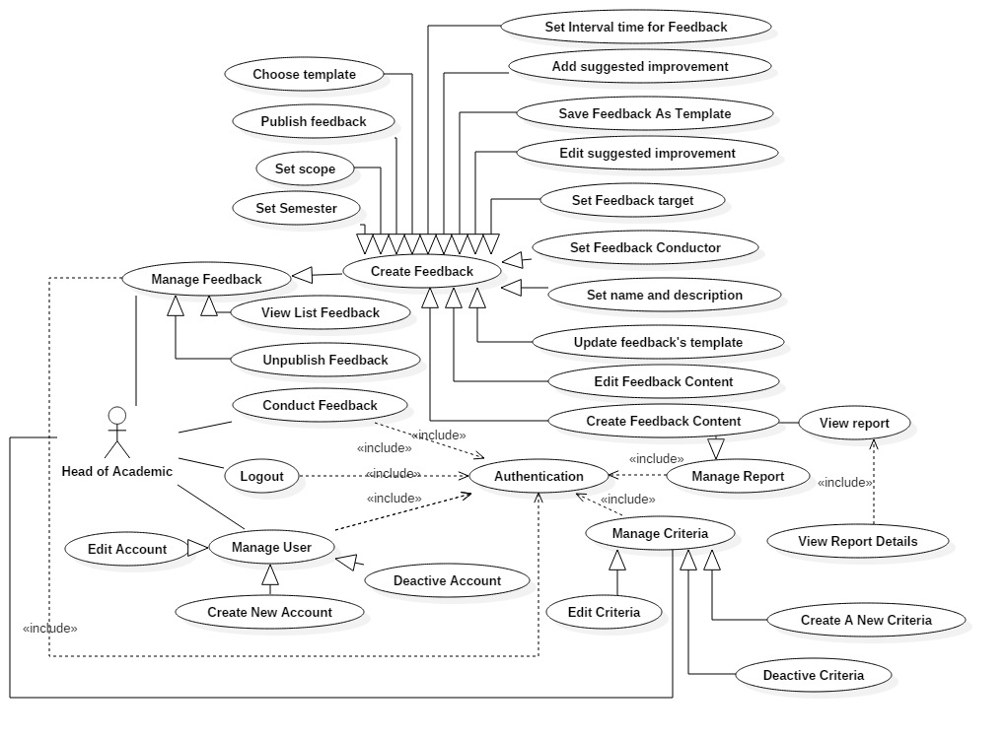

***Figure 29: <Head of Academic> Overview Use Case***

* + - 1. ***Head of Academic Create New Criteria***

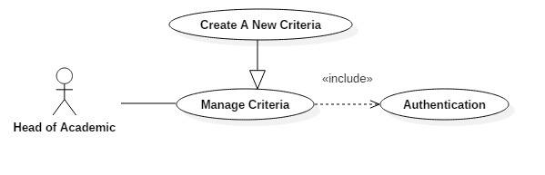

***Figure 30: <Head of Academic> Create new criteria***

|  |  |  |  |
| --- | --- | --- | --- |
| **USE CASE – UC024** | | | |
| **Use Case No.** | 024 | **Use Case Version** | 1.0 |
| **Use Case Name** | Create new criteria | | |
| **Author** | VietHQ | | |
| **Date** | 03/04/2018 | **Priority** | High |
| **Actor:**   * Head of Academic   **Summary:**   * This use case allows Head to create new criteria.   **Goal:**   * Criteria is created successfully and store in database of the system.   **Triggers:**   * Head clicks on create new criteria button.   **Preconditions:**   * Head has been authorized and accessed the system with proper role.   **Post Conditions:**   * **Success:** New criteria is created. * **Fail:** Criteria is not created.   **Main Success Scenario:**   |  |  |  | | --- | --- | --- | | Step | Actor Action | System Response | | 1 | Head sends create new criteria command. | System requires information:   * Criteria name * Status | | 2 | Head inputs information and sends command to “Save”. | Criteria created. |   **Alternative Scenario 1:**   |  |  |  | | --- | --- | --- | | Step | Actor Action | System Response | |  | Head sends command to reset. | System reset all field to blank. |   **Exceptions :**   |  |  |  | | --- | --- | --- | | No | Cause | System Response | | 1 | Head does not input required field. | System notices that Head need to input all these field:   * “Criteria name” |   **Relationships:** N/A  **Business Rules:**   * After creating new criteria and active, actor can create question with new criteria. | | | |

* + - 1. ***Head of Academic Edit Criteria***

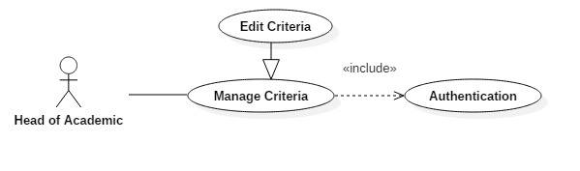

***Figure 31: <Head of Academic> Edit criteria***

|  |  |  |  |
| --- | --- | --- | --- |
| **USE CASE – UC025** | | | |
| **Use Case No.** | 025 | **Use Case Version** | 1.0 |
| **Use Case Name** | Edit Criteria | | |
| **Author** | VietHQ | | |
| **Date** | 03/04/2018 | **Priority** | High |
| **Actor:**   * Head of Academic   **Summary:**   * This use case allows Head to edit criteria.   **Goal:**   * Criteria is updated.   **Triggers:**   * Head clicks on edit criteria button.   **Preconditions:**   * Head has been authorized and accessed the system with proper role.   **Post Conditions:**   * **Success:** Information of criteria is updated and display. * **Fail:** Information of criteria is not updated.   **Main Success Scenario:**   |  |  |  | | --- | --- | --- | | Step | Actor Action | System Response | | 1 | Head sends edit criteria command. | System requires information:   * Criteria name: free text input, required, length (9-20), unique * Status: Active or Deactive | | 2 | Head inputs information and sends command to “Save”. | Criteria updated. |   **Alternative Scenario 1:**   |  |  |  | | --- | --- | --- | | Step | Actor Action | System Response | |  | Head sends command to reset. | System reset all field to blank. |   **Exceptions :**   |  |  |  | | --- | --- | --- | | No | Cause | System Response | | 1 | Head does not input required field. | System notices that Head need to input all these field:   * “Criteria name” |   **Relationships:** N/A  **Business Rules:**   * After edited, new information will be save to database. | | | |

* + - 1. ***Head of Academic Deactivate Edit***

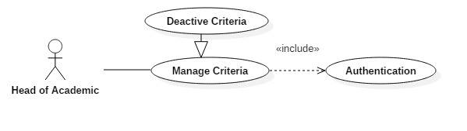

***Figure 32: <Head of Academic> Deactivate criteria***

|  |  |  |  |
| --- | --- | --- | --- |
| **USE CASE – UC026** | | | |
| **Use Case No.** | 026 | **Use Case Version** | 1.0 |
| **Use Case Name** | Deactivate Criteria | | |
| **Author** | VietHQ | | |
| **Date** | 03/04/2018 | **Priority** | High |
| **Actor:**   * Head of Academic   **Summary:**   * This use case allows Head to deactivate criteria.   **Goal:**   * Criteria is deactivated.   **Triggers:**   * Head clicks on deactivate criteria button.   **Preconditions:**   * Head has been authorized and accessed the system with proper role.   **Post Conditions:**   * **Success:** Criteria is deactivated * **Fail:** Criteria is not deactivated   **Main Success Scenario:**   |  |  |  | | --- | --- | --- | | Step | Actor Action | System Response | | 1 | Head sends deactivate criteria command. | System requires information:   * Criteria Id | | 2 | Head hits confirm button | Criteria deactivated. |   **Exceptions :**   |  |  |  | | --- | --- | --- | | No | Cause | System Response | | 1 | Id does not exist in database | System notices that cannot find criteria in database |   **Relationships:** N/A  **Business Rules:**   * Deactivated criteria cannot be used in creating feedback content. | | | |

* + - 1. ***Head of Academic Deactivate Account***

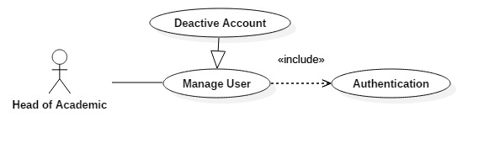

***Figure 33: <Head of Academic> Deactivate account***

|  |  |  |  |
| --- | --- | --- | --- |
| **USE CASE – UC027** | | | |
| **Use Case No.** | 027 | **Use Case Version** | 1.0 |
| **Use Case Name** | Deactivate Account | | |
| **Author** | VietHQ | | |
| **Date** | 03/04/2018 | **Priority** | High |
| **Actor:**   * Head of Academic   **Summary:**   * This use case allows Head to deactivate account.   **Goal:**   * Account is deactivated.   **Triggers:**   * Head clicks on deactivate account button.   **Preconditions:**   * Head has been authorized and accessed the system with proper role.   **Post Conditions:**   * **Success:** Account is deactivated * **Fail:** Account is not deactivated   **Main Success Scenario:**   |  |  |  | | --- | --- | --- | | Step | Actor Action | System Response | | 1 | Head sends deactivate account command. | System requires information:   * Account Id | | 2 | Head hits confirm button | Account deactivated. |   **Exceptions :**   |  |  |  | | --- | --- | --- | | No | Cause | System Response | | 1 | Id does not exist in database | System notices that cannot find account in database |   **Relationships:** N/A  **Business Rules:**   * Deactivated account cannot login and access to the system. | | | |

* + 1. ***System (Actor) Overview Use Case***

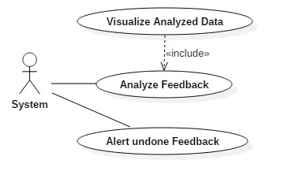

***Figure 34: <System (Actor)> Overview Use Case***

* + - 1. ***System (Actor) Analyze Feedback***

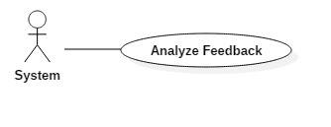

***Figure 35: <System (Actor)> Analyze Feedback***

|  |  |  |  |
| --- | --- | --- | --- |
| **USE CASE – UC028** | | | |
| **Use Case No.** | 028 | **Use Case Version** | 1.0 |
| **Use Case Name** | Analyze Feedback | | |
| **Author** | VietHQ | | |
| **Date** | 03/04/2018 | **Priority** | High |
| **Actor:**   * System   **Summary:**   * This use case allows system to analyze from feedbacks’ answers.   **Goal:**   * Feedbacks’ answer will be sum up and calculated by overall semester or criteria or classes.   **Triggers:**   * Users with see all report or see self’s report privileges click the “Xem báo cáo” link.   **Preconditions:**   * Users triggers the event has been authorized and accessed the system with proper role.   **Post Conditions:**   * **Success:** Return an overall average point and component (class, criteria) average point. * **Fail:** Return NaN for any kind of point.   **Main Success Scenario:**   |  |  |  | | --- | --- | --- | | Step | Actor Action | System Response | | 1 | Users click on “Xem báo cáo” menu item | Redirect users to view list reports pages. | | 2 | Users click on “Xem báo cáo” on any record show on table. | Redirect users to view reports throughout semesters. | | 3 | Actor composes feedbacks’ answers then calculate overall average point throughout semesters. | Return the result to visualize these data. | | 4. | Actor selects a semester to view detail point. | Return the result to visualize these data. |   **Alternative Scenario 1:**   |  |  |  | | --- | --- | --- | | Step | Actor Action | System Response | | 3a | Users filter from which semester to which semester. | System re-draws to satisfy user desire. | | 4a | Actor selects a semester for a subject by a lecturer. | System provides users with which class should be viewed. |   **Exceptions :**   |  |  |  | | --- | --- | --- | | No | Cause | System Response | | 1 | Divided by 0 | System removes this calculation from the result. | | 2 | No feedback for this target has been done. | System show warning message “Đối tượng này chưa có feedback nào”. |   **Relationships:** N/A  **Business Rules:**   * Only user with “Head of Academic” and “Admin” can see report for all departments and classes. * User with “Lecturer” role can see only report for classes who he/she is in charge of. * User with “Staff” role can see only report for his/her department. * User with “Student” role cannot access these data. | | | |

* + - 1. ***System (Actor) Visualize Data***

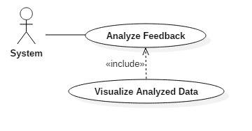

***Figure 36: <System (Actor)> Visualize Analyzed Data***

|  |  |  |  |
| --- | --- | --- | --- |
| **USE CASE – UC029** | | | |
| **Use Case No.** | 029 | **Use Case Version** | 1.0 |
| **Use Case Name** | Visualize Analyzed Data | | |
| **Author** | VietHQ | | |
| **Date** | 03/04/2018 | **Priority** | High |
| **Actor:**   * System   **Summary:**   * This use case allows system to visualize analyzed data.   **Goal:**   * Calculated overall point will be shown as bar charts or pie charts, enable users to see the progress or which criteria need to improved   **Triggers:**   * Users with see all report or see self’s report privileges click the “Xem báo cáo” link and data has been calculated.   **Preconditions:**   * User triggers the event has been authorized and accessed the system with proper role. * Overall average points and component points had been calculated.   **Post Conditions:**   * **Success:** Visualize the calculated data as pie chart or bar chart. * **Fail:** Cannot show the data as charts.   **Main Success Scenario:**   |  |  |  | | --- | --- | --- | | Step | Actor Action | System Response | | 1 | Users click on “Xem báo cáo” menu item | Redirect users to view list reports pages. | | 2 | Users click on “Xem báo cáo” on any record show on table. | Redirect users to view reports throughout semesters. | | 3 | Actor get the calculated data and display as bar chart throughout semesters | Display bar charts to users’ screens. | | 4. | Actor selects a semester to view detail point. | Display pie charts to users’ screens |   **Alternative Scenario 1:**   |  |  |  | | --- | --- | --- | | Step | Actor Action | System Response | | 3a | Users filter from which semester to which semester. | System re-draws charts to satisfy user desire. | | 4a | Actor selects a semester for a subject by a lecturer. | System provides users with which class should be viewed. |   **Exceptions :**   |  |  |  | | --- | --- | --- | | No | Cause | System Response | | 1 | NaN point | Corresponding chart will be blank. | | 2 | No feedback for this target has been done. | System show warning message “Đối tượng này chưa có feedback nào”. |   **Relationships:** N/A  **Business Rules:**   * Only user with “Head of Academic” and “Admin” can see report for all departments, classes. * User with “Lecturer” role can see only report for classes who he/she is in charge of. * User with “Staff” role can see only report for his/her department. * User with “Student” role cannot access these data. | | | |

* + - 1. ***System (Actor) Alert undone Feedback***

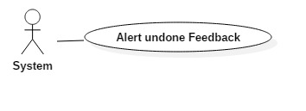

***Figure 37: <System (Actor)> Alert undone Feedback***

|  |  |  |  |
| --- | --- | --- | --- |
| **USE CASE – UC030** | | | |
| **Use Case No.** | 030 | **Use Case Version** | 1.0 |
| **Use Case Name** | Alert undone Feedback | | |
| **Author** | TuNV | | |
| **Date** | 04/04/2018 | **Priority** | High |
| **Actor:**   * System   **Summary:**   * This use case allows system to alert undone Feedback to users.   **Goal:**   * Alert undone Feedback to corresponding users.   **Triggers:**   * Feedback is published.   **Preconditions:**   * Feedback is still in available time and has at least one conductor.   **Post Conditions:**   * **Success:** Alert undone Feedback to users. * **Fail:** Feedback is not alerted.   **Main Success Scenario:**   |  |  |  | | --- | --- | --- | | Step | Actor Action | System Response | | 1 | Users click on Publish Feedback button. | System checks list conductors and send email, alert them to do feedback.  [Exception 1] |   **Exceptions :**   |  |  |  | | --- | --- | --- | | No | Cause | System Response | | 1 | There is no conductors. | System shows error message “Xin chọn ít nhất một người thực hiện” |   **Relationships:** N/A  **Business Rules:**   * Alert icon will be keep displaying until Feedback is conducted. * Once user conducts Feedback, user can conducts again as long as Feedback is still available. | | | |

1. **Software System Attribute**
   1. **Usability**

* Head of Academic and staff should need less than 0.5 day of training to use the system.
* Mobile and web application use Vietnamese including all dialogs and messages.
* Student and Lecturer can understand and perform functions immediately without the training process.
  1. **Availability**
* System is divided into modules, if a function is down, it will not influence others.
* The system can be adapted for a large number of requests.
  1. **Security**
* All input data should be validated before saving to database.
* Roles permission should be specified clearly and user should be authenticated and authorized when accessing to the system.
  1. **Maintainability**
* System is divided into modules.
* When a module of a function is down, it is easy to take it down to fix without impact other functions.

### Portability

* Web application can run on Chrome, Firefox, IE browser.
* User can use the mobile application on devices running Android 6 or later.

### Performance

* System converts and returns results in 1 seconds or less depend on information of inputted driver.

1. **Conceptual Diagram**

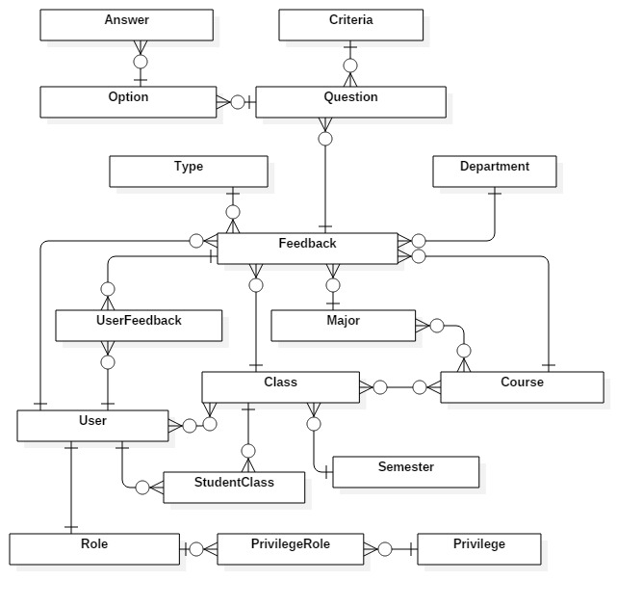

**Figure 38: Conceptual diagram**

**Data Dictionary**

|  |  |
| --- | --- |
| **Entity Data dictionary: describe content of all entities** | |
| **Entity Name** | **Description** |
| Feedback | Contain Feedback information |
| Question | Contain Question information |
| Option | Contain Option information |
| Answer | Contain Answer information |
| Criteria | Contain Criteria information |
| Semester | Contain Semester information |
| Type | Contain Feedback type information |
| User | Contain User information |
| UserFeedback | Contain information about relationship between a user with a feedback |
| Role | Contain Role information |
| Privilege | Contain Privilege information |
| PrivilegeRole | Contain Privilege information for each role |
| StudentClass | Contain information about class of each student |
| Class | Contain Class information |
| Course | Contain Course information |
| Major | Contain Major information |
| Department | Contain Department information |

Table 7: Conceptual diagram data dictionary

# Software Design Description

## Design Overview

This document describes the technical and user interface design of SFMS System. It includes the architectural design, the detailed design of common functions and business functions and the design of database model. Document overview:

* + Section 2: gives an overall description of the system architecture design.
  + Section 3: gives component diagrams that describes the connection and integration of the system.
  + Section 4: gives the detail design description which includes class diagram, class explanation and sequence diagram to details the application functions.
  + Section 5: describes screen design.
  + Section 6: describes a fully attributed ERD.
  + Section 7: describes algorithms.
  1. **System Architectural Design**

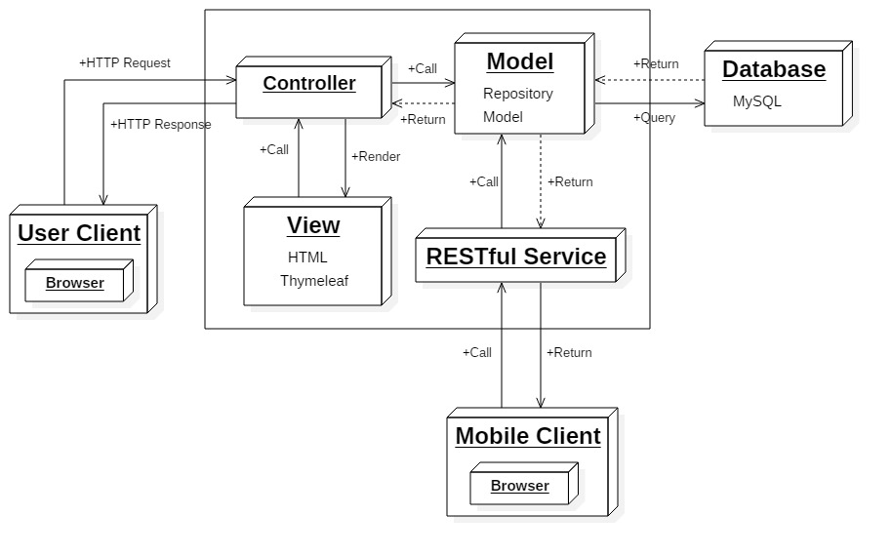

***Figure 39: System Architecture Design***

In Web Application, the system is developed under MVC architecture style. We choose this architecture for Web Application because of following advantages:

* The application will be divided into three clear parts.
* Testing each component in the architecture become easier.
* Ease of maintenance, we can change any component without effect to other component.
* Faster development process: MVC supports rapid and parallel development. With MVC, one programmer can work on the view while other can work on the controller to create business logic of the web application. The application developed using MVC can be three times faster than application developed using other development patterns.

This project follows MVC architecture with following components:

* Controller is the parts of the application that acts like event handler to handles user interaction. Typically, controller read data from a request and calls appropriate Business’s method then selects view to return to user.
* View is responsible for rendering the model data and in general it generates HTML output that the client's browser can interpret.
* The model is responsible for managing the data of the application. It responds to the request from the view and it also responds to instructions from the controller to update itself.
  1. **Component Diagram**

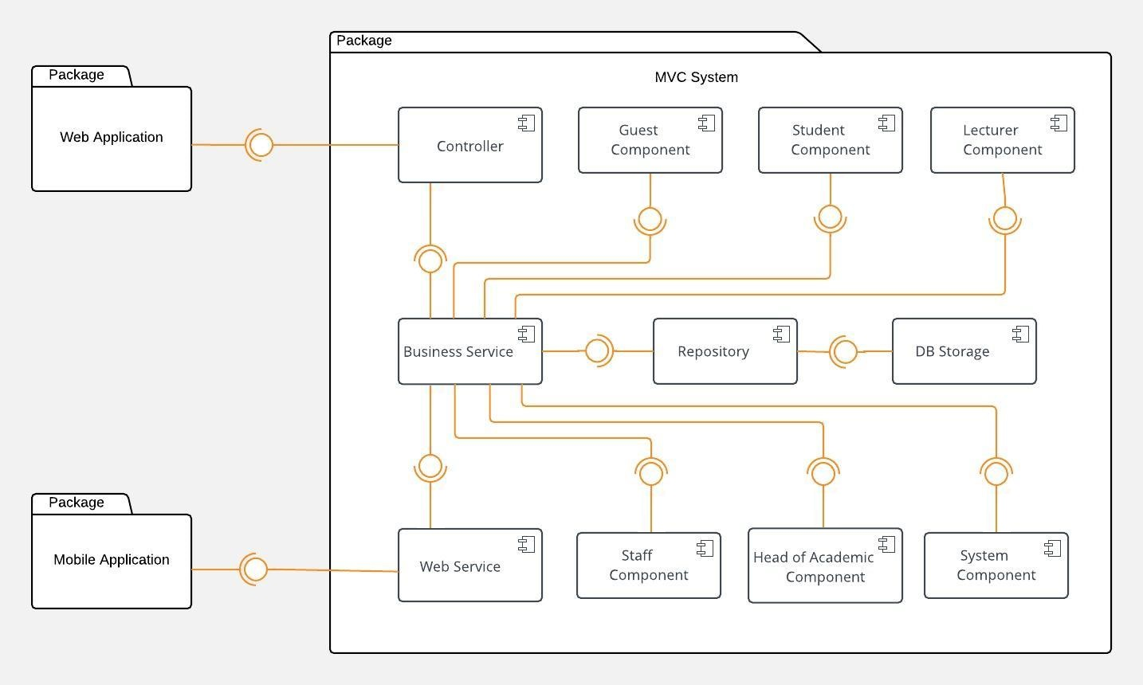

**Figure 40: Component Diagram**

|  |  |
| --- | --- |
| **Component Dictionary: Describes components** | |
| Web Application | Web application package contains operation of SFMS on web |
| Mobile Application | Mobile application package contains operation of SFMS on mobile device |
| Business Service | Handle Business logic |
| Controller | Handle Request and Response. Accepts input and coverts it to commands for the model and view. |
| Web Service | Provide API for mobile applications to interact with the system |
| Guest Component | Component to handle customer activities in the system |
| Student Component | Component to handle student activities in the system |
| Lecturer Component | Component to handle lecturer activities in the system |
| Staff Component | Component to handle staff activities in the system |
| Head of Academic Component | Component to handle head of academic activities in the system |
| System Component | Component to handle system |
| Repository | Store data |
| DB Storage | Database on hard disk. Contain method for tranferring data between database and data object |

**Table 8: Component Dictionary**

## Detailed Description

### Class Diagram

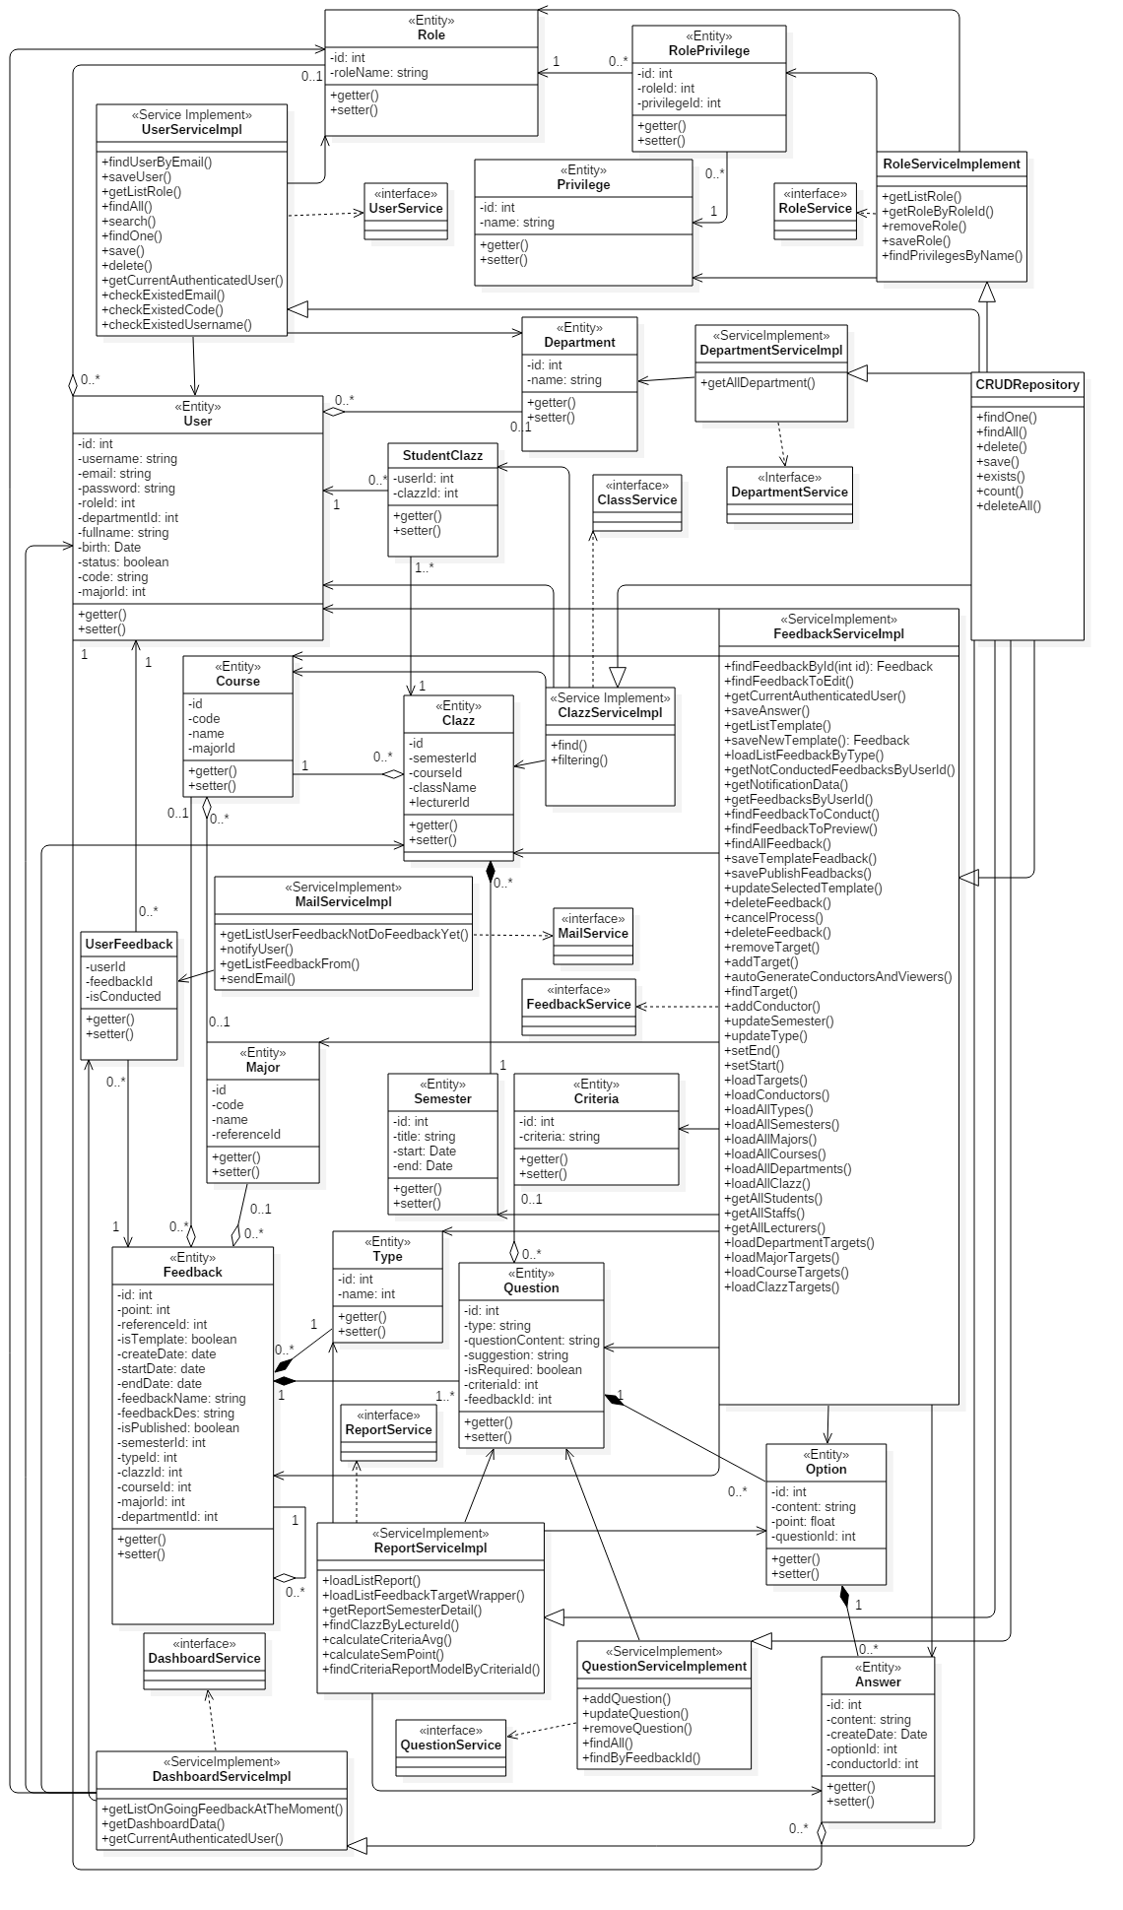

**Figure 41: Class Diagram**

**Figure 41: Class Diagram**

|  |  |
| --- | --- |
| **Class dictionary: describe Class** | |
| **Class Name** | **Description** |
| User | Contain the user's account & profile information |
| Privilege | Contain the previlege information |
| Role | Contain the role information |
| RolePrivilege | Contain the information about the relationship between role & privilege |
| Department | Contain the department information |
| Major | Contain the major information |
| Course | Contain the course information |
| Clazz | Contain the class information |
| StudentClazz | Contain the information the relationship between user whom role is Student and Clazz which he's enrolled |
| Type | Contain the feedback's type information |
| Semester | Contain the semester information |
| Feedback | Contain the feedback information |
| UserFeedback | Contain the information the relationship between user (whom role is Student) and Clazz which he's enrolled |
| Criteria | Contain the criteria information |
| Question | Contain the question information |
| Option | Contain the option information |
| Answer | Contain the answer information |

**Table 9: Class dictionary**

### Class Diagram Explanation

#### User

|  |  |  |  |
| --- | --- | --- | --- |
| **Attribute** | **Type** | **Visibility** | **Description** |
| id | int | private | unique identifier of a user's account |
| username | string | private | unique username of a user's account |
| email | string | private | unique email of a user's account |
| password | string | private | password of a user's account |
| roleId | int | private | identifier of the role of account |
| departmentId | int | private | Identifier of the department of account |
| fullname | string | private | fullname of user |
| code | string | private | code of user's account |
| birth | date | private | date of birth of user |
| status | boolean | private | status of user's account |
| majorId | int | private | identifier of the department of user |
|  |  |  |  |

#### Priviledge

|  |  |  |  |
| --- | --- | --- | --- |
| **Attribute** | **Type** | **Visibility** | **Description** |
| id | int | private | Unique identifier of a privilege |
| name | string | private | name of privilege |

#### Role

|  |  |  |  |
| --- | --- | --- | --- |
| **Attribute** | **Type** | **Visibility** | **Description** |
| id | int | private | Unique identifier of a role |
| roleName | string | private | name of role |

#### RolePriviledge

|  |  |  |  |
| --- | --- | --- | --- |
| **Attribute** | **Type** | **Visibility** | **Description** |
| id | int | private | Unique identifier of a role |
| roleId | int | private | Identifier of RolePrivilege's role |
| privilegeId | int | private | Identifier of RolePrivilege's privilege |

#### Department

|  |  |  |  |
| --- | --- | --- | --- |
| **Attribute** | **Type** | **Visibility** | **Description** |
| id | int | private | Unique identifier of a department |
| name | int | private | name of a department |

#### Major

|  |  |  |  |
| --- | --- | --- | --- |
| **Attribute** | **Type** | **Visibility** | **Description** |
| id | int | private | Unique identifier of a major |
| code | string | private | code of a major |
| name | string | private | name of a major |
| referenceId | int | private | Identifier of major's reference |

#### Course

|  |  |  |  |
| --- | --- | --- | --- |
| **Attribute** | **Type** | **Visibility** | **Description** |
| id | int | private | Unique identifier of a course |
| code | string | private | code of a course |
| name | string | private | name of a course |
| majorId | int | private | Identifier of course's major |

#### Clazz

|  |  |  |  |
| --- | --- | --- | --- |
| **Attribute** | **Type** | **Visibility** | **Description** |
| id | int | private | Unique identifier of a course |
| courseId | int | private | Identifier of class's course |
| className | string | private | name of a course |
| lecturerId | int | private | Identifier of class's lecturer |
| semesterId | int | private | Identifier of class's semester |

#### StudentClazz

|  |  |  |  |
| --- | --- | --- | --- |
| **Attribute** | **Type** | **Visibility** | **Description** |
| userid | int | private | identifier of student |
| clazzId | int | private | Identifier of class |

#### Semester

|  |  |  |  |
| --- | --- | --- | --- |
| **Attribute** | **Type** | **Visibility** | **Description** |
| id | int | private | Unique identifier of a semester |
| title | string | private | title of a semester |
| start | date | private | a day when semester start |
| end | date | private | a day when semester will end |

#### Type

|  |  |  |  |
| --- | --- | --- | --- |
| **Attribute** | **Type** | **Visibility** | **Description** |
| id | int | private | Unique identifier of a type |
| name | string | private | name of type |

#### Feedback

|  |  |  |  |
| --- | --- | --- | --- |
| **Attribute** | **Type** | **Visibility** | **Description** |
| id | int | private | unique identifier of a feedback |
| point | string | private | point of e feedback |
| referenceId | int | private | identifier of feedback's reference |
| isTemplate | boolean | private | the feedback is template or not |
| isPublished | boolean | private | the feedback is published or not |
| createDate | date | private | create date of feedback |
| startDate | date | private | when the feedback start to receive answers |
| endDate | date | private | when the feedback end to receive answers |
| feedbackName | string | private | name of feedback |
| feedbackDes | string | private | description of feedback |
| semesterId | int | private | identifier of feedback's semester |
| typeId | int | private | identifier of feedback's type |
| majorId | int | private | identifier of feedback's major |
| courseId | int | private | identifier of feedback's course |
| clazzId | int | private | identifier of feedback's class |
| departmentId | int | private | identifier of feedback's department |

#### UserFeedback

|  |  |  |  |
| --- | --- | --- | --- |
| **Attribute** | **Type** | **Visibility** | **Description** |
| userId | int | private | Identifier of conductor |
| feedbackId | string | private | Identifier of feedback |
| isConducted | boolean | private | the feedback has been conducted by user or not |

#### Criteria

|  |  |  |  |
| --- | --- | --- | --- |
| **Attribute** | **Type** | **Visibility** | **Description** |
| id | int | private | Unique identifier of a criteria |
| criteria | string | private | name of criteria |
| status | boolean | private | the criteria is activated to be use or not |

#### Question

|  |  |  |  |
| --- | --- | --- | --- |
| **Attribute** | **Type** | **Visibility** | **Description** |
| id | int | private | unique identifier of a question |
| type | string | private | type of question, depend on the way we answer it |
| questionContent | boolean | private | content of question |
| suggestion | string | private | suggestion for improving question's result |
| isRequired | boolean | private | question must be answered or not |
| criteriaId | int | private | identify of question's criteria |
| feedbackId | int | private | identify of question's feedback |

#### Option

|  |  |  |  |
| --- | --- | --- | --- |
| **Attribute** | **Type** | **Visibility** | **Description** |
| id | int | private | unique identifier of an option |
| isRequired | boolean | private | question must be answered or not |
| point | int | private | point of option |
| questionId | int | private | identify of option's question |

#### Answer

|  |  |  |  |
| --- | --- | --- | --- |
| **Attribute** | **Type** | **Visibility** | **Description** |
| id | int | private | unique identifier of an answer |
| answerContent | int | private | content of answer as text |
| createDate | date | private | when te answer was created |
| optionId | int | private | identify of answer's option |
| conductorId | int | private | identify of answer's conductor |

* 1. **Interaction Diagram**
     1. ***Create new Feedback***

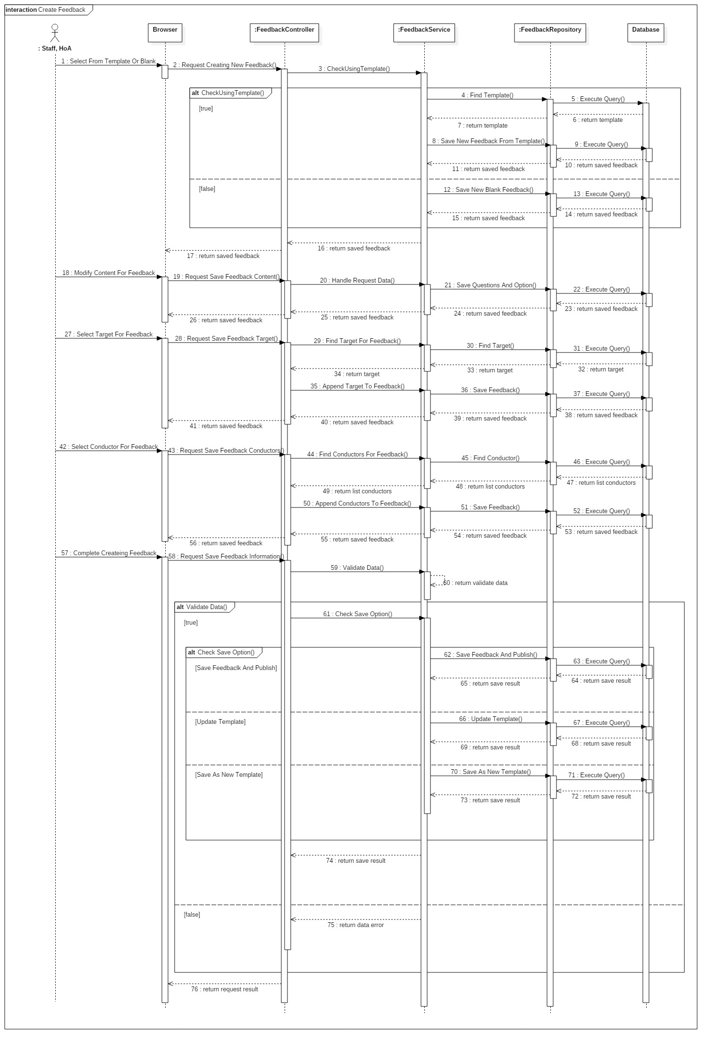

***Figure 42: Sequence diagram - Create new Feedback***

* + 1. ***Conduct Feedback***

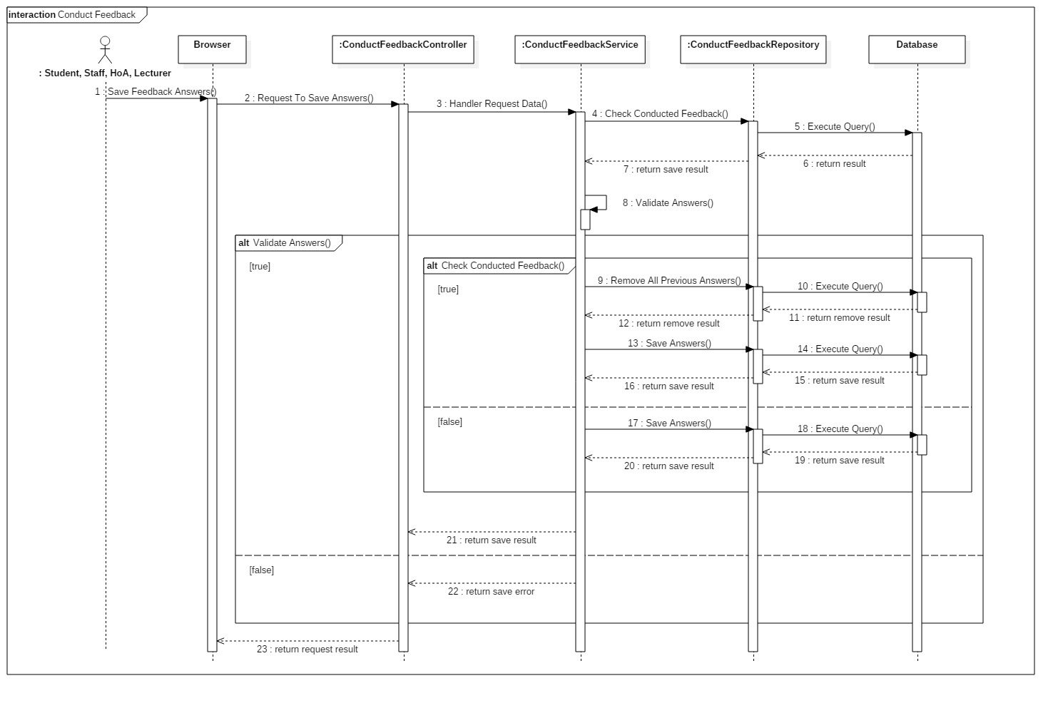

***Figure 43: Sequence diagram - Conduct Feedback***

* + 1. ***View Feedback Report***

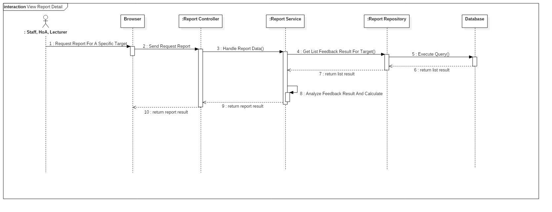

***Figure 44: Sequence diagram - View Feedback Report***

* + 1. ***Alert Undone Feedback***

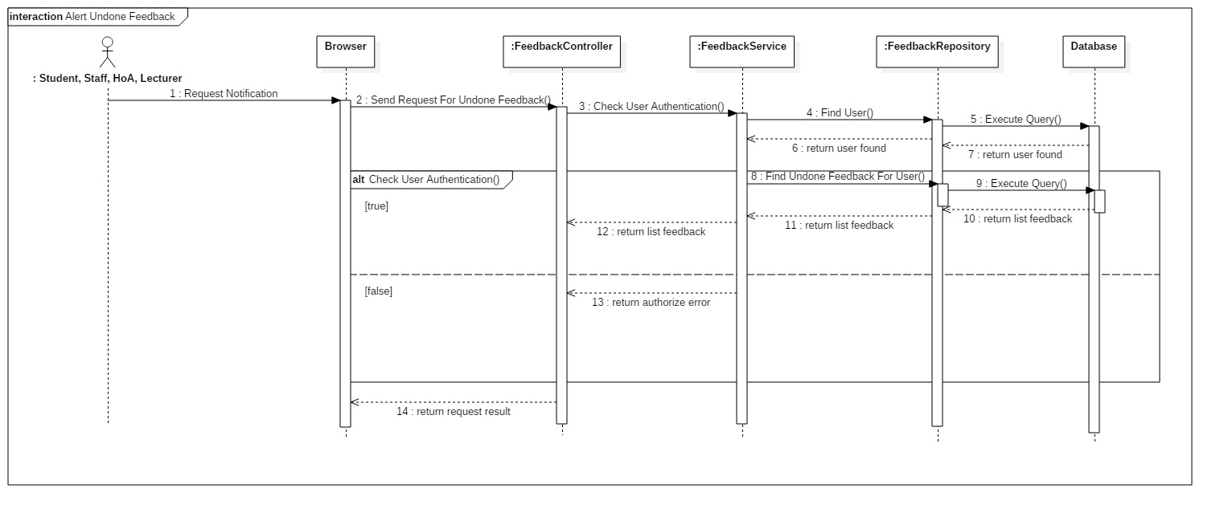

***Figure 45: Sequence diagram - Alert Undone Feedback***

* + 1. ***Create User***

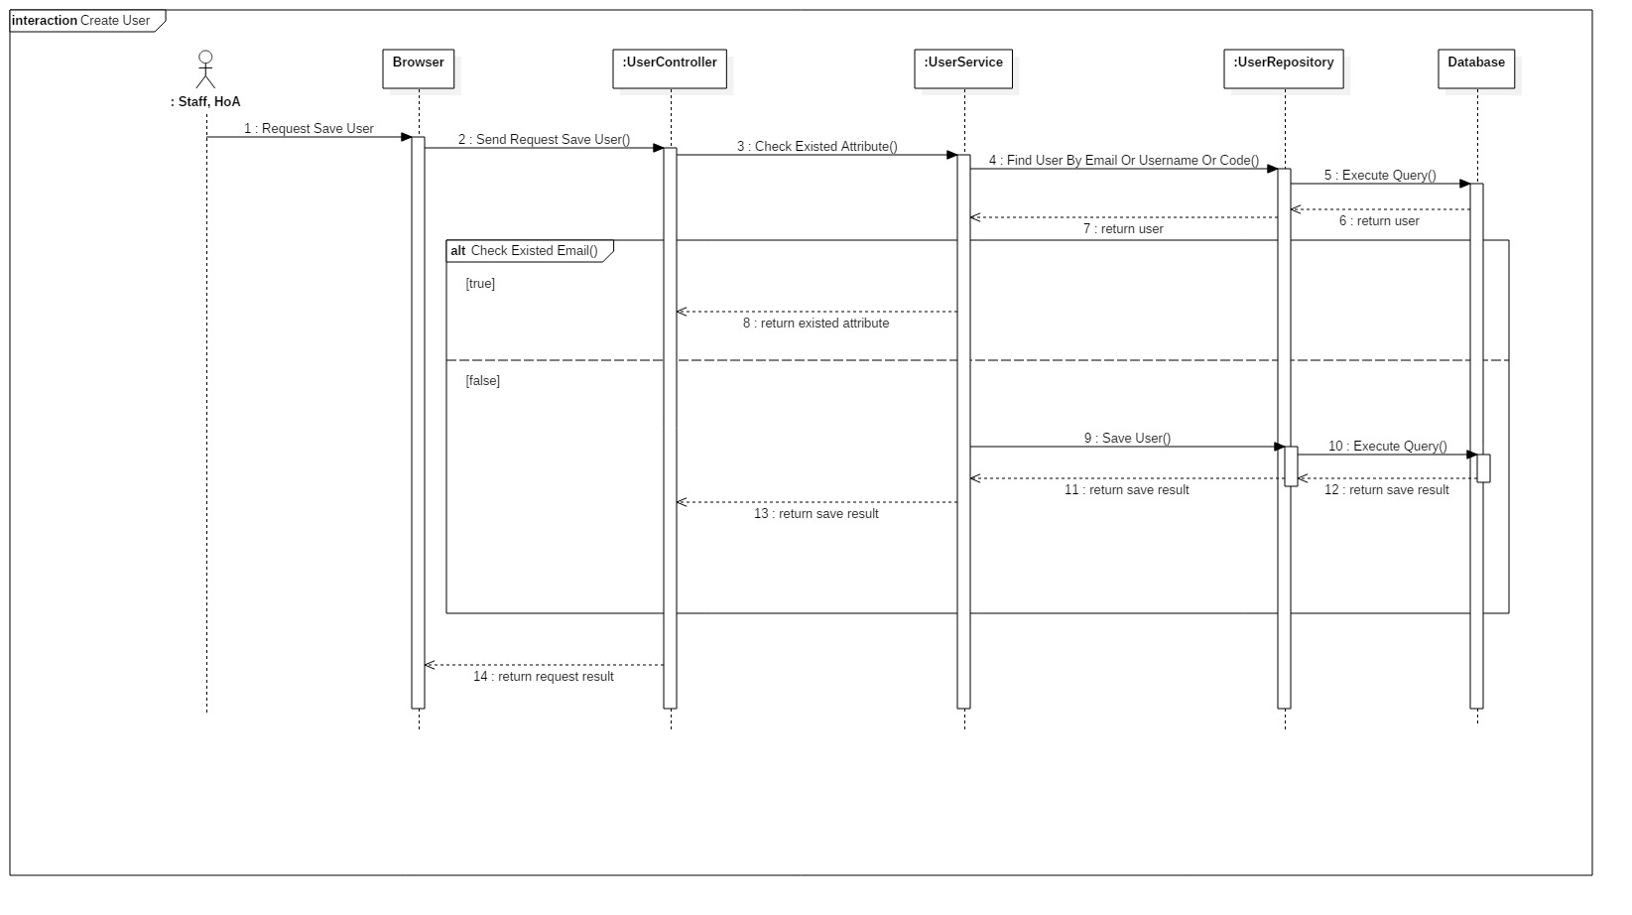

***Figure 46: Sequence diagram – Create User***

* + 1. ***Create criteria***

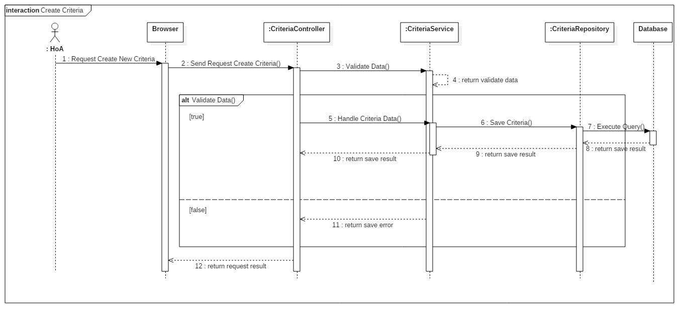

***Figure 47: Sequence diagram – Create Criteria***

1. **Interface**



**Figure 40: Component Diagram**

|  |  |
| --- | --- |
| **Component Dictionary: Describes components** | |
| Web Application | Web application package contains operation of SFMS on web |
| Mobile Application | Mobile application package contains operation of SFMS on mobile device |
| Business Service | Handle Business logic |
| Controller | Handle Request and Response. Accepts input and coverts it to commands for the model and view. |
| Web Service | Provide API for mobile applications to interact with the system |
| Guest Component | Component to handle customer activities in the system |
| Student Component | Component to handle student activities in the system |
| Lecturer Component | Component to handle lecturer activities in the system |
| Staff Component | Component to handle staff activities in the system |
| Head of Academic Component | Component to handle head of academic activities in the system |
| System Component | Component to handle system |
| Repository | Store data |
| DB Storage | Database on hard disk. Contain method for tranferring data between database and data object |

**Table 8: Component Dictionary**

* 1. **Component interface**

#### Module of User Api

|  |  |  |  |
| --- | --- | --- | --- |
| **Signature** | **Description** | **Output** | **Exception** |
| mobileLogin(String username, String password) | Login into Mobile Application | boolean | N/A |
| findAll | Find all users | JSON of List Users | N/A |
| getUser(int id) | Get user information | JSON of User | N/A |
| saveUser(SaveUserModel userModel) | Save user | ResponseEntity | N/A |
| updateUser(SaveUserModel userModel) | Update user | ResponseEntity | N/A |
| deleteUser(int id) | Delete user | N/A | N/A |
| checkExistedEmail(String email) | Check if email is existed when create new user | ResponseEntity | N/A |
| checkExistedCode(String code) | Check if code is existed when create new user | ResponseEntity | N/A |
| checkExistedUsername(String username) | Check if username is existed when create new user | ResponseEntity | N/A |

* + 1. ***Module of Feedback Api***

|  |  |  |  |
| --- | --- | --- | --- |
| **Signature** | **Description** | **Output** | **Exception** |
| getFeedback(int id) | Get content of Feedback | ResponseEntity | N/A |
| listClazzesTargets(HttpSession session) | Get list target for Feedback type Clazz | ResponseEntity | N/A |
| listDepartmentTargets(HttpSession session) | Get list target for Feedback type Department | ResponseEntity | N/A |
| listMajorTargets(HttpSession session) | Get list target for Feedback type Major | ResponseEntity | N/A |
| listCourseTargets(HttpSession session) | Get list target for Feedback type Course | ResponseEntity | N/A |
| createFeedbackFromTemplate(int id, HttpSession session) | Create Feedback from a Template | ResponseEntity | N/A |
| editTitle(Feedback feedback, HttpSession session) | Edit Title when creating Feedback | ResponseEntity | N/A |
| editDescription(Feedback feedback, HttpSession session) | Edit Description when creating Feedback | ResponseEntity | N/A |
| editStart(Feedback feedback, HttpSession session) | Edit Start date of Feedback when creating Feedback | ResponseEntity | N/A |
| editEnd(Feedback feedback, HttpSession session) | Edit End date of Feedback when creating Feedback | ResponseEntity | N/A |
| editType(Feedback feedback, HttpSession session) | Edit Type of Feedback when creating Feedback | ResponseEntity | N/A |
| editSemester(Feedback feedback, HttpSession session) | Edit Semester of Feedback when creating Feedback | ResponseEntity | N/A |
| addTarget(Target t, HttpSession session) | Add target of creating Feedback | ResponseEntity | N/A |
| removeTarget(Target t, HttpSession session) | Remove target when creating Feedback | ResponseEntity | N/A |
| addConductor(int targetId, User conductor, HttpSession session) | Add conductor for a target when creating Feedback | ResponseEntity | N/A |
| removeConductor(int id, User conductor, HttpSession session) | Remove conductor when creating Feedback | ResponseEntity | N/A |
| addQuestion(AddQuestionModel model) | Add created Question | Response | N/A |
| addMultipleQuestions(AddQuestionModel[] model) | Add multiple created Questions at the same time | Response | N/A |
| updateQuestion(UpdateQuestionModel model) | Update created Question | Response | N/A |
| removeQuestion(RemoveQuestionModel model) | Remove created Question | Response | N/A |
| saveFeedback(int opt, HttpSession session) | Save Feedback and complete creating Feedback process | ResponseEntity | N/A |
| getListTemplate(boolean isTemplate) | Get list templates | JSON of List Templates | N/A |
| getTemplateContent(int id) | Get content of template | JSON of Feedback | N/A |
| saveQuestion(FeedbackCreateModel model) | Save questions | Response | N/A |
| deactiveTemplate(String templateIDS) | Deactive template | Response | N/A |
| modifyQuestion(FeedbackUpdateModel model) | Modify questions | Response | N/A |
| modifySuggestion(FeedbackModifySuggestionModel model) | Modify suggestions | Response | N/A |
| getListNotConductedFeedbackByAuthorizedUser() | Get list of undone Feedback | ResponseEntity | N/A |
| conductFeedback(int id) | Load content of Feedback by Id to conduct | JSON of Feedback | N/A |
| conductFeedback(int id) saveConductedFeedback(ConductAnswerWrapper conductAnswerWrapper) | Save answers after conducting Feedback | ResponseEntity | N/A |

* + 1. ***Module of Report Api***

|  |  |  |  |
| --- | --- | --- | --- |
| **Signature** | **Description** | **Output** | **Exception** |
| getListReport(String type) | Get list of Reports | JSON of List Reports | N/A |
| getListSemester() | Get list semester for Bar chart Report | ResponseEntity | N/A |
| getSemesterStatistic(int courseId, List<Integer> semesterIds) | Get statistic results for Bar chart Reports | ResponseEntity | N/A |

* + 1. ***Module of Criteria Api***

|  |  |  |  |
| --- | --- | --- | --- |
| **Signature** | **Description** | **Output** | **Exception** |
| getAll() | Get list of Criterias | ResponseEntity | N/A |
| create(Criteria c) | Create new Criteria | ResponseEntity | N/A |
| update(Criteria c) | Update new Criteria | ResponseEntity | N/A |
| active(Criteria c) | Active new Criteria | ResponseEntity | N/A |
| deactive(Criteria c) | Deactive new Criteria | ResponseEntity | N/A |

### User Interface Design

* + 1. ***Login***

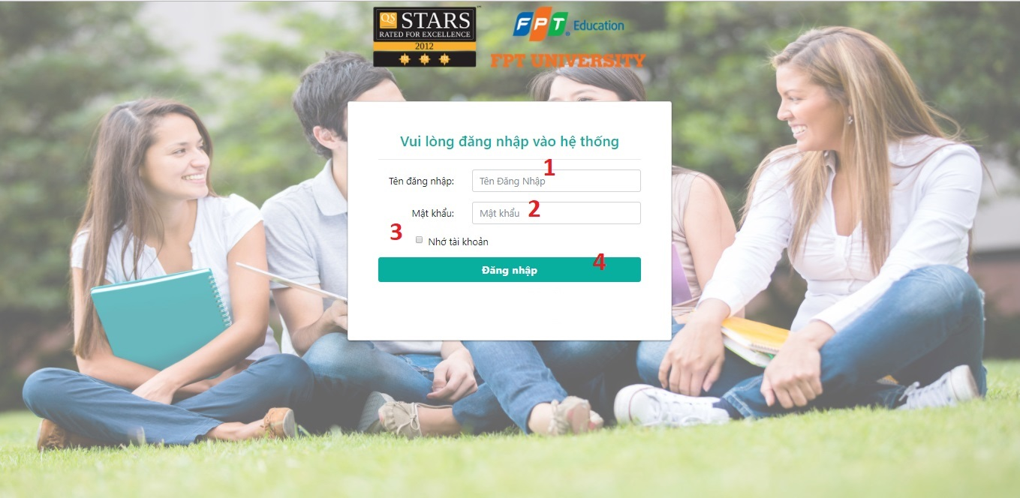

***Figure 48: <Web Application> Login***

|  |  |  |  |  |  |  |
| --- | --- | --- | --- | --- | --- | --- |
| **No** | **Field Name** | **Description** | **Read only** | **Mandatory** | **Control Type** | **Data Type** |
| 1 | Username | Fill username | No | Yes | Textbox | String |
| 2 | Password | Fill password | No | Yes | Password | String |
| 3 | rememberAccount | Remember account | No | No | RadioButton | String |

**Buttons/Hyperlinks**

|  |  |  |  |  |
| --- | --- | --- | --- | --- |
| **No** | **Function** | **Description** | **Validation** | **Outcome** |
| 4 | Login | Log-in into the system | N/A | Transfer to Dashboard |

#### Side Menu

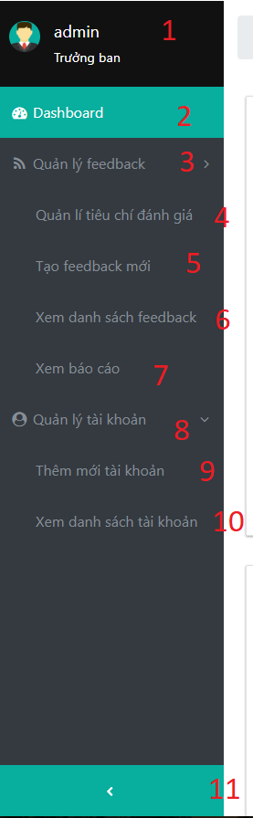

Figure 49: <Web Application> Side menu

|  |  |  |  |  |  |  |
| --- | --- | --- | --- | --- | --- | --- |
| No | Field Names | Description | Read Only | Mandatory | Control Type | Data Type |
| 1 | accountInformation | Display user’s full name and role. | Yes | Yes | Text | String |

**Buttons/Hyperlinks**

|  |  |  |  |  |
| --- | --- | --- | --- | --- |
| No | Function | Description | Validation | Outcome |
| 2 | Dashboard | Redirect to dashboard. | User must had been authorized. | Redirect to dashboard. |
| 3 | manageFeedback | Menu contains submenu with corresponding function. | N/A | Collapse sub-menus inside. |
| 4 | manageCriteria | Sub-menu contains hyperlink to manage criteria | User must have one of these roles:  Head of Academic | Redirect to manage criteria. |
| 5 | createNewCriteria | Sub-menu contains hyperlink to create new feedback. | User must have one of these roles:  -Head of Academic.  -Staff. | Redirect to create new feedback page. |
| 6 | seeListFeedback | Sub-menu contains hyperlink to list conduct feedback page. | User must have been authorized. | Redirect to see list feedback page. |
| 7 | seeReports | Sub-menu contains hyperlink to see reports. | User must have one of these roles:  -Head of Academic.  -Staff.  -Lecturer. | Redirect to see reports page. |
| 8 | mngUser | Menu contains sub-menu with corresponding function. | User must have one of these roles:  -Head of Academic.  -Staff. | Collapse sub-menus inside it. |
| 9 | createUser | Sub-menu contains hyperlink to create new user page. | User must have one of these roles:  -Head of Academic.  -Staff. | Redirect to create new user page. |
| 10 | seeUser | Sub-menu contains hyperlink to see users page. | User must have one of these roles:  -Head of Academic.  -Staff. | Redirect to see users. |
| 11 | toggleSideMenu | Button to toggle show/hide state of side menu. | N/A | Show/hide side menu. |

* + 1. ***Dashboard***

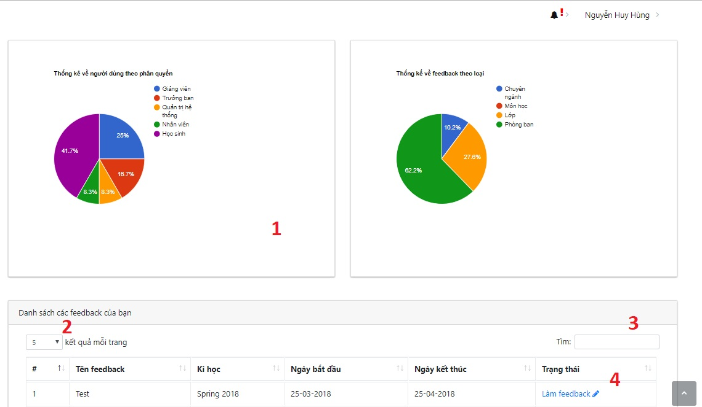

***Figure 50: <Web Application> Login***

|  |  |  |  |  |  |  |
| --- | --- | --- | --- | --- | --- | --- |
| **No** | **Field Name** | **Description** | **Read only** | **Mandatory** | **Control Type** | **Data Type** |
| 1 | statisticChart | Pie Chart statistics number of users, feedbacks | Yes | No | N/A | Chart |
| 2 | pageFilter | Change page of table Feedback list | No | No | Dropdown List | String |
| 3 | search | Search Feedback | No | No | Text | String |

**Buttons/Hyperlinks**

|  |  |  |  |  |
| --- | --- | --- | --- | --- |
| **No** | **Function** | **Description** | **Validation** | **Outcome** |
| 4 | conductFeedback | Conduct the Feedback | N/A | Transfer to conduct Feedback Page |

* + 1. ***Alert Undone Feedback***

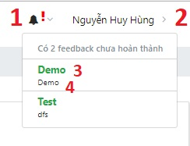

***Figure 51: <Web Application> Alert Undone Feedback***

|  |  |  |  |  |  |  |
| --- | --- | --- | --- | --- | --- | --- |
| **No** | **Field Name** | **Description** | **Read only** | **Mandatory** | **Control Type** | **Data Type** |
| 2 | fullname | Fullname of user | Yes | Yes | Text | String |
| 4 | feedbackDes | Description of undone Feedback | Yes | Yes | Text | String |

**Buttons/Hyperlinks**

|  |  |  |  |  |
| --- | --- | --- | --- | --- |
| **No** | **Function** | **Description** | **Validation** | **Outcome** |
| 1 | iconAlert | Icon alerts User that they have Feedback to do | N/A | Dropdown the list of Undone Feedback |
| 3 | feedbackName | Name of undone Feedback | N/A | Transfer to conduct Feedback page |

* + 1. ***Manage Criteria***

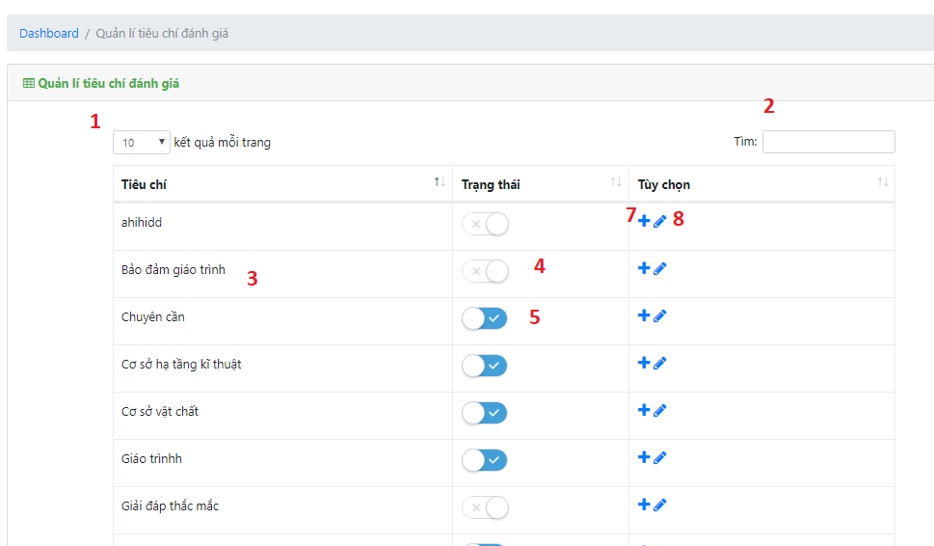

***Figure 52: <Web Application> Manage Criteria***

|  |  |  |  |  |  |  |
| --- | --- | --- | --- | --- | --- | --- |
| **No** | **Field Name** | **Description** | **Read only** | **Mandatory** | **Control Type** | **Data Type** |
| 1 | pageFilter | Change page of table Feedback list | No | No | Dropdown List | String |
| 2 | search | Search Criteria or Type | No | No | Text | String |
| 3 | critName | Criteria Name | Yes | Yes | Text | String |
| 5 | actToggle | Active a criteria | No | Yes | Toggle | N/A |

**Buttons/Hyperlinks**

|  |  |  |  |  |
| --- | --- | --- | --- | --- |
| **No** | **Function** | **Description** | **Validation** | **Outcome** |
| 7 | addCrit | Add new Criteria | N/A | Open popup window to create new Criteria |
| 8 | editCrit | Edit new Criteria | N/A | Open popup window to edit Criteria |

* + 1. ***Add Criteria***

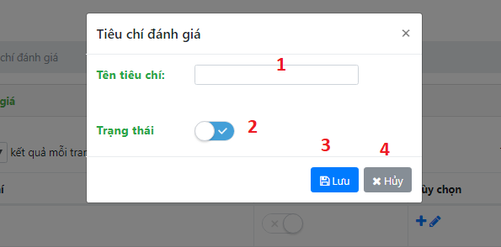

***Figure 53: <Web Application> Add Criteria***

|  |  |  |  |  |  |  |
| --- | --- | --- | --- | --- | --- | --- |
| **No** | **Field Name** | **Description** | **Read only** | **Mandatory** | **Control Type** | **Data Type** |
| 1 | critName | Criteria Name | No | Yes | Text | String |
| 2 | actToggle | Active a criteria | No | Yes | Toggle | N/A |

**Buttons/Hyperlinks**

|  |  |  |  |  |
| --- | --- | --- | --- | --- |
| **No** | **Function** | **Description** | **Validation** | **Outcome** |
| 3 | save | Save new Criteria | N/A | Add new Criteria |
| 4 | cancel | Cancel | N/A | Cancel Creating |

* + 1. ***Select template***

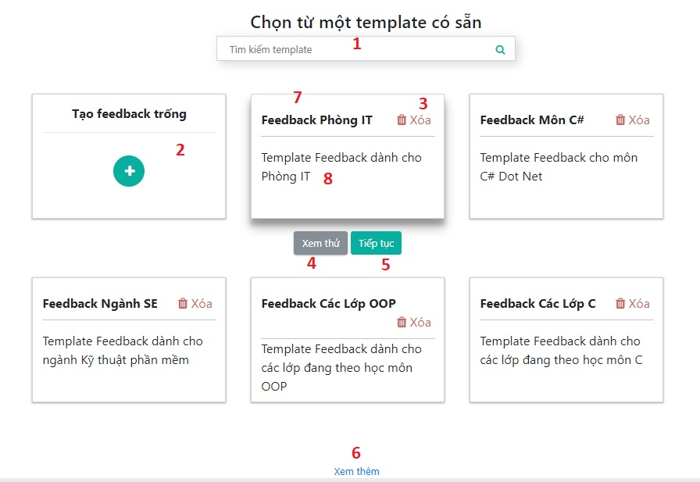

***Figure 54 <Web Application> Select Template***

|  |  |  |  |  |  |  |
| --- | --- | --- | --- | --- | --- | --- |
| **No** | **Field Name** | **Description** | **Read only** | **Mandatory** | **Control Type** | **Data Type** |
| 7 | tempName | Template Name | No | Yes | Text | String |
| 8 | tempDes | Template Description | No | Yes | Text | String |

**Buttons/Hyperlinks**

|  |  |  |  |  |
| --- | --- | --- | --- | --- |
| **No** | **Function** | **Description** | **Validation** | **Outcome** |
| 1 | search | Search Template | N/A | Template match with search keyword |
| 2 | createFb | Create blank new Feedback | N/A | Open popup window to create blank new Feedback |
| 3 | removeTemp | Remove Template | N/A | Remove a Template |
| 4 | previewTemp | Preview content of a Template | N/A | Open popup window to show content of a Template |
| 5 | nextTemp | Choose Template | N/A | Transfer to create content Feedback page |
| 3 | loadMore | Load more Template | N/A | Load more Templates |

* + 1. ***Preview Template***

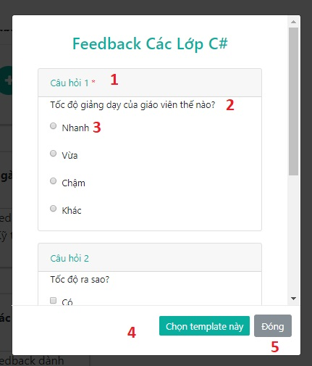

***Figure 55 <Web Application> Preview Template***

|  |  |  |  |  |  |  |
| --- | --- | --- | --- | --- | --- | --- |
| **No** | **Field Name** | **Description** | **Read only** | **Mandatory** | **Control Type** | **Data Type** |
| 1 | questionNum | Question Number | Yes | Yes | Text | String |
| 2 | questionContent | Content of Question | Yes | Yes | Text | String |
| 3 | optionContent | Content of Option | No | Yes | Radio | String |

**Buttons/Hyperlinks**

|  |  |  |  |  |
| --- | --- | --- | --- | --- |
| **No** | **Function** | **Description** | **Validation** | **Outcome** |
| 1 | selectButton | Choose this Template | N/A | Transfer to create content Feedback page |
| 2 | cancelButton | Cancel | N/A | Cancel |

* + 1. ***Create New Blank Feedback***

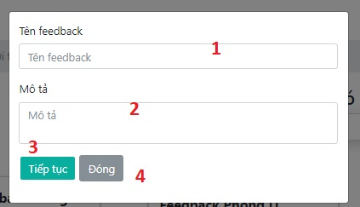

***Figure 56 <Web Application> Create New Blank Feedback***

|  |  |  |  |  |  |  |
| --- | --- | --- | --- | --- | --- | --- |
| **No** | **Field Name** | **Description** | **Read only** | **Mandatory** | **Control Type** | **Data Type** |
| 1 | fbName | Name of Feedback | No | Yes | Text | String |
| 2 | fbDes | Description of Feedback | No | Yes | Text | String |

**Buttons/Hyperlinks**

|  |  |  |  |  |
| --- | --- | --- | --- | --- |
| **No** | **Function** | **Description** | **Validation** | **Outcome** |
| 1 | selectButton | Create new blank Feedback | N/A | Transfer to create content Feedback page |
| 2 | cancelButton | Cancel | N/A | Cancel |

* + 1. ***Create Feedback Content***

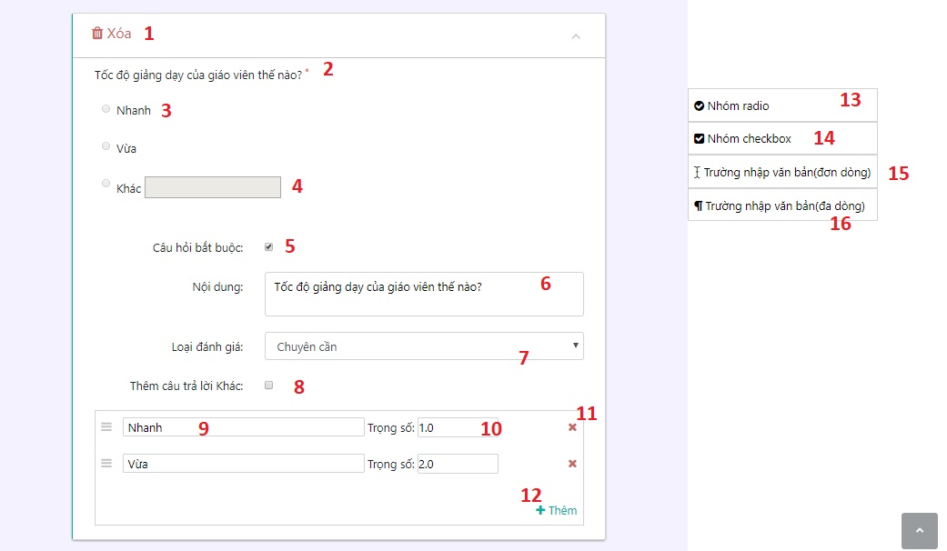

***Figure 57 <Web Application> Create Feedback Content***

|  |  |  |  |  |  |  |
| --- | --- | --- | --- | --- | --- | --- |
| **No** | **Field Name** | **Description** | **Read only** | **Mandatory** | **Control Type** | **Data Type** |
| 2 | quesContent | Content of Question | Yes | Yes | Text | String |
| 3 | optContent | Content of Option | Yes | Yes | Radio | String |
| 4 | otherText | Other Answer | Yes | No | Text | String |
| 5 | requireCheck | Check if this question is required | No | No | Checkbox | String |
| 6 | quesText | Edit content of question | No | Yes | Text | String |
| 7 | criteriaList | Choose question Criteria | No | Yes | Dropdown List | String |
| 8 | otherCheck | Check if this question has “Other Answer” | No | No | Checkbox | String |
| 9 | optText | Edit content of option | No | Yes | Text | String |
| 10 | point | Edit option point | No | Yes | Number | Integer |

**Buttons/Hyperlinks**

|  |  |  |  |  |
| --- | --- | --- | --- | --- |
| **No** | **Function** | **Description** | **Validation** | **Outcome** |
| 1 | delQuesBtn | Delete this question | N/A | Question disappeared |
| 11 | delOptBtn | Delete this option | N/A | Option dissappeared |
| 12 | moreOptBtn | Add more option | N/A | New option appeared |
| 13 | addRadioBtn | Drag-n-Drop more Radio question | N/A | New Radio question appreared |
| 14 | addChkBtn | Drag-n-Drop more Checkbox question | N/A | New Checkbox question appreared |
| 15 | addTextBtn | Drag-n-Drop more Text question | N/A | New Text question appreared |
| 16 | addTxtAreaBtn | Drag-n-Drop more Text Area question | N/A | New Text Area question appreared |

* + 1. ***Overview Creating Feedback***

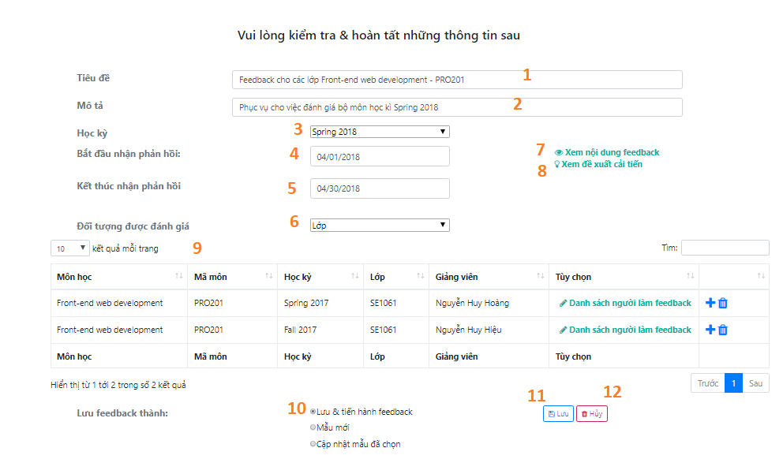

***Figure 58 <Web Application> Overview Creating Feedback***

|  |  |  |  |  |  |  |
| --- | --- | --- | --- | --- | --- | --- |
| **No** | **Field Names** | **Description** | **Read Only** | **Mandatory** | **Control Type** | **Data Type** |
| 1 | feedbackName | Feedback’s name | No | Yes | Text | String |
| 2 | feedbackDes | Feedback’s description | No | Yes | Text | String |
| 3 | semester | Feedback’s semester | No | Yes | Dropdown List | String |
| 4 | startdate | Feedback’s start date | No | Yes | Date picker | Date |
| 555 5 | enddate | Feedback’s end date | No | Yes | Date picker | Date |
| 6 | type | Type of feedback | No | Yes | Dropdown List | String |
| 9 | tableTarget | Table shows list targets of Feedback | No | Yes | Table | N/A |
| 10 | optionSave | Choose type of saving options | No | Yes | Radio | String |

**Buttons/Hyperlinks**

|  |  |  |  |  |
| --- | --- | --- | --- | --- |
| **No** | **Function** | **Description** | **Validation** | **Outcome** |
| 7 | prevFeedbackContent | Preview content of selected feedback | N/A | Open a modal pop-up display content of feedback |
| 8 | viewSuggestion | Edit selected feedback’s suggestions | N/A | Redirect to edit sugesstion page |
| 11 | saveButtion | Save Feedback | N/A | Redirect to list Feedback page |
| 12 | cancel | cancel | N/A | cancel |

* + - 1. ***Table List Class Targets***

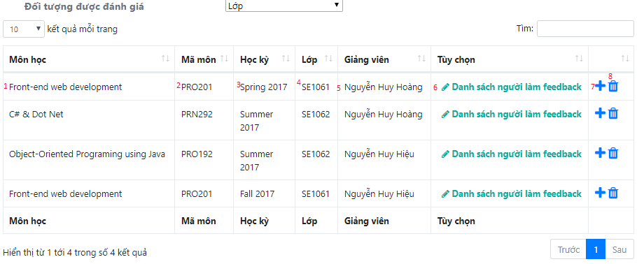

***Figure 59 <Web Application> Table List Class Targets***

|  |  |  |  |  |  |  |
| --- | --- | --- | --- | --- | --- | --- |
| **No** | **Field Names** | **Description** | **Read Only** | **Mandatory** | **Control Type** | **Data Type** |
| 1 | courseName | Name of class’s course | Yes | Yes | Text | String |
| 2 | courseCode | Code of class’s course | Yes | Yes | Text | String |
| 3 | semester | Class’s semester | Yes | Yes | Text | String |
| 4 | className | Class’s name | Yes | Yes | Text | String |
| 5 | lecturer | Class’s Lecturer | Yes | Yes | Text | String |

**Buttons/Hyperlinks**

|  |  |  |  |  |
| --- | --- | --- | --- | --- |
| **No** | **Function** | **Description** | **Validation** | **Outcome** |
| 6 | editConductor | Modify conductors of this target | N/A | Go to customize list conductors page for selected target |
| 7 | editTarget | Modify this feedback target | N/A | Go to customize feedback’s targets page |
| 8 | removeTarget | Remove selected target | N/A | Remove selected target |

* + - 1. ***Table List Course Targets***

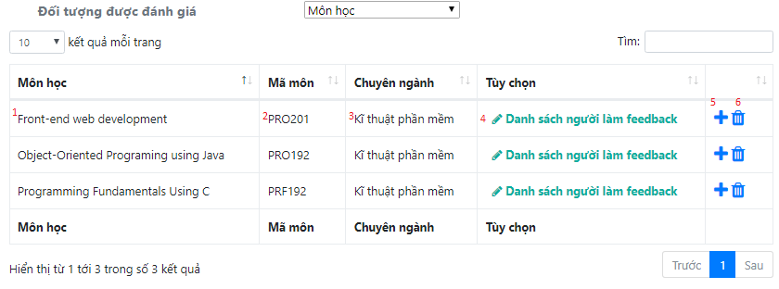

***Figure 60 <Web Application> Table List Course Targets***

|  |  |  |  |  |  |  |
| --- | --- | --- | --- | --- | --- | --- |
| **No** | **Field Names** | **Description** | **Read Only** | **Mandatory** | **Control Type** | **Data Type** |
| 1 | courseName | Name of class’s course | Yes | Yes | Text | String |
| 2 | courseCode | Code of class’s course | Yes | Yes | Text | String |
| 3 | major | Name of course’s major | Yes | Yes | Text | String |

**Buttons/Hyperlinks**

|  |  |  |  |  |
| --- | --- | --- | --- | --- |
| **No** | **Function** | **Description** | **Validation** | **Outcome** |
| 4 | editConductor | Modify conductors of this target | N/A | Go to customize list conductors page for selected target |
| 5 | editTarget | Modify this feedback target | N/A | Go to customize feedback’s targets page |
| 6 | removeTarget | Remove selected target | N/A | Remove selected target |

* + - 1. ***Table List Major Targets***

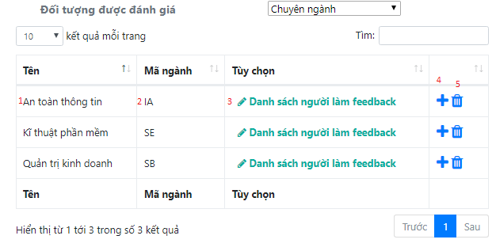

**Figure 61 <Web Application> Table List Major Targets**

|  |  |  |  |  |  |  |
| --- | --- | --- | --- | --- | --- | --- |
| **No** | **Field Names** | **Description** | **Read Only** | **Mandatory** | **Control Type** | **Data Type** |
| 1 | majorName | Major’s name | Yes | Yes | Text | String |
| 2 | majorCode | Major’s code | Yes | Yes | Text | String |

**Buttons/Hyperlinks**

|  |  |  |  |  |
| --- | --- | --- | --- | --- |
| **No** | **Function** | **Description** | **Validation** | **Outcome** |
| 3 | editConductor | Modify conductors of this target | N/A | Go to customize list conductors page for selected target |
| 4 | editTarget | Modify this feedback target | N/A | Go to customize feedback’s targets page |
| 5 | removeTarget | Remove selected target | N/A | Remove selected target |

* + - 1. ***Table List Department Targets***

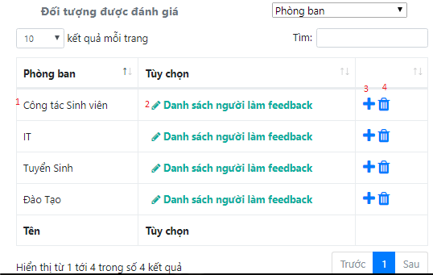

***Figure 62 <Web Application> Table List Department Targets***

|  |  |  |  |  |  |  |
| --- | --- | --- | --- | --- | --- | --- |
| **No** | **Field Names** | **Description** | **Read Only** | **Mandatory** | **Control Type** | **Data Type** |
| 1 | depName | Department’s name | Yes | Yes | Text | String |

**Buttons/Hyperlinks**

|  |  |  |  |  |
| --- | --- | --- | --- | --- |
| **No** | **Function** | **Description** | **Validation** | **Outcome** |
| 2 | editConductor | Modify conductors of this target | N/A | Go to customize list conductors page for selected target |
| 3 | editTarget | Modify this feedback target | N/A | Go to customize feedback’s targets page |
| 4 | removeTarget | Remove selected target | N/A | Remove selected target |

* + - 1. ***Preview Edit Feedback Content***

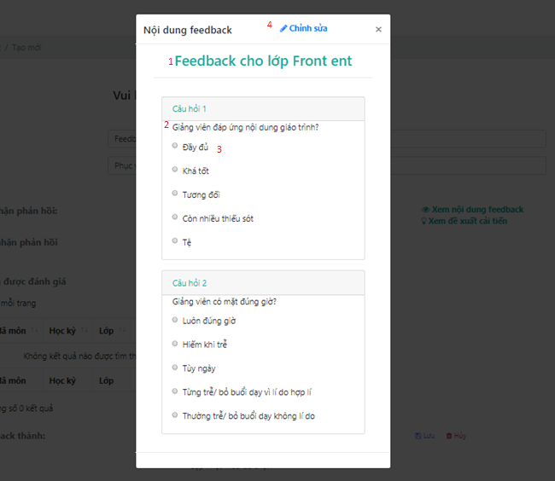

***Figure 63 <Web Application> Preview Edit Feedback Content***

|  |  |  |  |  |  |  |
| --- | --- | --- | --- | --- | --- | --- |
| **No** | **Field Names** | **Description** | **Read Only** | **Mandatory** | **Control Type** | **Data Type** |
| 1 | title | Feedback’s name | Yes | Yes | Text | String |
| 2 | questionContent | Content of question | Yes | Yes | Text | String |
| 3 | optionContent | Content of option | Yes | Yes | Radio | String |

**Buttons/Hyperlinks**

|  |  |  |  |  |
| --- | --- | --- | --- | --- |
| **No** | **Function** | **Description** | **Validation** | **Outcome** |
| 4 | edit | Go to edit feedback’s content page | N/A | edit feedback’s content page |

* + - 1. ***Modify Suggestions***

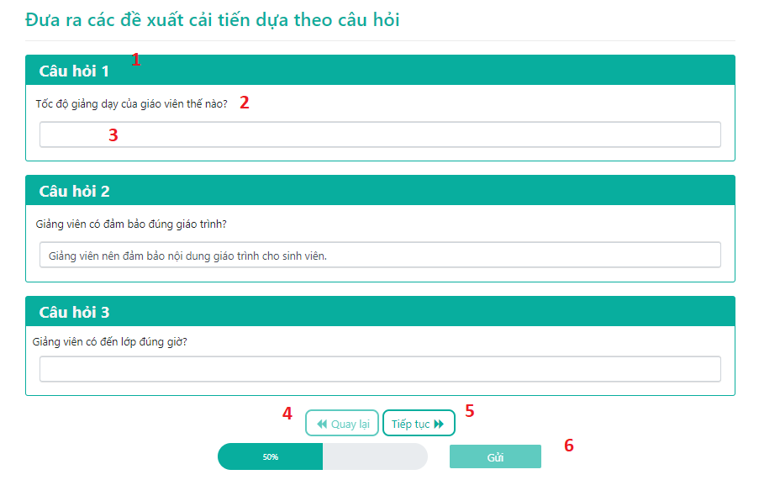

**4**

***Figure 64 <Web Application> Modify Suggestions***

|  |  |  |  |  |  |  |
| --- | --- | --- | --- | --- | --- | --- |
| **No** | **Field Names** | **Description** | **Read Only** | **Mandatory** | **Control Type** | **Data Type** |
| 1 | quesNum | Number of Question | Yes | Yes | Text | String |
| 2 | quesContent | Content of Question | Yes | Yes | Text | String |
| 3 | sugContent | Content of Suggestion | No | No | Text | String |

**Buttons/Hyperlinks**

|  |  |  |  |  |
| --- | --- | --- | --- | --- |
| **No** | **Function** | **Description** | **Validation** | **Outcome** |
| 4 | prevBtn | Previous Page | N/A | Tranfers to previous page of modifying suggestion page |
| 5 | nextBtn | Next Page | N/A | Tranfers to next page of modifying suggestion page |
| 4 | sendBtn | Submit | N/A | Tranfers to overview page |

* + - 1. ***Modify Targets***
         1. ***Modify Class Target***

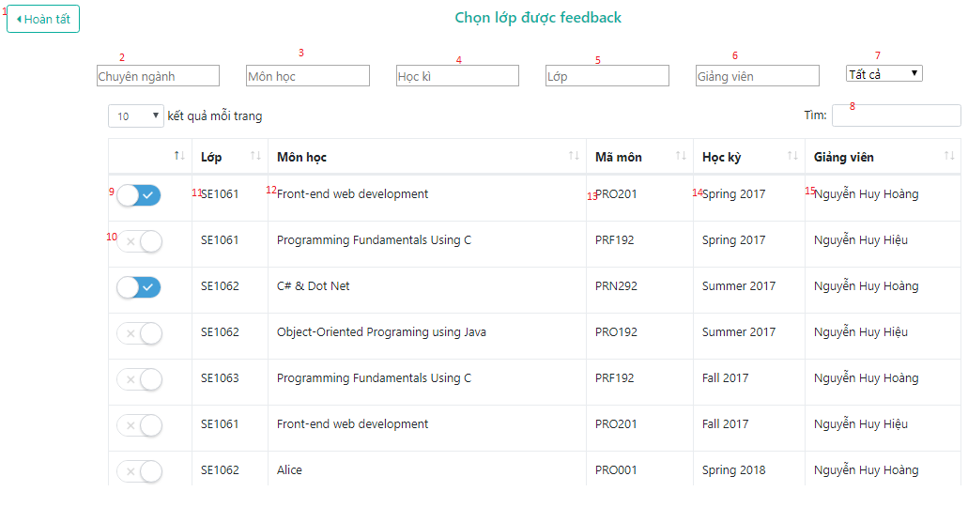

***Figure 65 <Web Application> Modify Class Targets***

|  |  |  |  |  |  |  |
| --- | --- | --- | --- | --- | --- | --- |
| **No** | **Field Names** | **Description** | **Read Only** | **Mandatory** | **Control Type** | **Data Type** |
| 2 | searchMajor | Input keyword for searching classes by major’s name | No | No | Datalist | String |
| 3 | searchCourse | Input keyword for searching classes by course’s name | No | No | Datalist | String |
| 4 | searchSemester | Input keyword for searching classes by semester’s name | No | No | Datalist | String |
| 5 | searchClass | Input keyword for searching classes by class’s name | No | No | Datalist | String |
| 6 | searchLecturer | Input keyword for searching classes by lecturer’s name | No | No | Datalist | String |
| 7 | filterAllSelected | Filter results of targets displayed in table by whether they were selected/ get all result | No | No | Dropdown List | String |
| 8 | searchAllFields | Input keyword for searching classes by all fields in table | No | No | Text | String |
| 11 | className | Name of class | Yes | Yes | Text | String |
| 12 | courseName | Name of class’s course | Yes | Yes | Text | String |
| 13 | courseCode | Code of class’s course | Yes | Yes | Text | String |
| 14 | semester | Name of class’s semester | Yes | Yes | Text | String |
| 15 | lecturer | Name of class’s lecturer | Yes | Yes | Text | String |

**Buttons/Hyperlinks**

|  |  |  |  |  |
| --- | --- | --- | --- | --- |
| **No** | **Function** | **Description** | **Validation** | **Outcome** |
| 1 | completeBtn | Finish modify feedback’s targets | N/A | Transfer to Feedback’s overview page |
| 9 | removeTarget | Remove selected class as a target | N/A | Removed target & updated results in table |
| 10 | addTarget | Add selected class as target | N/A | Added target & updated results in table |

* + - * 1. ***Modify Course Target***

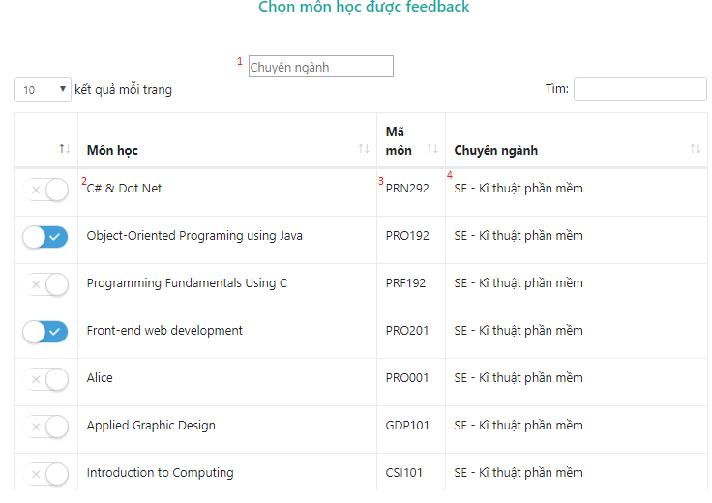

***Figure 66 <Web Application> Modify Course Targets***

|  |  |  |  |  |  |  |
| --- | --- | --- | --- | --- | --- | --- |
| **No** | **Field Names** | **Description** | **Read Only** | **Mandatory** | **Control Type** | **Data Type** |
| 1 | searchMajor | Input keyword for searching classes by major’s name | No | No | Datalist | String |
| 2 | courseName | Name of course | Yes | Yes | Text | String |
| 3 | courseCode | Code of course | Yes | Yes | Text | String |
| 4 | major | Name of major whom course belong to | Yes | Yes | Text | String |

* + - * 1. ***Modify Major Target***

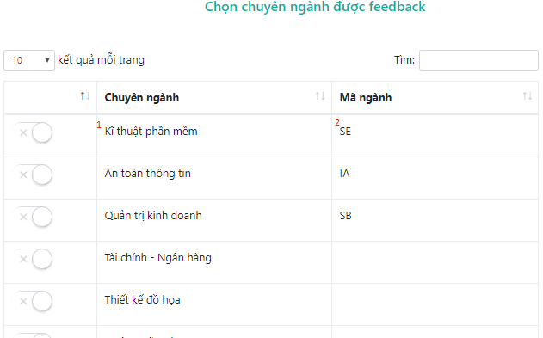

***Figure 67 <Web Application> Modify Major Targets***

|  |  |  |  |  |  |  |
| --- | --- | --- | --- | --- | --- | --- |
| **No** | **Field Names** | **Description** | **Read Only** | **Mandatory** | **Control Type** | **Data Type** |
| 1 | majorName | Major’s name | Yes | Yes | Text | String |
| 2 | majorCode | Major’s code | Yes | Yes | Text | String |

* + - * 1. ***Modify Department Target***

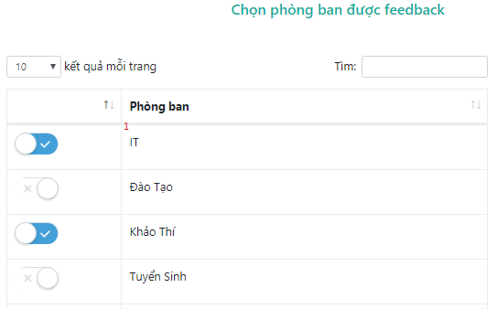

***Figure 68 <Web Application> Modify Department Targets***

|  |  |  |  |  |  |  |
| --- | --- | --- | --- | --- | --- | --- |
| **No** | **Field Names** | **Description** | **Read Only** | **Mandatory** | **Control Type** | **Data Type** |
| 1 | depName | Department’s name | Yes | Yes | Text | String |

* + - * 1. ***Modify Conductors***

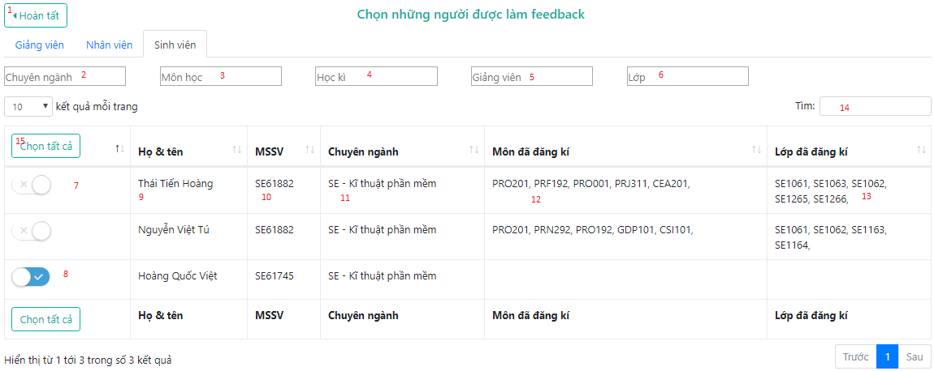

***Figure 69 <Web Application> Modify Conductors***

|  |  |  |  |  |  |  |
| --- | --- | --- | --- | --- | --- | --- |
| **No** | **Field Names** | **Description** | **Read Only** | **Mandatory** | **Control Type** | **Data Type** |
| 2 | searchMajor | Input keyword for searching classes by major’s name | No | No | Datalist | String |
| 3 | searchCourse | Input keyword for searching classes by course’s name | No | No | Datalist | String |
| 4 | searchSemester | Input keyword for searching classes by semester’s name | No | No | Datalist | String |
| 5 | searchLecturer | Input keyword for searching classes by lecturer’s name | No | No | Datalist | String |
| 6 | searchClass | Input keyword for searching classes by class’s name | No | No | Datalist | String |
| 14 | searchAllFields | Input keyword for searching classes by all fields in table | No | No | Text | String |
| 9 | fullname | User’s fullname | Yes | Yes | Text | String |
| 10 | code | User’s code | Yes | Yes | Text | String |
| 11 | major | User’s major | Yes | Yes | Text | String |
| 12 | enrolledClasses | Names of enrolled classes | Yes | Yes | Text | String |
| 13 | learnedCourse | Name of learned courses | Yes | Yes | Text | String |

**Buttons/Hyperlinks**

|  |  |  |  |  |
| --- | --- | --- | --- | --- |
| **No** | **Function** | **Description** | **Validation** | **Outcome** |
| 1 | completeBtn | Finish modify feedback’s targets | N/A | Transfer to Feedback’s overview page |
| 8 | removeTarget | Remove selected class as a target | N/A | Removed target & updated results in table |
| 9 | addTarget | Add selected class as target | N/A | Added target & updated results in table |
| 15 | selectAll | Select all targets | N/A | Added all target & updated results in table |

* + 1. ***View List Feedbacks***

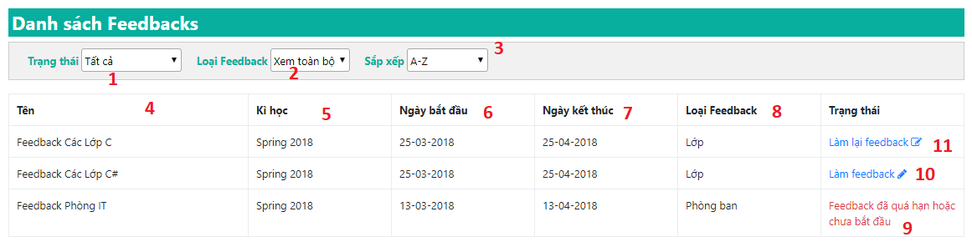

***Figure 70 <Web Application> View List Feedbacks***

|  |  |  |  |  |  |  |
| --- | --- | --- | --- | --- | --- | --- |
| **No** | **Field Names** | **Description** | **Read Only** | **Mandatory** | **Control Type** | **Data Type** |
| 1 | filterStatus | Filter Feedback by its Status (Conducted or Not) | No | Yes | Dropdown List | String |
| 2 | filterType | Filter Feedback by its Type (Class, Major, Course, Department) | No | Yes | Dropdown List | String |
| 3 | sort | Sort Feedback by name | No | Yes | Dropdown List | String |
| 4 | name | Feedback Name | Yes | Yes | Text | String |
| 5 | semester | Feedback Semester | Yes | Yes | Text | String |
| 6 | startDate | Feedback Start Date | Yes | Yes | Text | String |
| 7 | endDate | Feedback End Date | Yes | Yes | Text | String |
| 8 | type | Feedback Type | Yes | Yes | Text | String |
| 9 | fbStatus | Status states that Feedback is expired | Yes | Yes | Text | String |

**Buttons/Hyperlinks**

|  |  |  |  |  |
| --- | --- | --- | --- | --- |
| **No** | **Function** | **Description** | **Validation** | **Outcome** |
| 10 | conductBtn | Conduct Feedback | N/A | Transfer to Conduct Feedback Page |
| 11 | editBtn | Edit Feedback Answers | N/A | Transfer to Edit Answers Page |

* + 1. ***Conduct Feedbacks***

**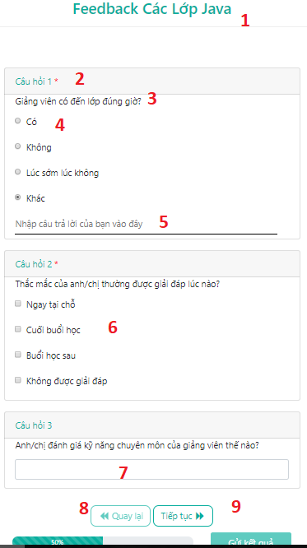*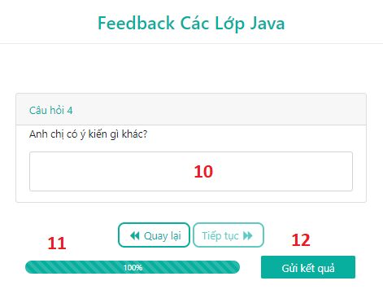***

***Figure 71: <Web Application> Conduct Feedbacks***

|  |  |  |  |  |  |  |
| --- | --- | --- | --- | --- | --- | --- |
| **No** | **Field Names** | **Description** | **Read Only** | **Mandatory** | **Control Type** | **Data Type** |
| 1 | feedbackName | Name of Feedback | Yes | Yes | Text | String |
| 2 | quesNum | Number of Question | Yes | Yes | Text | String |
| 3 | quesContent | Content of Question | Yes | Yes | Text | String |
| 4 | optRadio | Content of Radio type Option | No | Yes | Radio | String |
| 5 | otherCotent | Content when user chooses “Other” option | No | No | Text | String |
| 6 | optChkBox | Content of Checkbox type Option | No | Yes | Check Box | String |
| 7 | optText | Content of Text type Option | No | Yes | Text | String |
| 10 | optTextArea | Content of Text Area type Option | No | Yes | Text Area | String |
| 11 | progressBar | Progress bar displays completed percentage | Yes | Yes | N/A | N/A |

**Buttons/Hyperlinks**

|  |  |  |  |  |
| --- | --- | --- | --- | --- |
| **No** | **Function** | **Description** | **Validation** | **Outcome** |
| 8 | prevBtn | Previous Page of Conducting Feedback page | N/A | Transfer to previous page of Conduct Feedback Page |
| 9 | nextBtn | Next Page of Conducting Feedback page | N/A | Transfer to next page of Conduct Feedback Page |
| 12 | sendBtn | Submit all answers | N/A | Transfer to view list Feedbacks page |

* + 1. ***View List Feedbacks for Staff and Head Academic***

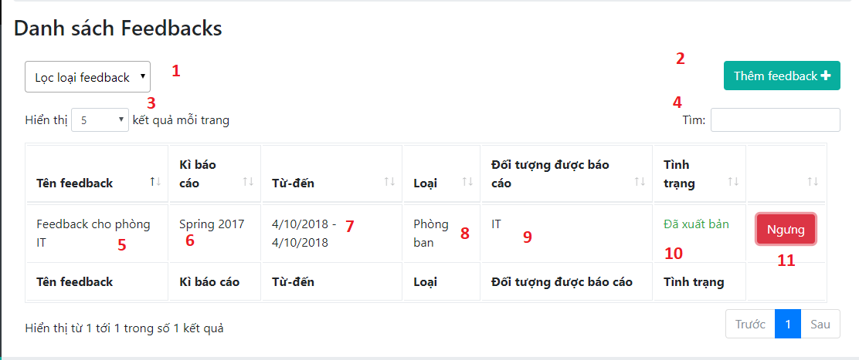

***Figure 72 <Web Application> View List Feedbacks for Staff and Head Academic***

|  |  |  |  |  |  |  |
| --- | --- | --- | --- | --- | --- | --- |
| **No** | **Field Names** | **Description** | **Read Only** | **Mandatory** | **Control Type** | **Data Type** |
| 1 | filterStatus | Filter Feedback by its Type | No | Yes | Dropdown List | String |
| 3 | filterPage | Number of Feedbacks is shown in one page | No | Yes | Dropdown List | Integer |
| 4 | search | Search Feedback | No | Yes | Text | String |
| 5 | name | Feedback Name | Yes | Yes | Text | String |
| 6 | semester | Feedback Semester | Yes | Yes | Text | String |
| 7 | avaiDate | Feedback Available Date | Yes | Yes | Text | String |
| 8 | type | Feedback Type | Yes | Yes | Text | String |
| 9 | target | Feedback Target | Yes | Yes | Text | String |
| 10 | fbStatus | Status states that Feedback is published or not | Yes | Yes | Text | String |

**Buttons/Hyperlinks**

|  |  |  |  |  |
| --- | --- | --- | --- | --- |
| **No** | **Function** | **Description** | **Validation** | **Outcome** |
| 2 | addFBBtn | Add more Feedback | N/A | Transfer to Select Template page |
| 11 | deactiveBtn | Unpublish a Feedback | N/A | Open a modal to confirm unpublish Feedback |

* + 1. ***Publish/Unpublish Feedback***

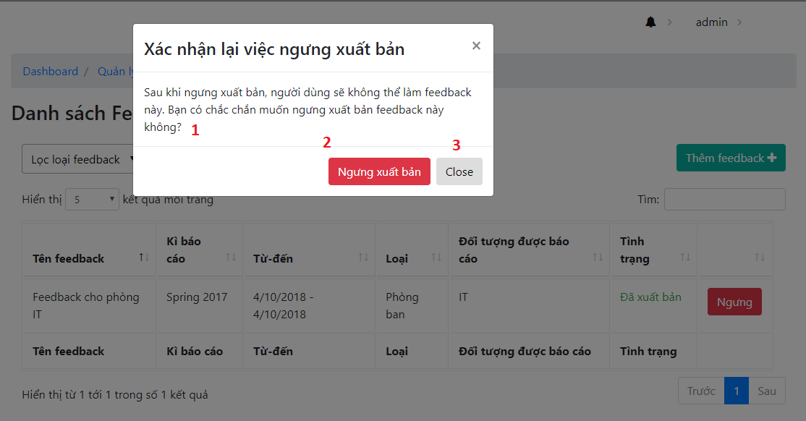

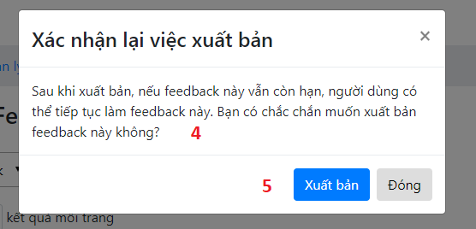

***Figure 73 <Web Application> Publish/Unpublish Feedback***

|  |  |  |  |  |  |  |
| --- | --- | --- | --- | --- | --- | --- |
| **No** | **Field Names** | **Description** | **Read Only** | **Mandatory** | **Control Type** | **Data Type** |
| 1 | unpubWarn | Warning when unpublish Feedback | Yes | No | Text | String |
| 4 | pubWarn | Warning when publish Feedback | Yes | No | Text | String |

**Buttons/Hyperlinks**

|  |  |  |  |  |
| --- | --- | --- | --- | --- |
| **No** | **Function** | **Description** | **Validation** | **Outcome** |
| 2 | unpubBtn | Unpublish a Feedback | N/A | Unpublish a Feedback and reload screen |
| 3 | cancel | Cancel | N/A | Cancel |
| 5 | pubBtn | Publish a Feedback | N/A | Publish a Feedback and reload screen |

* + 1. ***View list Reports***

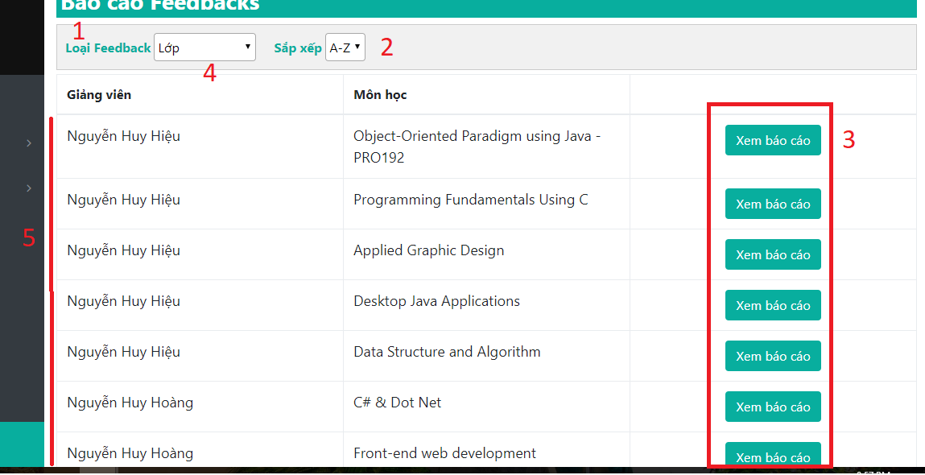

***Figure 74: <Web Application> View list Reports***

|  |  |  |  |  |  |  |
| --- | --- | --- | --- | --- | --- | --- |
| No | Field Names | Description | Read Only | Mandatory | Control Type | Data Type |
| 1 | filterType | This box contains 4 types of report:  -Departments.  -Courses.  -Majors.  -Courses taught by teachers. | No | Yes | Dropdown List | String |
| 2 | filterSort | This box allows user to sort from ascending order or descending order. | No | Yes | Dropdown List | String |
| 4 | attrName | Name of the attribute. | Yes | Yes | Text | String |
| 5 | tblTarget | Data of corresponding type selected. | Yes | Yes | Text | String |

**Buttons/Hyperlinks**

|  |  |  |  |  |
| --- | --- | --- | --- | --- |
| No | Function | Description | Validation | Outcome |
| 3 | seeReportDetails | Redirect to view reports for this record throughout semesters. | User must have one of these roles:  -Head of Academic.  -Staff.  -Lecturer. | Redirect to view report detail page. |

* + 1. ***View Report Details***

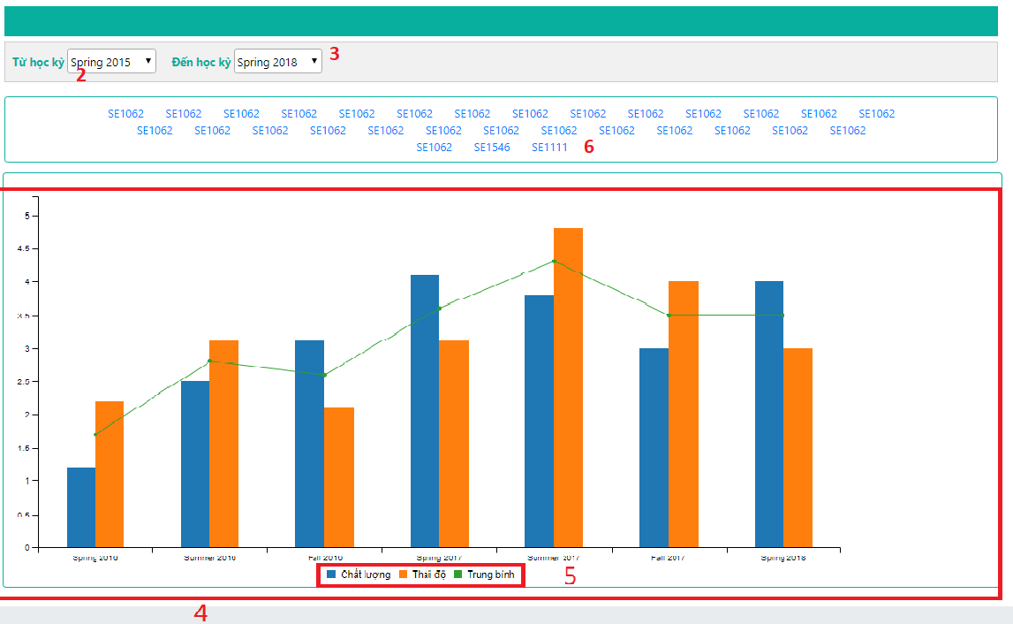

***Figure 75: <Web Application> View Report Details***

|  |  |  |  |  |  |  |
| --- | --- | --- | --- | --- | --- | --- |
| No | Field Names | Description | Read Only | Mandatory | Control Type | Data Type |
| 2 | filterFromSemester | This box allow user to select which semester is starting point. | No | Yes | Dropdown List | String |
| 4 | filterToSemester | This box allow user to select which semester is end point. | Yes | Yes | Text | String |
| 4 | chartData | Visualized data calculated from feedbacks’ result. | Yes | Yes | Bar chart | N/A |
| 5 | criteria | Name of criteria calculated. Click on this toggle will hide or unhide corresponding bar on chart | Yes | Yes | Toggle | String |

**Buttons/Hyperlinks**

|  |  |  |  |  |
| --- | --- | --- | --- | --- |
| No | Function | Description | Validation | Outcome |
| 6 | targetName | List of target that corresponding with the chosen report bar |  | Transfer to View Report semester details page |

* + 1. ***View Semester Report Details***

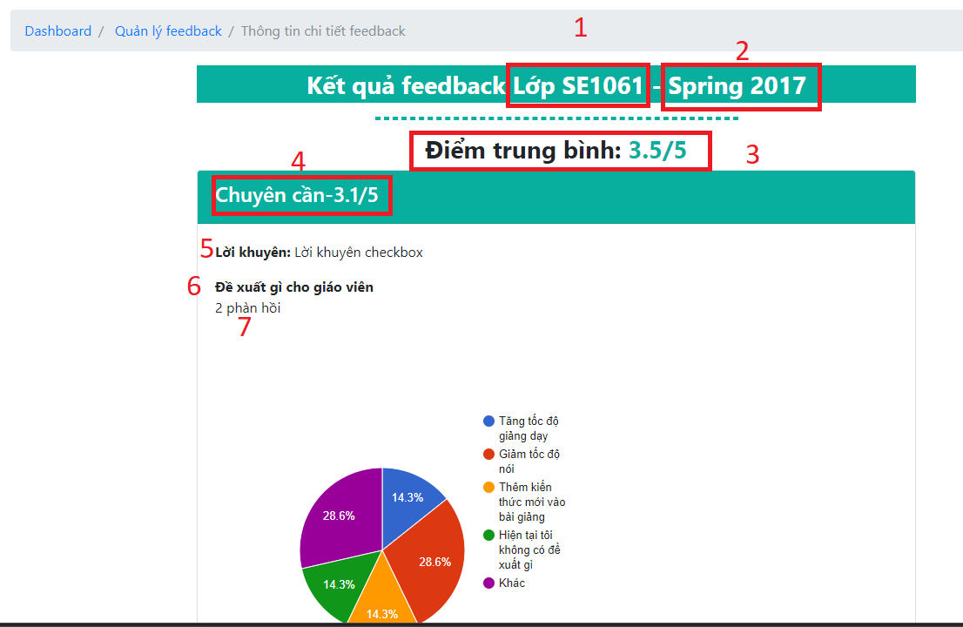

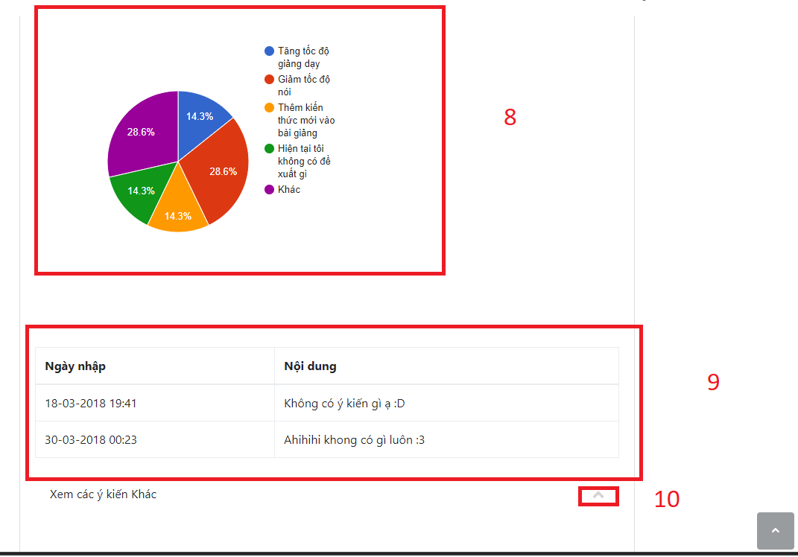

***Figure 76 <Web Application> View Semester Report Details***

|  |  |  |  |  |  |  |
| --- | --- | --- | --- | --- | --- | --- |
| No | Field Names | Description | Read Only | Mandatory | Control Type | Data Type |
| 1 | targetName | Name of which this report is for | Yes | Yes | Text | String |
| 2 | semesterName | Name of the semester | Yes | Yes | Text | String |
| 3 | overallAvgPoint | Semester’s overall average point. | Yes | Yes | Text | float |
| 4 | criteriaAvgPoint | Name of criteria and its average point. | Yes | Yes | Text | String |
| 5 | suggestion | Suggestion for this question. | Yes | Yes | Text | String |
| 6 | questionContent | Content for this question. | Yes | Yes | Text | String |
| 7 | responseCount | Number of user response for this question. | Yes | Yes | Text | int |
| 8 | pieChart | Pie chart representing options for this question and its number. | Yes | Yes | N/A | N/A |
| 9 | otherOptionTable | Table representing which users inputted after they select “Khác” option. | Yes | No | N/A | String |
| 10 | toggleOtherOptionTable | Show/hide users’ inputted answers | Yes | No | Toggle | N/A |

* + 1. ***View List Users***

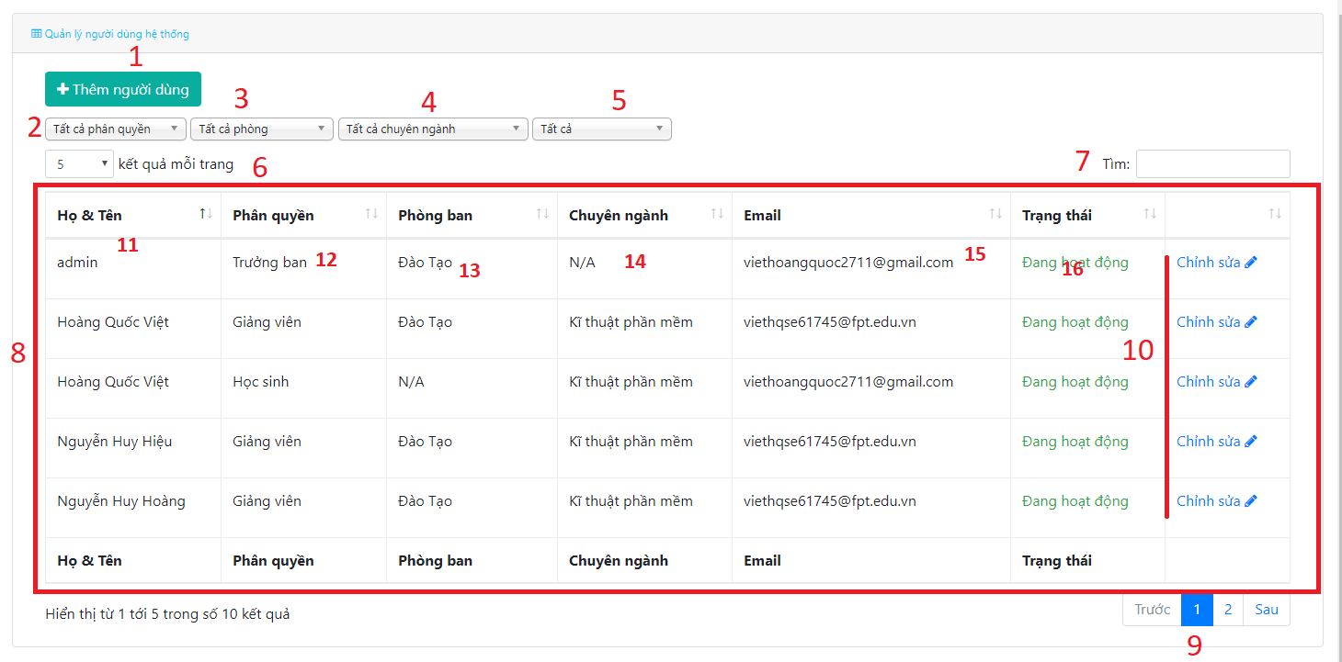

***Figure 77: <Web Application> View List Users***

|  |  |  |  |  |  |  |
| --- | --- | --- | --- | --- | --- | --- |
| No | Field Names | Description | Read Only | Mandatory | Control Type | Data Type |
| 2 | filterByRole | Filter user by role | No | Yes | Dropdown List | String |
| 3 | filterByDepartment | Filter user by department | No | Yes | Dropdown List | String |
| 4 | filterByMajor | Filter users by major | No | Yes | Dropdown List | String |
| 5 | filterByStatus | Filter users by status | No | Yes | Dropdown List | String |
| 7 | txtSearch | Search user | No | Yes | Text | String |
| 8 | tblUser | Table representing list of users | Yes | Yes | Table | String |
| 11 | fullname | Fullname of user | Yes | Yes | Text | String |
| 12 | role | Role of user | Yes | Yes | Text | String |
| 13 | department | Department of user | Yes | Yes | Text | String |
| 14 | major | Major of user | Yes | Yes | Text | String |
| 15 | email | Email of user | Yes | Yes | Text | String |
| 16 | status | Status of user | Yes | Yes | Text | String |

**Buttons/Hyperlinks**

|  |  |  |  |  |
| --- | --- | --- | --- | --- |
| No | Function | Description | Validation | Outcome |
| 1 | btnAddUser | Add New User Button | N/A | Redirect User to |
| 9 | btnPagination | Change page of table | N/A | Change which page is the table on |
| 10 | btnEditUser | Edit a user | N/A | Transfer to edit user page |

* + 1. ***Add new User***

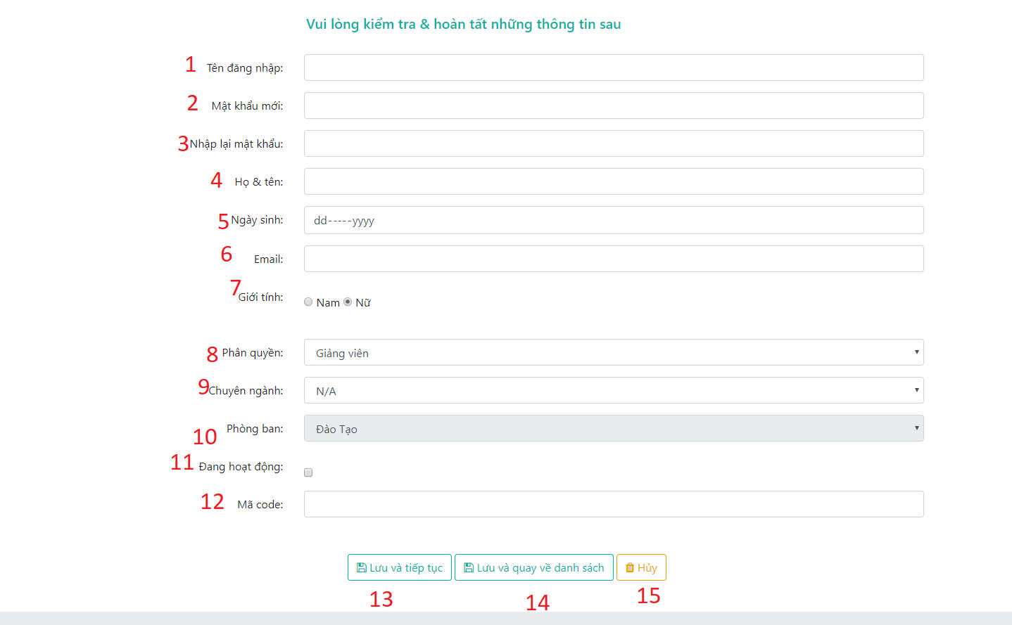

***Figure 78: <Web Application> Add New User***

|  |  |  |  |  |  |  |
| --- | --- | --- | --- | --- | --- | --- |
| No | Field Names | Description | Read Only | Mandatory | Control Type | Data Type |
| 1 | txtUsername | User’s username | No | Yes | Text | String |
| 2 | txtPassword | User’s password | No | Yes | Password | String |
| 3 | txtConfirmPassworm | User retypes password | No | Yes | Password | String |
| 4 | txtFullname | User’s full name | No | Yes | Text | String |
| 5 | txtBirth | User’s birth | No | Yes | date | Date |
| 6 | txtEmail | User’s email | No | Yes | email | String |
| 7 | rbtGender | User’s gender | No | Yes | boolean | String |
| 8 | selectRole | User’s role | No | Yes | Dropdown List | String |
| 9 | selectMajor | User’s major | No | Yes | Dropdown List | String |
| 10 | selectDept | User’s department | No | Yes | Dropdown List | String |
| 11 | chkStatus | User’s status | No | Yes | Checkbox | String |
| 12 | txtCode | User’s code | No | Yes | Text | String |

**Buttons/Hyperlinks**

|  |  |  |  |  |
| --- | --- | --- | --- | --- |
| No | Function | Description | Validation | Outcome |
| 13 | saveAndContinue | Save User and continue to add new user | All required field must be filled.  Username, email, code must not be existed in database.  Username must contain only character and number.  Password must be at least 6 characters.  Email must match format.  Confirm password must match password. | Save then reload page. |
| 14 | saveAndBackToList | Save User and then go back to see list users | All required field must be filled.  Username, email, code must not be existed in database.  Username must contain only character and number.  Password must be at least 6 characters.  Email must match format.  Confirm password must match password. | Save then redirect user to see users page. |
| 15 | cancelInput | Clear all inputted data | N/A | All control return to its default. |

* + 1. ***Edit User***

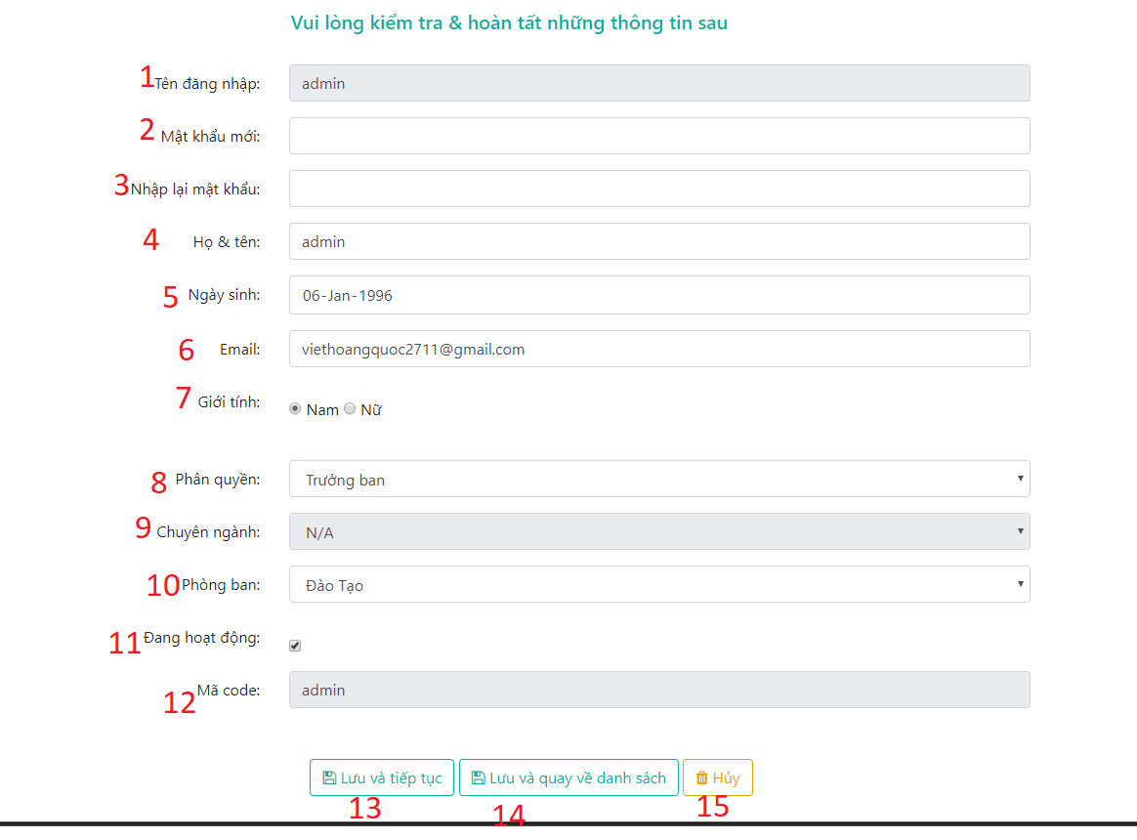

***Figure 79: <Web Application> Edit User***

|  |  |  |  |  |  |  |
| --- | --- | --- | --- | --- | --- | --- |
| No | Field Names | Description | Read Only | Mandatory | Control Type | Data Type |
| 1 | txtUsername | User’s username | Yes | Yes | Text | String |
| 2 | txtPassword | User’s password | No | Yes | Password | String |
| 3 | txtConfirmPassworm | User retypes password | No | Yes | Password | String |
| 4 | txtFullname | User’s full name | No | Yes | Text | String |
| 5 | txtBirth | User’s birth | No | Yes | date | Date |
| 6 | txtEmail | User’s email | No | Yes | email | String |
| 7 | rbtGender | User’s gender | No | Yes | boolean | String |
| 8 | selectRole | User’s role | No | Yes | Dropdown List | String |
| 9 | selectMajor | User’s major | No | Yes | Dropdown List | String |
| 10 | selectDept | User’s department | No | Yes | Dropdown List | String |
| 11 | chkStatus | User’s status | No | Yes | Checkbox | String |
| 12 | txtCode | User’s code | Yes | Yes | Text | String |

**Buttons/Hyperlinks**

|  |  |  |  |  |
| --- | --- | --- | --- | --- |
| No | Function | Description | Validation | Outcome |
| 13 | saveAndContinue | Save User and continue to update user | All required field must be filled.  Username, email, code must not be existed in database.  Username must contain only character and number.  Password must be at least 6 characters.  Email must match format.  Confirm password must match password. | Save then reload page. |
| 14 | saveAndBackToList | Save User and then go back to see list users | All required field must be filled.  Username, email, code must not be existed in database.  Username must contain only character and number.  Password must be at least 6 characters.  Email must match format.  Confirm password must match password. | Save then redirect user to see users page. |
| 15 | cancelInput | Clear all inputted data | N/A | All control return to its default. |

* + 1. ***Login***

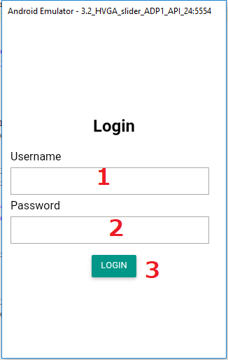

***Figure 80 <Mobiel Application> Login***

|  |  |  |  |  |  |  |
| --- | --- | --- | --- | --- | --- | --- |
| No | Field Names | Description | Read Only | Mandatory | Control Type | Data Type |
| 1 | username | Username | No | Yes | TextView | String |
| 2 | password | Password | No | Yes | TextView | String |

**Buttons/Hyperlinks:**

|  |  |  |  |  |
| --- | --- | --- | --- | --- |
| No | Function | Description | Validation | Outcome |
| 3 | loginBtn | Login | N/A | Transfer to View list Feedback page |

* + 1. ***View List Feedbacks***

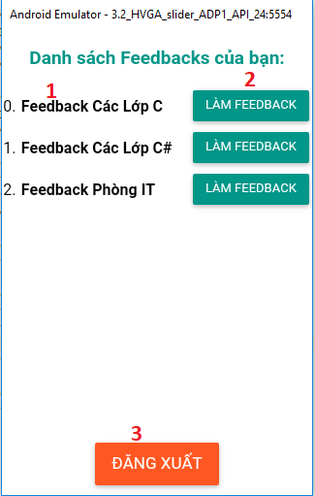

***Figure 81: <Mobiel Application> View List Feedbacks***

|  |  |  |  |  |  |  |
| --- | --- | --- | --- | --- | --- | --- |
| No | Field Names | Description | Read Only | Mandatory | Control Type | Data Type |
| 1 | fbName | Feedback Name | Yes | Yes | TextView | String |

**Buttons/Hyperlinks:**

|  |  |  |  |  |
| --- | --- | --- | --- | --- |
| No | Function | Description | Validation | Outcome |
| 2 | conductBtn | Conduct Feedback | N/A | Transfer to Condcut Feedback screen |
| 3 | logoutBtn | Log out | N/A | Transfer to Login Page |

* + 1. ***Conduct Feedback***

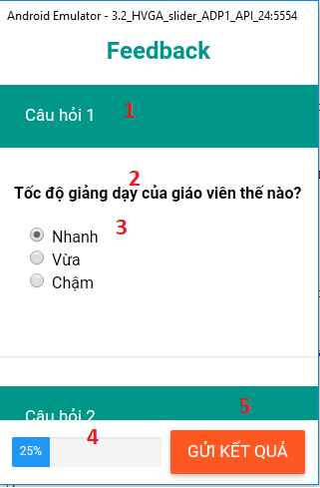

***Figure 82: <Mobiel Application> Conduct Feedback***

|  |  |  |  |  |  |  |
| --- | --- | --- | --- | --- | --- | --- |
| No | Field Names | Description | Read Only | Mandatory | Control Type | Data Type |
| 1 | quesNum | Number of Question | Yes | Yes | TextView | String |
| 2 | quesContent | Content of Question | Yes | Yes | TextView | String |
| 3 | optRadioContent | Content of Radio Type Option | No | Yes | Radio | String |
| 4 | progressBar | Display completed percentage | Yes | Yes | N/a | N/a |

**Buttons/Hyperlinks:**

|  |  |  |  |  |
| --- | --- | --- | --- | --- |
| No | Function | Description | Validation | Outcome |
| 5 | submitBtn | Submit Answers | N/A | Submit answers and transfer to view list page |

1. **Database Design**
   1. **Entity relationship diagram (ERD)**

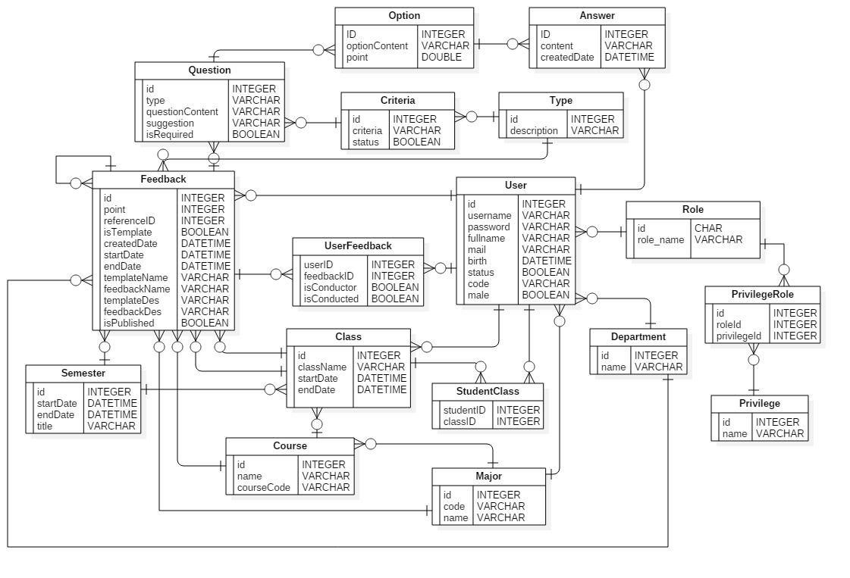

**Figure 83: Entity relationship diagram**

* 1. **Data Dictionary**

|  |
| --- |
| **Entity Data dictionary: describe content of all entities** |

|  |  |
| --- | --- |
| **Entity Name** | **Description** |
| Feedback | Contain Feedback information |
| Question | Contain Question information |
| Option | Contain Option information |
| Answer | Contain Answer information |
| Criteria | Contain Criteria information |
| Semester | Contain Semester information |
| Type | Contain Feedback type information |
| User | Contain User information |
| UserFeedback | Contain information about relationship between a user with a feedback |
| Role | Contain Role information |
| Privilege | Contain Privilege information |
| PrivilegeRole | Contain Privilege information for each role |
| StudentClass | Contain information about class of each student |
| Class | Contain Class information |
| Course | Contain Course information |
| Major | Contain Major information |
| Department | Contain Department information |

**Table 10: Entity Data dictionary**

1. **Algorithms**
   1. ***Edit Feedback Content***

#### Definition

Edit Feedback Content is the way to create new, update, delete existed questions and options that created before.

* + 1. ***Define Problem***

When choose “Edit Feedback content”, users is redirected to edit content screen which displays all created questions and options. On this screen, users can change type of question, edit question content, create new or delete question. Besides, users can also change point of a option, edit option content, create new of delete option of a question.

All changes can only be saved once users click “Send” button. Systems has to recognize and distinguish those changes to take suitable action.

* + 1. ***Solution***

To solve this problem, we should follow these steps:

* Get all questions and options exisitng on screen. Attach Question ID for questions that created before. Questions created new don’t have Question ID.
* Loop through list questions, if:

+ Question doesn’t have question ID, add new Question.

+ Question has Question ID, update Question. In each Question, loop through list options, if:

* Option doesn’t have question ID, add new Option.
* Option has Option ID, update Option.
* Option has Option ID, but its ID currently isn’t in the list of existed Option ID anymore, delete that Option.

+ Question has Question ID, but its ID currently isn’t in the list of existed Question ID anymore, delete that Question.

* + 1. ***Complexity***
* In total, the complexity of this algorithm is O(N2)

### Match conductors to target

#### Definition

Matching Conductors to Target is the way to auto finding suitable conductors for that Feedback and add to the list.

* + 1. ***Define Problem***

A Feedback can be one of four type: Feedback for Major, Course, Class or Department. Each type has a specific type of conductors (can be student in the class, staff in the department) and has different way to get the correct list.

* + 1. ***Solution***

To solve this problem, we should follow these steps:

* Create database with structure like this:

+ Table Users: Including all types of users (Head of Academic, Staff, Lecturer, Student). Having field DepartmentID and MajorID. Those two fields are nullable.

+ Table Class: Including all classes. Having CourseID field which presents which course the class belongs to.

+ Table Student_Class: This table is used to connect table Users and table Class. It including all user has Student role and their class. Having field UserID and ClassID.

* Get selected type of Feedback. If:

+ Type is Major: Conductors for Majors type is all users belong to that Major (including Head of Academic, Lecturer and Student). Select from Database, table Users, list users has corresponding Major.

+ Type is Course: Conductors for Courses type is all students belong to that Course.

* Select from Database, table Class, all classes has corresponding Course
* Loop through Class list, select unique from database, table Student_Class, all students belong to each class

+ Type is Class: Conductors for Class type is all students belong to that Class. Select from database, table Student_Class, all students has corresponding Class.

+ Type is Department: Conductors for Department type is all users who not belong to that Department (including Head of Academic, Lecturer, Student, Staff from other Department). Select from Database, table Users, list users has Department field different from selected one.

* + 1. ***Complexity***
* In total, the complexity of this algorithm is O(N) to O(N2)

### Statistic and generate report

#### Define Problem

Head of Academic, Staff and Lecturers can see reports of Feedbacks. Because we have 4 types of

Feedback so as a result, we also have 4 types of Report: Report for Major, Course, Class and Department.

Staff can only see report of their Department. Lecturer can only see report of the classes he teaches. Head of Academic can see all reports.

* + 1. ***Requirement***
* We have 2 types of Report Visualization. First, users will be shown a list of reports, after chosing one, users will be redirected to Bar Chart type report as Figure 81. Bar Chart compares points of the target through semester. When user clicks on a bar, user will be redirected to Pie Chart type report as Figure 82, which shows detailed information of selected semester.



***Figure 84: Bar Chart report***



***Figure 85: Pie Chart report***

* Bar Chart Report:

+ Major, Course, Department: Each bar shows the average points of a criteria in a semester. Line shows the total average point of a semester.

+ Class: Each bar shows the average points of a criteria of all classes (That lecturer teaches) of one Course in a semester. Line shows the total average point of all classes (that lecturers teaches) of one Course in a semester.

*For example: Lecture Nguyen Huy Hung, has 2 Java Web classes SE1061 and SE1063, in semester Spring 2018. His bar char report shows the average point from 2 classes SE1061 and SE1063.*

* Pie Chart Report: Show total average point, average point of each Criteria, Suggestion (if point < 3.4), number of respones, percentage of answers in each question.
  + 1. ***Solution***

- Each question has many Options. Each Options will have a specific point. When user chooses one answer, its point will be counted.

- Average Criteria Point will be counted as:

Average Criteria = $\frac{\sum_{i=1}^{n}{\left(\frac{\sum_{j=1}^{m}{(a*p)}}{\sum_{j=1}^{m}{(a)}}\right)}}{n}$

where: n is number of Questions belong to that Criteria

m is number of Options belong to Question i

a is number of Answers of Option j

p is Point of Option j

* Total Average Point will be counted as:

Total Average = $\frac{\sum_{i=1}^{n}{\left(p\right)}}{n}$

where: n is number of Criterias

p is Average Point of Criteria i

* + 1. ***Example***

- Lecturer Nguyen Huy Hung , has 2 Java Web classes SE1061 and SE1063, in semester Spring 2018. His Feedback form for 2 those classes has the same questions set like this:

+ Question 1 – Criteria 1, Radio type question, has 2 Options:

Option 1 gives him 3 points

Option 2 gives him 5 points

+ Question 2 – Criteria 1, Checkbox type question, has 3 Options:

Option 1 gives him 5 points

Option 2 gives him 4 points

Option 3 gives him 2 points

+ Question 3 - Criteria 2, Radio type question, has 3 Options:

Option 1 gives him 4 points

Option 2 gives him 3 points

Option 3 gives him 2 points

* Now, there are 10 students in his 2 classes, they give answers like this. The number represent number of people chooses that option:

|  |  |  |  |
| --- | --- | --- | --- |
|  | Option 1 | Option 2 | Option 3 |
| Question 1 | 6 | 4 |  |
| Question 2 | 6 | 8 | 3 |
| Question 3 | 3 | 4 | 3 |

- Average point of Criteria 1 is:

- Average point of Criteria 2 is:

- Total Average point is:

$\frac{3.9+3}{2}=3.5$

1. **System Implementation & Test**
2. **Introduction**
   1. **Overview**

This section describes the approach and methodologies used by group to plan, organize and manage the testing of SFMS system. It provides in the detail all necessary information about the implementation and testing procedure of the system included test plans, test cases, test result, test environments, pass/fail criteria and risks estimations as well as a checklist to cover all possible cases.

### Test Approach

• Goal: Test all features in the whole SFMS system based on the core flow.

• Method: black-box testing

• Technique: check list

• The testing for this project will consists of Integration System test level. Testing the program which was integrated and as a complete system to ensure that the software requirements have been met. Integration testing would be performed by all member of team and approved by team leader

• System testing is focused on assessing the system’s reliability. This process is concerned with finding errors that result from unanticipated interactions between components and component interface problems.

1. **Database Relationship Diagram**
   1. **Physical Diagram**

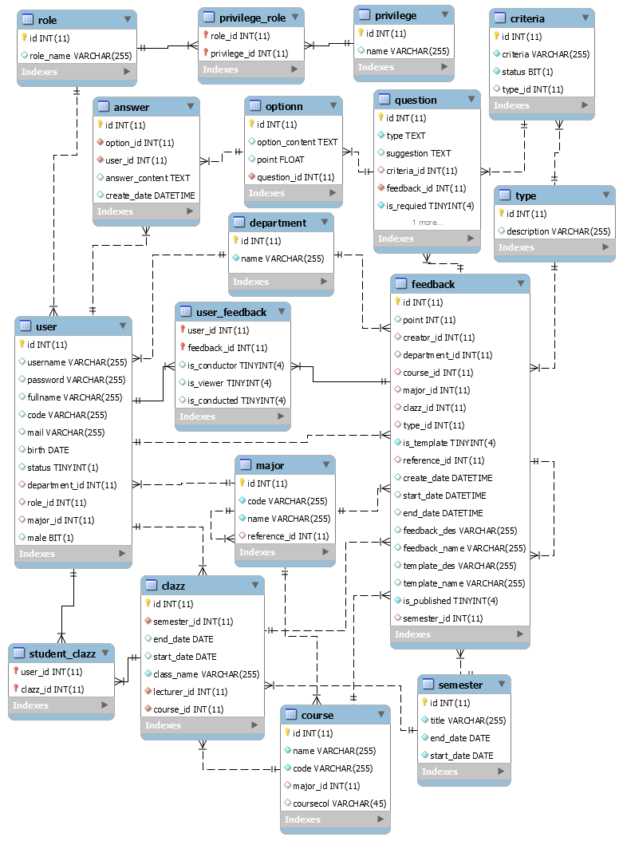

Figure 86: Physical Diagram

* 1. **Data Dictionary**

|  |
| --- |
| **Entity Data dictionary: describe content of all tables** |

|  |  |
| --- | --- |
| **Table Name** | **Description** |
| Feedback | Contain Feedback information |
| Question | Contain Question information |
| Optionn | Contain Option information |
| Answer | Contain Answer information |
| Criteria | Contain Criteria information |
| Semester | Contain Semester information |
| Type | Contain Feedback type information |
| User | Contain User information |
| User_Feedback | Contain information about relationship between a user with a feedback |
| Role | Contain Role information |
| Privilege | Contain Privilege information |
| Privilege_Role | Contain Privilege information for each role |
| Student_Clazz | Contain information about class of each student |
| Clazz | Contain Class information |
| Course | Contain Course information |
| Major | Contain Major information |
| Department | Contain Department information |

Table 11: Describe content of all tables

|  |  |  |  |  |
| --- | --- | --- | --- | --- |
| **Entity name** | **Attributes** | **Description** | **Domain** | **Null** |
| Feedback | id | Unique identifier of the Feedback | INT(11) | N |
| point | Average point of Feedback | INT(11) | Y |
| creator_id | Id of the user creates Feedback | INT(11) | N |
| department_id | Id of the Department that Feedback belongs to | INT(11) | Y |
| course_id | Id of the Course that Feedback belongs to | INT(11) | Y |
| major_id | Id of the Major that Feedback belongs to | INT(11) | Y |
| clazz_id | Id of the Class that Feedback belongs to | INT(11) | Y |
| type_id | Id of the Type that Feedback belongs to | INT(11) | N |
| is_template | Feedback is used as Template or not | BIT(1) | N |
| reference_id | Id of the Feedback that Feedback uses as Template | INT(11) | Y |
| create_date | Created Date of Feedback | DATETIME | N |
| start_date | Start Date of Feedback | DATETIME | N |
| end_date | End Date of Feedback | DATETIME | N |
| feedback_des | Description of Feedback | VARCHAR(255) | N |
| feedback_name | Name of Feedback | VARCHAR(255) | N |
| template_des | Description of Template | VARCHAR(255) | Y |
| template_name | Name of Template | VARCHAR(255) | Y |
| is_published | Feedback is published or not | BIT(1) | N |
| semester_id | Id of the Semester that Feedback belongs to | INT(11) | N |
| Question | id | Unique identifier of the Question | INT(11) | N |
| type | Type of Question | VARCHAR(255) | N |
| suggestion | Suggestion for this Question | VARCHAR(255) | Y |
| criteria_id | Id of the Criteria that Question belongs to | INT(11) | N |
| feedback_id | Id of the Feedback that Question belongs to | INT(11) | N |
| question_content | Content of Question | VARCHAR(255) | N |
| is_requied | Question is required or not | BIT(1) | N |
| Optionn | id | Unique identifier of the Option | INT(11) | N |
| point | Point of Option | FLOAT | N |
| question_id | Id of the Question that Option belongs to | INT(11) | N |
| option_content | Content of Option | VARCHAR(255) | N |
| Answer | id | Unique identifier of the Answer | INT(11) | N |
| option_id | Id of the Option that Answer belongs to | INT(11) | N |
| user_id | Id of the User replies that Answer | INT(11) | N |
| answer_content | Content of Answer | VARCHAR(255) | Y |
| create_date | Created Date of Answer | DATETIME | N |
| Criteria | id | Unique identifier of the Criteria | INT(11) | N |
| type_id | Id of the Type that Criteria belongs to | INT(11) | Y |
| status | Status of Criteria | BIT(1) | N |
| criteria | Name of Criteria | VARCHAR(255) | N |
| Semester | id | Unique identifier of the Semester | INT(11) | N |
| start_date | Start Date of Semester | DATETIME | N |
| end_date | End Date of Semester | DATETIME | N |
| title | Name of Semester | VARCHAR(255) | N |
| User | id | Unique identifier of the User | INT(11) | N |
| department_id | Id of the Department that User belongs to | INT(11) | Y |
| role_id | Id of the Role that User belongs to | INT(11) | N |
| major_id | Id of the Major that User belongs to | INT(11) | Y |
| male | Gender of User | BIT(1) | N |
| status | Status of User | BIT(1) | N |
| username | Username of User | VARCHAR(255) | N |
| password | Password of User | VARCHAR(255) | N |
| fullname | Name of User | VARCHAR(255) | N |
| code | Code of User | VARCHAR(255) | N |
| mail | Email of User | VARCHAR(255) | N |
| birth | Birthdate of User | DATE | N |
| User_Feedback | user_id | Unique identifier of the User | INT(11) | N |
| feedback_id | Id of the Feedback that User has relation to | INT(11) | N |
| is_conductor | User is conductor of this Feedback or not | BIT(1) | N |
| is_viewer | User is Report viewer of this Feedback or not | BIT(1) | N |
| is_conducted | This Feedback is conducted or not | BIT(1) | N |
| Type | id | Unique identifier of the Type | INT(11) | N |
| description | Description of Type | VARCHAR(255) | N |
| Role | id | Unique identifier of the Role | INT(11) | N |
| role_name | Name of Role | VARCHAR(255) | N |
| Privilege | id | Unique identifier of the Privilege | INT(11) | N |
| name | Name of Privilege | VARCHAR(255) | N |
| Privilege_Role | role_id | Unique identifier of the Role | INT(11) | N |
| privilege_id | Id of the Privilege that the Role can do | INT(11) | N |
| Student_Clazz | user_id | Unique identifier of the User | INT(11) | N |
| clazz_id | Id of the Class that User belongs to | INT(11) | N |
| Clazz | id | Unique identifier of the Class | INT(11) | N |
| semester_id | Id of the Semester that Class belongs to | INT(11) | N |
| end_date | Start Date of Clazz | DATE | N |
| start_date | End Date of Clazz | DATE | N |
| class_name | Name of Class | VARCHAR(255) | N |
| lecturer_id | Id of the User that teaches this Class | INT(11) | N |
| course_id | Id of the Course that Class belongs to | INT(11) | N |
| Course | id | Unique identifier of the Course | INT(11) | N |
| name | Name of Course | VARCHAR(255) | N |
| code | Code of Course | VARCHAR(255) | N |
| major_id | Id of the Major that Course belongs to | INT(11) | N |
| Major | id | Unique identifier of the Major | INT(11) | N |
| name | Name of Major | VARCHAR(255) | N |
| code | Code of Major | VARCHAR(255) | N |
| reference_id |  | INT(11) | N |
| Department | id | Unique identifier of the Department | INT(11) | N |
| name | Name of Department | VARCHAR(255) | N |

**Table 12: Attribute Data Dictionary**

1. **Test Plan**

The overall purpose of testing is to ensure SFMS meets its entire technical, functional and business requirement. The purpose of this document is to describe the overall test plan and strategy for testing the SFMS. The approach described in this document provides the framework for all testing related to this application. Individual test cases will be written for each version of the application that is released. This document will also be updated as required for each release.

### Features to be tested

* Student: Conduct Feedback
* Staff:

+ Preview Template

+ Select Feedback Timeframe

+ Modify Suggested Improvement

+ Modify Feedback Targets

+ Modify Feedback Conductors

+ View list Feedbacks

* Head of Academic: View list Reports
* System: Alert undone Feedback
  1. **Features not to be tested**
* Guest: Login
* Student: Filter Feedback
* Lecturer:

+ Compares Report by Semester

+ View Report Details

+ Filter Report

* Staff:

+ Create blank new feedabck

+ Drag-n-drop feedback items to create content

+ Edit feedback content

+ Set name and description for feedback

+ Set semester for feedback

+ Choose scope (lecture, major, course, department)

+ Create new feedback from template

+ Save Feedback

+ Manage Users

* Head of Academic: Manage Criterias
* System: Statistic and generate reports

1. **System Testing Test Case**
   1. **Communication Diagram**

* Test cases are created from below communication diagram

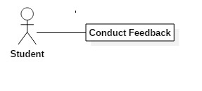

***Figure 87: Student Communication Diagram***

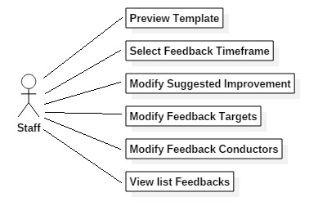

***Figure 88: Staff Communication Diagram***

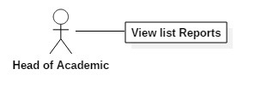

***Figure 89: Head of Academic Communication Diagram***

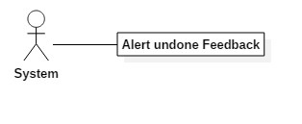

***Figure 90: System Communication Diagram***

* 1. **Test Case**
     1. ***<Student> Conduct feedback***

|  |  |  |  |  |  |  |  |
| --- | --- | --- | --- | --- | --- | --- | --- |
| **ID** | **Test Case Description** | **Precondition** | **Test case procedure** | **Expected output** | **Inter-test case dependence** | **Result** | **Test Date** |
| **Conduct feedback 1** | Test student conduct feedback | There is at least 1 available Feedback in list | 1.User login  2.User open notification panel  3.User select a feedback to conduct  4.User submit conduct feedback form after filled all required feedback | 1. System alert user’s answer saved  2. System show list feedbacks view | N/A | Pass | 15/4/2018 |
| **Conduct feedback 2** | Test student conduct feedback without input all required fields | There is at least 1 available Feedback in list | 1.User login  2.User open notification panel  3.User select a feedback to conduct  4.User submit conduct feedback form without filled all required feedback | 1.System display alert to prompt answer for each required question | N/A | Pass | 1504/2018 |

* + 1. ***<Staff> Preview template content***

|  |  |  |  |  |  |  |  |
| --- | --- | --- | --- | --- | --- | --- | --- |
| **ID** | **Test Case Description** | **Precondition** | **Test case procedure** | **Expected output** | **Inter-test case dependence** | **Result** | **Test Date** |
| **Preview template content 1** | Test staff previews template content | - There is at least 1 Template in list  - Template has at least 1 question | 1.User login as Staff  2.User clicks on “Quản lý feedback” menu.  3.User clicks on “Tạo feedback mới” option  4.User hovers on an icon of a template on screen  5.User click on button “Xem Thử” | 1.System pop-up a modal on screen that show sample content of questions of template feedback | N/A | Pass | 15/04/2018 |
| **Preview template content 2** | Test staff previews template content with template has no questions | - There is at least 1 available Feedback in list  - Template has no question | 1.User login as Staff  2.User click on “Quản lý feedback” menu.  3.User click on “Tạo feedback mới” option  4.User hover on an icon of a template on screen  5.User click on button “xem thử” | 1.System pop-up a modal which has content is “Không có câu hỏi nào” | N/A | Pass | 15/04/2018 |

* + 1. ***<Staff> Select Feedback Timeframe***

|  |  |  |  |  |  |  |  |
| --- | --- | --- | --- | --- | --- | --- | --- |
| **ID** | **Test Case Description** | **Precondition** | **Test case procedure** | **Expected output** | **Inter-test case dependence** | **Result** | **Test Date** |
| **Preview template content 1** | Test staff select Start date of Feedback timeframe | N/A | 1.User login as Staff  2.User click on “Quản lý feedback” menu.  3.User creates new Feedback  4. User select dropbox for label “Học kỳ” thèn select an item of semester in dropdown list  5. User select input “Bắt đầu nhận phản hồi” field then select a date in allowed range on datetime picker shown up as feedback’s startdate | 1.System change value of select “Bắt đầu nhận phản hồi” field to selected date  2.System close datetimepicker  3.System change min-value in allowed range for select “Kết thúc nhận phản hồi” field’s datetimepicker into selected startdate | N/A | Pass | 15/04/2018 |
| **Preview template content 2** | Test staff select End date of Feedback timeframe | N/A | 1.User login as Staff  2.User click on “Quản lý feedback” menu.  3.User creates new Feedback  4. User select dropbox for label “Học kỳ” then select an item of semester in dropdown list  5. User select input field for label “Kết thúc nhận phản hồi” then select a date in allowed range on datetime picker shown up as feedback’s enddate | 1.System change value of select “Kết thúc nhận phản hồi” field to selected date  2.System close datetimepicker | N/A | Pass | 15/04/2018 |
| **Preview template content 3** | Test staff Feedback timeframe that not match with select Semester | N/A | 1.User login as Staff  2.User click on “Quản lý feedback” menu.  3.User creates new Feedback  4. User select dropbox for label “Học kỳ” then select an item of semester in dropdown list  5. User select Start date or End date out of allowed range on datetime picker shown up | 1.System closes datetimepicker and changes nothing in shown up page | N/A | Pass | 15/04/2018 |

* + 1. ***<Staff> Modify Suggested Improvement***

|  |  |  |  |  |  |  |  |
| --- | --- | --- | --- | --- | --- | --- | --- |
| **ID** | **Test Case Description** | **Precondition** | **Test case procedure** | **Expected output** | **Inter-test case dependence** | **Result** | **Test Date** |
| **Suggestion 1** | Test staff Modify Suggested Improvement | N/A | 1.User login as Staff  2.User clicks on “Quản lý feedback” menu.  3.User clicks on “Tạo feedback mới” option  4.User clicks on icon of “Tạo Feedback trống”  5.User click on link “Chỉnh sửa lời khuyên” | 1.System shows screen of Modifying suggested improvement  2. Screen shows list of created Questions and textfield to input suggestion for each one | N/A | Pass | 15/04/2018 |
| **Suggestion 2** | Test staff Modify Suggested Improvement with creating from Template | - There is at least 1 template in list  - There is at least 1 suggestion in the template | 1.User login as Staff  2.User clicks on “Quản lý feedback” menu.  3.User clicks on “Tạo feedback mới” option  4.User clicks on button “Tiếp tục” of a template.  5.User click on link “Chỉnh sửa lời khuyên” | 1.System shows screen of Modifying suggested improvement  2. Screen shows list of existed Questions, created suggestion that exists in template before, and textfield to re-input suggestion for each one | N/A | Pass | 15/04/2018 |

* + 1. ***<Staff> Modify Feedback Targets***

|  |  |  |  |  |  |  |  |
| --- | --- | --- | --- | --- | --- | --- | --- |
| **ID** | **Test Case Description** | **Precondition** | **Test case procedure** | **Expected output** | **Inter-test case dependence** | **Result** | **Test Date** |
| **Target 1** | Test staff modifies Feedback Targets | - There is at least 1 target in list | 1.User login as Staff  2.User clicks on “Quản lý feedback” menu.  3.User clicks on “Tạo feedback mới” option  4.User create new Feedback  5.User clicks on link “Thêm đối tượng cho Feedback” | 1.System shows screen of Modifying Feedback Targets  2. Screen shows list of Target that matches with selected Type | N/A | Pass | 15/04/2018 |
| **Target 2** | Test staff modifies Feedback Targets with having no Target in list | N/A | 1.User login as Staff  2.User clicks on “Quản lý feedback” menu.  3.User clicks on “Tạo feedback mới” option  4.User create new Feedback  5.User clicks on link “Thêm đối tượng cho Feedback” | 1.System shows screen of Modifying Feedback Targets  2. Screen shows message “Không có đối tượng nào” | N/A | Pass | 15/04/2018 |

* + 1. ***<Staff> Modify Feedback Conductors***

|  |  |  |  |  |  |  |  |
| --- | --- | --- | --- | --- | --- | --- | --- |
| **ID** | **Test Case Description** | **Precondition** | **Test case procedure** | **Expected output** | **Inter-test case dependence** | **Result** | **Test Date** |
| **Target 1** | Test staff modifies Feedback Conductors | - There is at least 1 Conductorsin list | 1.User login as Staff  2.User clicks on “Quản lý feedback” menu.  3.User clicks on “Tạo feedback mới” option  4.User create new Feedback  5.User adds target to list  6.User clicks on icon add more Conductors for a Target | 1.System shows screen of Modifying Feedback Conductors  2. Screen shows list of Conductors that matches with selected Target. | N/A | Pass | 15/04/2018 |
| **Target 2** | Test staff modifies Feedback Conductors with having no Conductors in list | N/A | 1.User login as Staff  2.User clicks on “Quản lý feedback” menu.  3.User clicks on “Tạo feedback mới” option  4.User create new Feedback  5.User adds target to list  6.User clicks on icon add more Conductors for a Target | 1.System shows screen of Modifying Feedback Conductors  2. Screen shows message “Không có người thực hiện nào” | N/A | Pass | 15/04/2018 |

* + 1. ***<System> Alert undone Feedback***

|  |  |  |  |  |  |  |  |
| --- | --- | --- | --- | --- | --- | --- | --- |
| **ID** | **Test Case Description** | **Precondition** | **Test case procedure** | **Expected output** | **Inter-test case dependence** | **Result** | **Test Date** |
| **Alert1** | Test system alert undone feedback on panel | There is at least 1 new Feedback which user has to conduct | 1.User login  2.User open notification panel | 1.System shows undone feedback. | N/A | Pass | 15/04/2018 |
| **Alert2** | Test system alert undone feedback on Feedback List | There is at least 1 new Feedback which user has to conduct | 1.User login  2.User clicks on “Quản lý Feedback”  3. User clicks on “Danh sách Feedback” | 1.System shows Feedback along with button “Làm Feedback” | N/A | Pass | 15/04/2018 |
| **Alert3** | Test system alert undone feedback on panel when Feedback is expired | There is at least 1 new Feedback which user has to conduct | 1.User login  2.User open notification panel | 1.System will not show expired feedback | N/A | Pass | 15/04/2018 |
| **Alert4** | Test system alert undone feedback on Feedback list when Feedback is expired | There is at least 1 new Feedback which user has to conduct | 1.User login  2.User clicks on “Quản lý Feedback”  3. User clicks on “Danh sách Feedback” | 1.System shows Feedback along with text “Feedback đã hết hạn” | N/A | Pass | 15/04/2018 |

* + 1. ***<User> View list Feedbacks***

|  |  |  |  |  |  |  |  |
| --- | --- | --- | --- | --- | --- | --- | --- |
| **ID** | **Test Case Description** | **Precondition** | **Test case procedure** | **Expected output** | **Inter-test case dependence** | **Result** | **Test Date** |
| **ViewListFeedback1** | Test user view list feedback to conduct | N/A | 1.User login  2.User click on “Quản lý feedback” menu.  3.User click on “Xem danh sách feedback sub-menu” | 1.System shows list of feedback for logged in user.  2. System shows a hyperlink “Làm feedback” to answer | N/A | Pass | 15/04/2018 |
| **ViewListFeedback2** | Test user view list feedback with no result. | N/A | 1.User login  2.User click on “Quản lý feedback” menu.  3.User click on “Xem danh sách feedback sub-menu” | 1.System show a table with only 1 record whose content is “không có Feedback nào” | N/A | Pass | 15/04/2018 |
| **ViewListFeedback3** | Test user view list feedback with feedback at least conducted once and Feedback is still available | N/A | 1.User login  2.User click on “Quản lý feedback” menu.  3.User click on “Xem danh sách feedback sub-menu” | 1. System show list of feedback in a table.  2. System shows a hyperlink “Làm lại feedback” to re-answer | N/A | Pass | 15/04/2018 |
| **ViewListFeedback4** | Test user view list feedback when feedback is expired | N/A | 1.User login  2.User click on “Quản lý feedback” menu.  3.User click on “Xem danh sách feedback sub-menu” | 1. System show list of feedback in a table.  2. System shows a tesxt say: “Feedback đã quá hạn hoặc chưa bắt đầu”. | N/A | Pass | 15/04/2018 |
| **ViewListFeedback5** | Test user view list feedback with feedaback at least conducted once but feedback is expired | N/A | 1.User login  2.User click on “Quản lý feedback” menu.  3.User click on “Xem danh sách feedback sub-menu” | 1. System show list of feedback in a table.  2. System shows a tesxt say: “Đã hoàn thành”. | N/A | Pass | 15/04/2018 |

* + 1. ***<Head of Academic> View list Reports***

|  |  |  |  |  |  |  |  |
| --- | --- | --- | --- | --- | --- | --- | --- |
| **ID** | **Test Case Description** | **Precondition** | **Test case procedure** | **Expected output** | **Inter-test case dependence** | **Result** | **Test Date** |
| **ViewListReport1** | Test Head of Academic when views list report. | N/A | 1.User login as Head of Academic roles.  2.User click on “Xem báo cáo” menu | 1.System show these to user screen:  -Tables corresponding to 4 types of feedback.  -Filter to show which type of feedback should appear on the screen.  -Option to see to which reports. | N/A | Pass | 15/04/2018 |

1. **Software User’s Manual**
   1. **Installation Guide**
   2. **Setting up environment at server side**

The following software must be installed into the server machine:

* + 1. **Hardware requirements**

|  |  |  |
| --- | --- | --- |
| **Windows** | **Minimum Requirements** | **Recommended** |
| **Internet Connection** | Cable, Wi-Fi (4 Mbps) | Cable, Wi-Fi (8 Mbps) |
| **Operating System** | Window Server 2008 | Window Server 2008 |
| **Computer Processor** | Intel® Xeon ® 1.4GHz | Intel® Xeon ® Quad Core  (12M Cache, 2.50 GHz) |
| **Computer Memory** | 1GB RAM | 2GB or more |

* + 1. **Software requirements**

|  |  |  |
| --- | --- | --- |
| Software | Name / Version | Description |
| Operating system | Window 7 or above | Operating system and platform for development |
| Environment | Java EE 8, Spring, Gradle | Specification for developing web application |
| IDE | IntelliJ IDEA 17.2, Android Studio 3.0 | Programming tools |
| DBMS | MySQL 5.7 | Used to create & manage the database for system |
| Web browser | Chrome 42 or above | Testing browser |

* 1. **Deployment at server side**
     1. **Prepare deployment package**
* Install JDK 8.0
* Setup Tomcat
* Install IntelliJ IDEA 17.2, Spring and Gradle
* Install Android Studio 3.0
* Install MySQL 5.7 and restore database “Capstone”
  + 1. **Configure Server before deploy**
* Open file application.properties in folder SFMS\src\main\resources

+ Edit your port at property “server.port”

+ Edit your username to MySQL “spring.datasource.username”

+ Edit your password to MySQL “spring.datasource.password”

+ Edit your username to Email “spring.mail.username”

+ Edit your password to Email “spring.mail.password”

* + 1. **Deploy web application on server**
* Run app
* Open web browser, input url to app
  1. **Setting up the environment at client side**
     1. **Setting up for computer**

**For PC**

|  |  |  |
| --- | --- | --- |
| **Windows** | **Minimum Requirements** | **Recommended** |
| **Internet Connection** | Cable, Wi-Fi (2 Mbps) | Cable, Wi-Fi (4 Mbps) |
| **Operating System** | Windows 7 or above | Window 7 or above |
| **Computer Processor** | Intel® Pentinum 4 1.60Ghz | Intel® Pentinum 4 2.00Ghz |
| **Computer Memory** | 1GB RAM | 2GB or more |

**Table 13: Hardware Requirement for PC**

**For mobile**

|  |  |  |
| --- | --- | --- |
| **Windows** | **Minimum Requirements** | **Recommended** |
| **Internet Connection** | Wi-Fi (2 Mbps) | Wi-Fi (4 Mbps) |
| **Operating System** | Android 4.4.2 or above | Android 6.0 or above |
| **Memory** | 1GB RAM | 2GB or more |

**Table 14: Hardware Requirement for Mobile**

1. **User Guide**

### *Web application for all users*

#### Login



Figure 91: <Guest > Login page

|  |  |
| --- | --- |
| **Step** | **Description** |
| 1 | Enter username, password. |
| 2 | Tap “Đăng nhập” button. |

Table 15: <Guest> Login

#### Feedbacks need to be conducted list

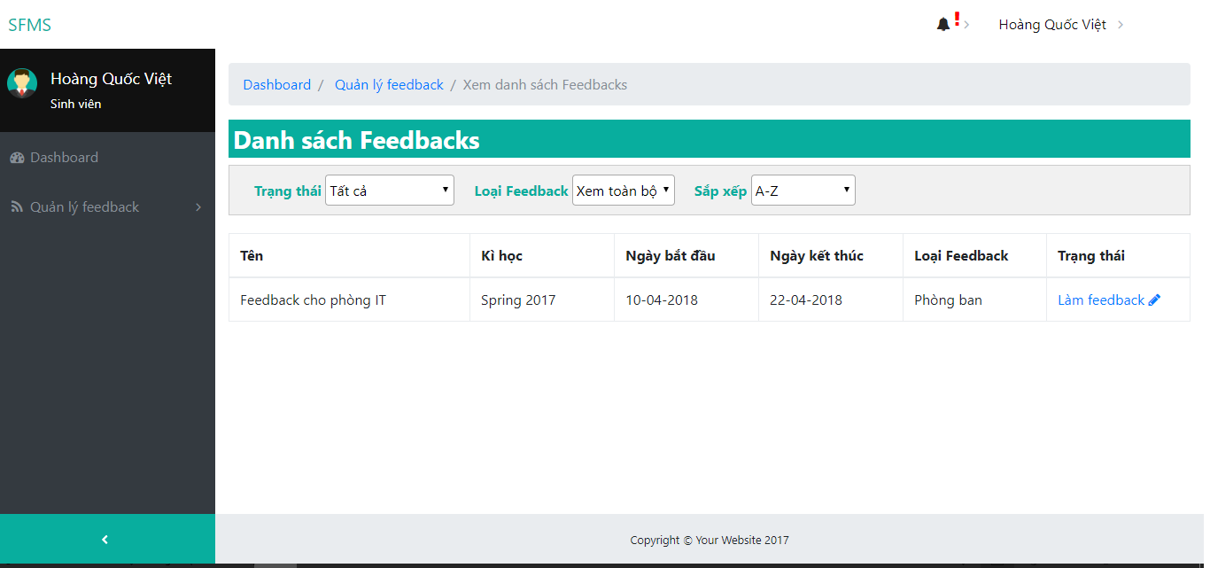

Figure 92: <All users> Feedback List

|  |  |
| --- | --- |
| **Step** | **Description** |
| 1 | Tap on “Quản lý feedback” |
| 2 | Tap on “Xem danh sách feedback” |

Table 16: <All user> Feedback List

#### Conduct Feedback

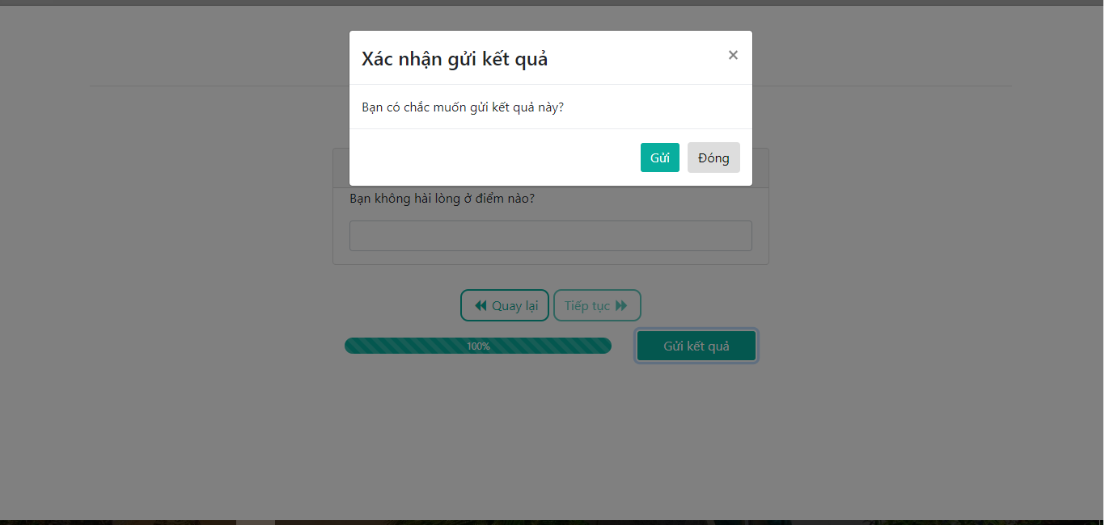

Figure 93: <All users> Conduct feedback

|  |  |
| --- | --- |
| **Step** | **Description** |
| 1 | Answer all required question. |
| 2 | Tap on “Quay lại” to return to previous page and “Tiếp tục” to continue to next page. |
| 3 | Tap on “Gửi kết quả” to send your answers. |
| 4 | Tap on “Gửi” again to cò |

Table 17: <All user> Conduct feedback

#### Notify user

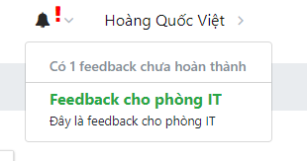

Figure 94: <All users> Notify user

|  |  |
| --- | --- |
| **Step** | **Description** |
| 1 | Click on bell notification |

Table 18: <All user> Notify user

### Web application for staffs

#### Initialize new feedback

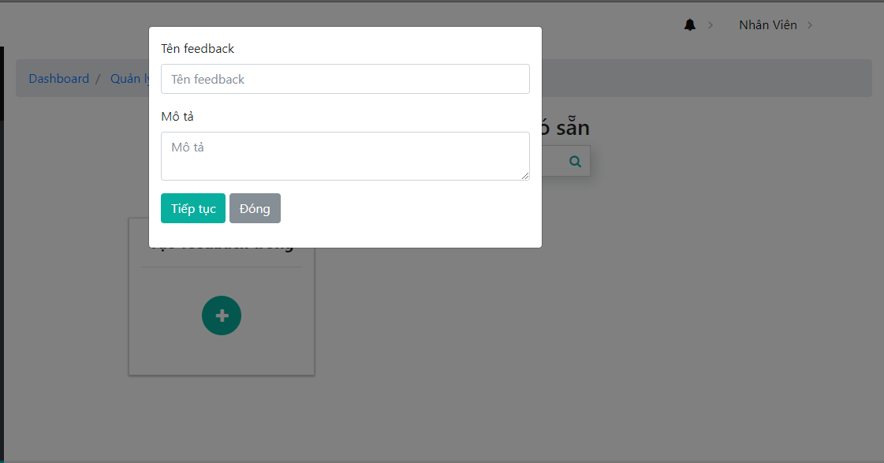

Figure 95: <Staff> Initialize new feedback

|  |  |
| --- | --- |
| **Step** | **Description** |
| 1 | Click on any template or click on “Tạo feedback trống”. |
| 2 | Fill in name and description for this feedback. |
| 3 | Tap on “Tiếp tục” |

Table 19: <Staff> Initialize new feedback

#### Create feedback content

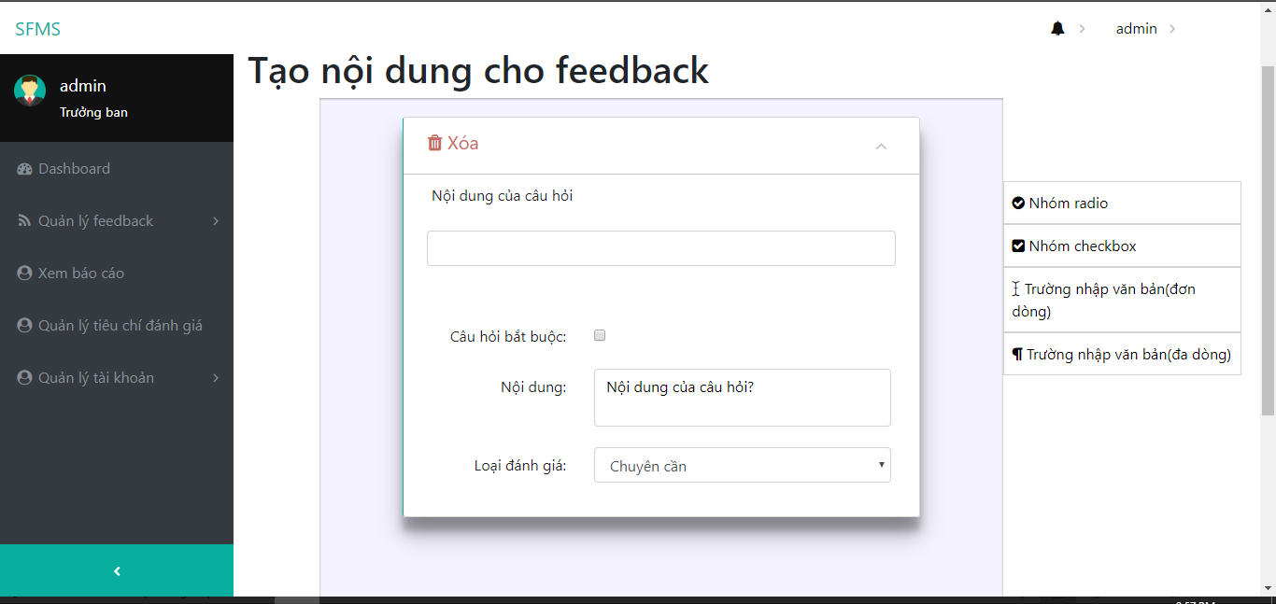

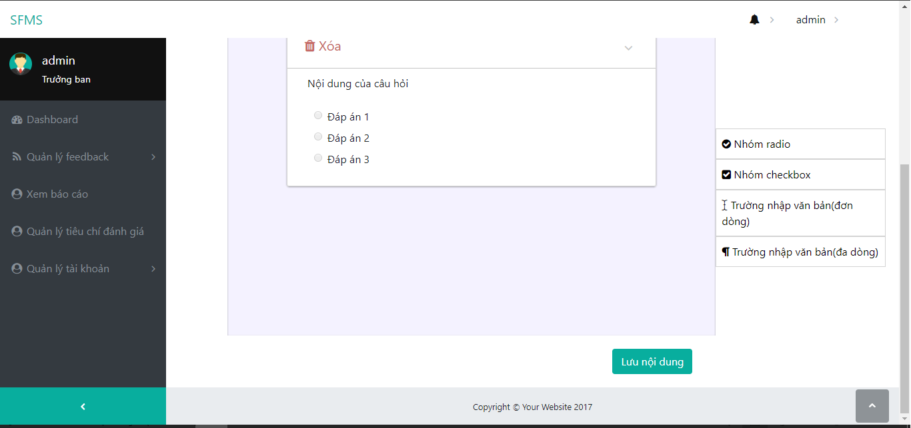

Figure 96: <Staff> Create feedback content

|  |  |
| --- | --- |
| **Step** | **Description** |
| 1 | Drag a question type from right menu to the greyscaled area. |
| 2 | Fill in question content. |
| 3 | Click on “Lưu nội dung” to save content for this feedback. |

Table 20: <Staff> Create feedback content

#### Modifying feedback information

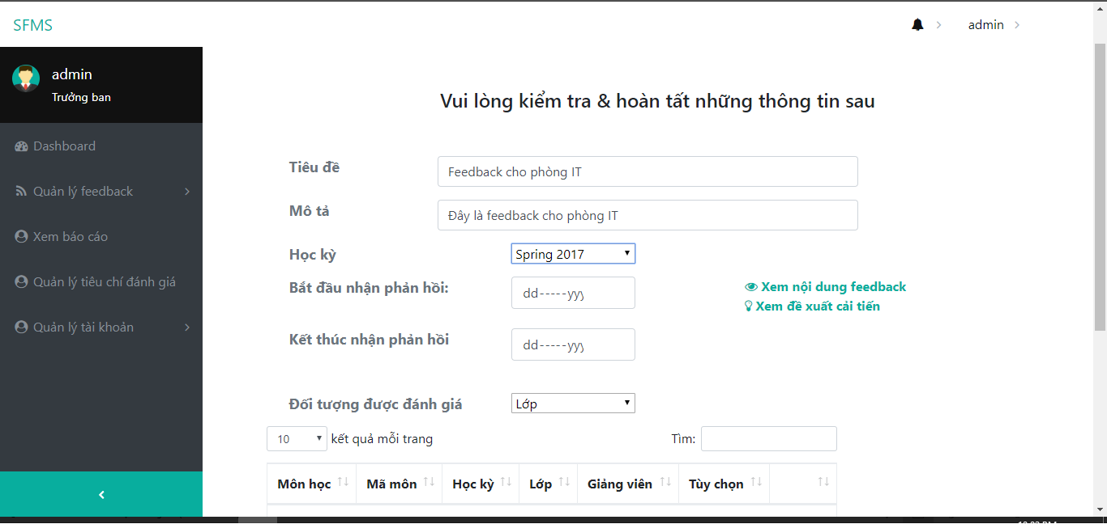

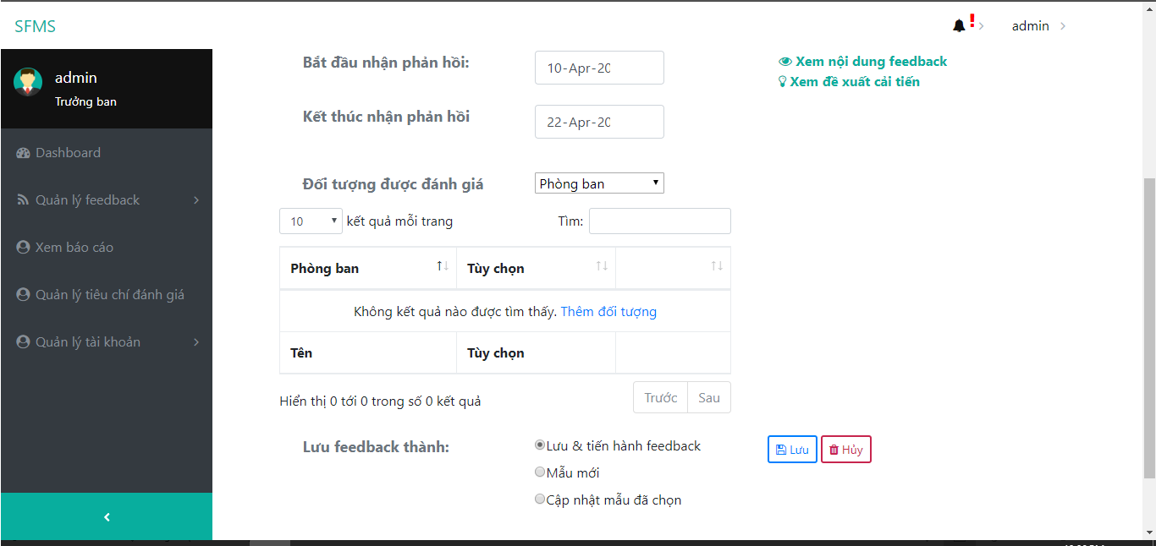

Figure 97: <Staff> Modifying Feedback Information

|  |  |
| --- | --- |
| **Step** | **Description** |
| 1 | Select from date and end date for this feedback. |
| 2 | Select which this feedback is to. |
| 3 | Select who should conduct this feedback. |
| 3 | -Select “Lưu và tiến hành feedback” to save this feedback.  -Select “Mẫu mới” to save this as new template.  -Select “Cập nhập mẫu đã chọn” to update this template. |
| 4 | Click on “Lưu” to complete modifying feedback/template content. |

Table 21: <Staff> Modifying Feedback Information

#### View list self’s report for teacher and staff

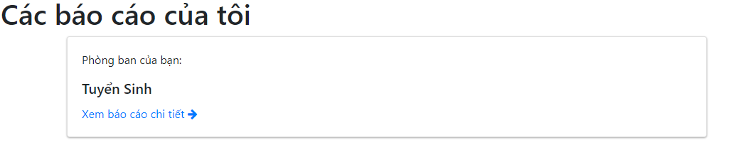

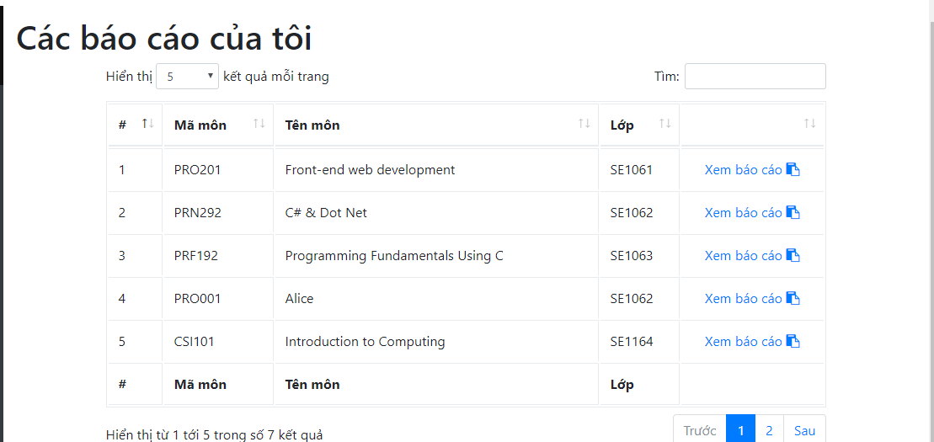

Figure 98: <Staff, Teacher> View list self’s report

|  |  |
| --- | --- |
| **Step** | **Description** |
| 1 | Select a subject, department to see your report. |

Table 22: <Staff, Lecturer> View list self’s report

#### View all report for Head of Academic

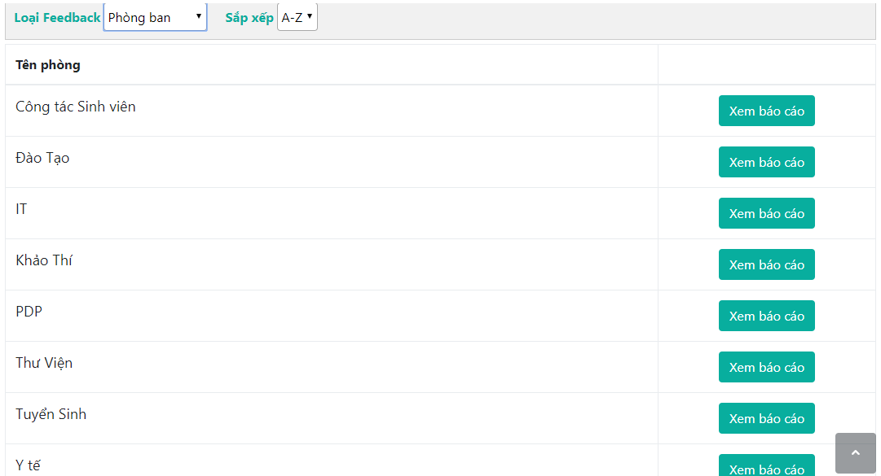

Figure 99: <Head of Academic > View all report

|  |  |
| --- | --- |
| **Step** | **Description** |
| 1 | Select a feedback type to filter table. |
| 2 | Select sort order. |
| 3 | Click on “Xem báo cáo” to see report detail. |

Table 23: <Head of Academic > View all report

#### View report details

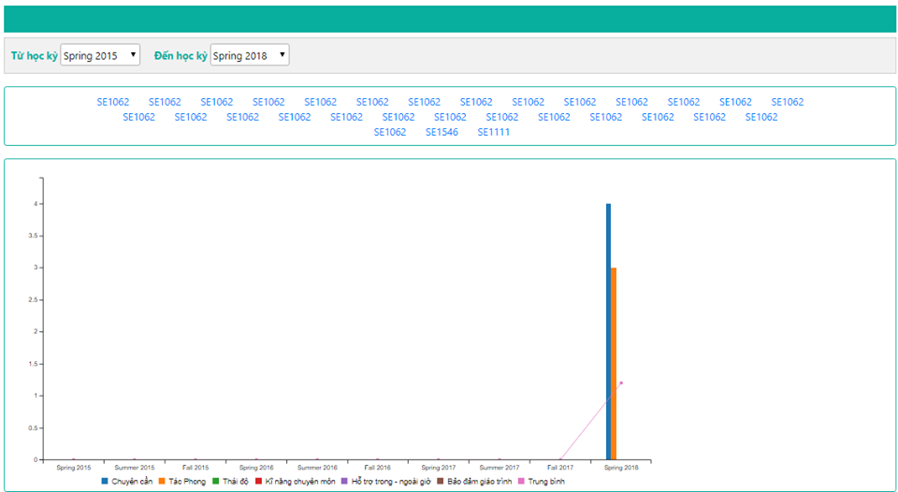

Figure 100: <Head of Academic, Staff, Lecturer> View report details

|  |  |
| --- | --- |
| **Step** | **Description** |
| 1 | Select from semester and to semester to filter which period of time you want to see. |
| 2 | Click on bar chart to show which classes are in this semester. |
| 3 | Click on class’s name to see detail for this semester. |

Table 24: <Head of Academic, Staff, Lecturer> View report details

#### View semester report details

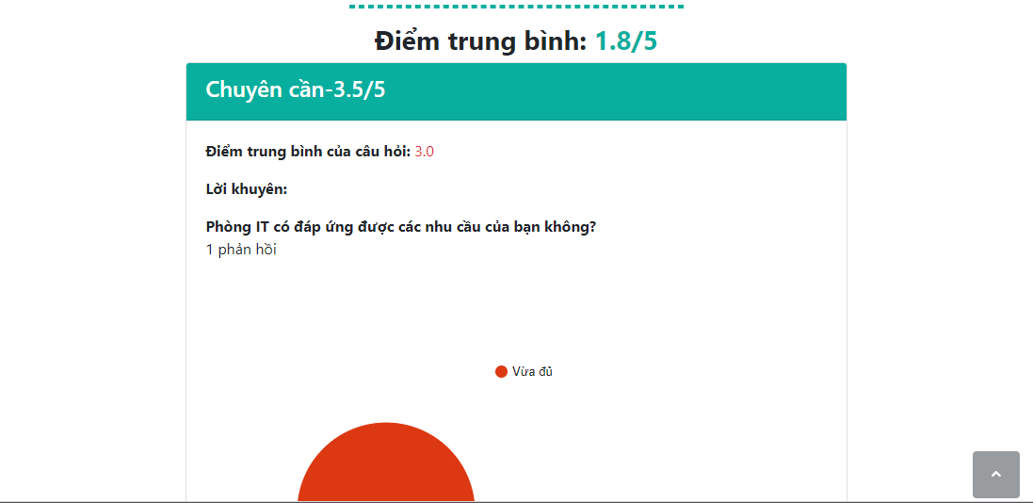

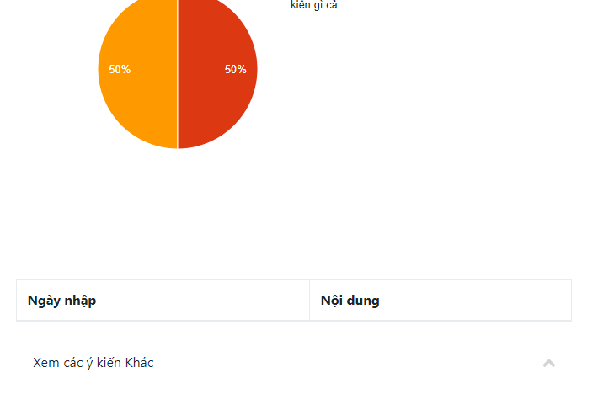

Figure 101: <Head of Academic, Staff, Lecturer> View semester report details

|  |  |
| --- | --- |
| **Step** | **Description** |
| 1 | Click on “Xem thêm các ý kiến khác” or “Xem nội dung câu trả lời” to see users’ inputted answer. |

Table 25: <Head of Academic, Staff, Lecturer> View semester report

#### View list users

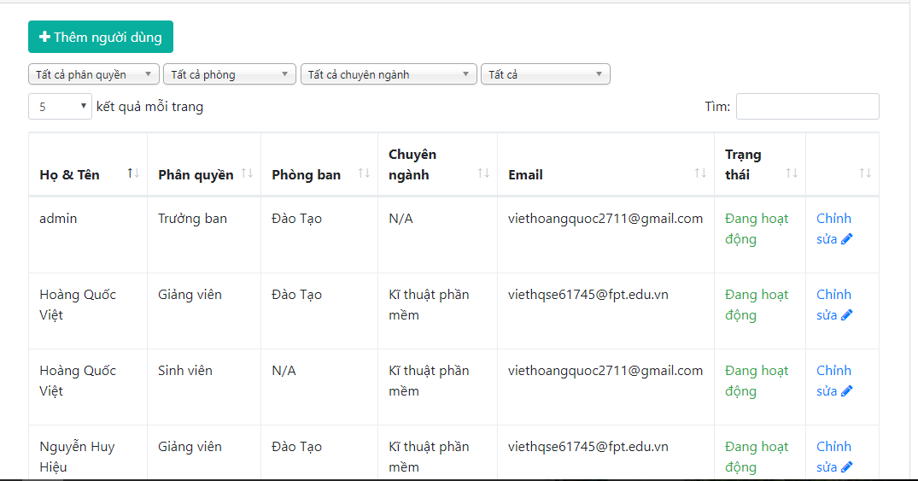

Figure 102: <Head of Academic, Staff> View list users

|  |  |
| --- | --- |
| **Step** | **Description** |
| 1 | Select from a filter to filter table. |
| 2 | Click on “Thêm người dùng” to add new user. |
| 3 | Click on “Chỉnh sửa” to see user’s detail. |

Table 26: <Head of Academic, Staff > View list users

#### Create new user

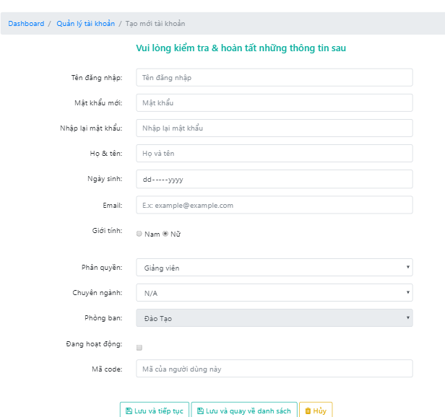

Figure 103: <Head of Academic, Staff> Create new user

|  |  |
| --- | --- |
| **Step** | **Description** |
| 1 | Fill in all field. |
| 2 | Click “Lưu và tiếp tục” to save and add another user.  Click “Lưu và quay về danh sách” to save and return to users list.  Click “Hủy” to reload page. |

Table 27: <Head of Academic, Staff> Create new user

#### Unpublish Feedback

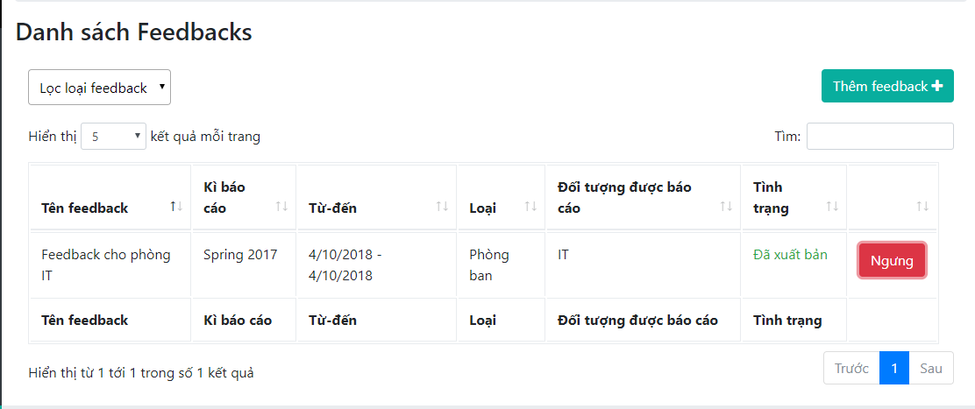

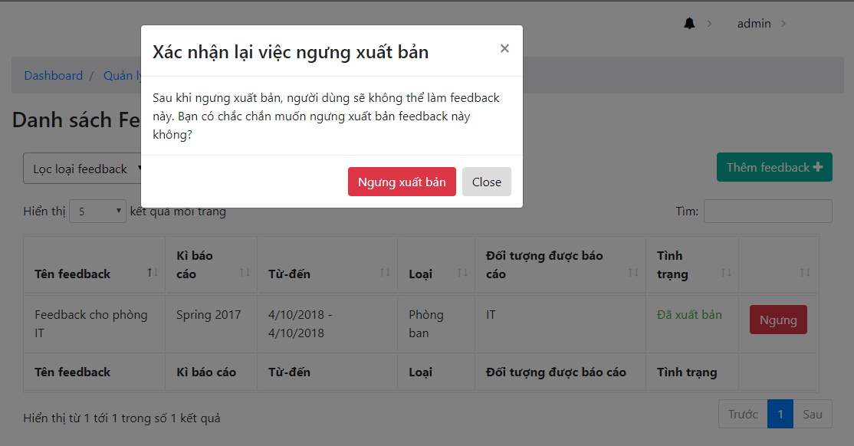

Figure 104: <Head of Academic, Staff> Unpublish Feedback

|  |  |
| --- | --- |
| **Step** | **Description** |
| 1 | Click “Ngưng” button |
| 2 | Click “Ngưng xuất bản” to unpublish Feedback.  Click “Close” to reload page. |

Table 28: <Head of Academic, Staff> Create new user

### Web application for Head of Academic

#### View all report for Head of Academic



Figure 105: <Head of Academic > View all reports

|  |  |
| --- | --- |
| **Step** | **Description** |
| 1 | Select a feedback type to filter table. |
| 2 | Select sort order. |
| 3 | Click on “Xem báo cáo” to see report detail. |

Table 29: <Head of Academic > View all reports

#### Manage criteria

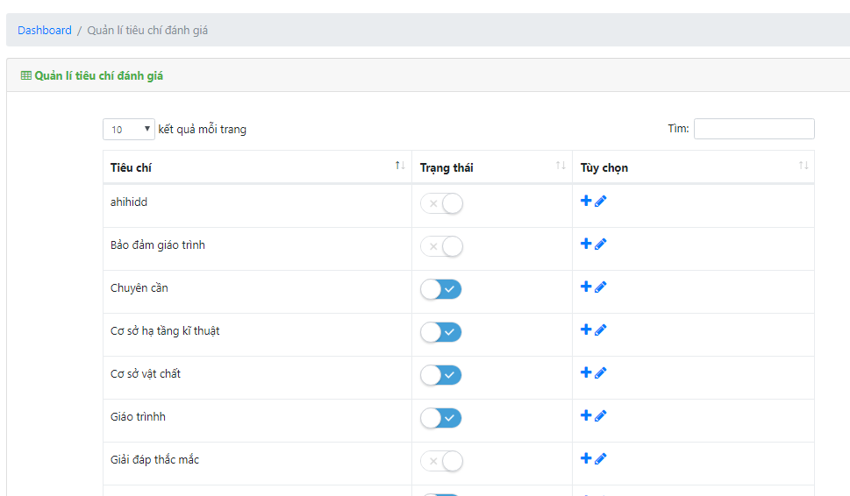

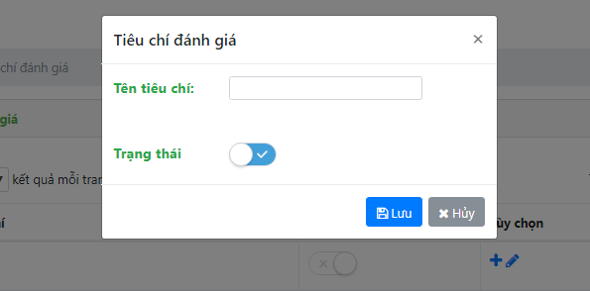

Figure 106: <Head of Academic > Manage criteria

|  |  |
| --- | --- |
| **Step** | **Description** |
| 1 | Click on “+” button to add new criteria. |
| 2 | Fill in name, taret and status for criteria. |
| 3 | Click on “Lưu” to save criteria. |

Table 30: <Head of Academic > Manage criteria

### Mobile application for all users

#### Login

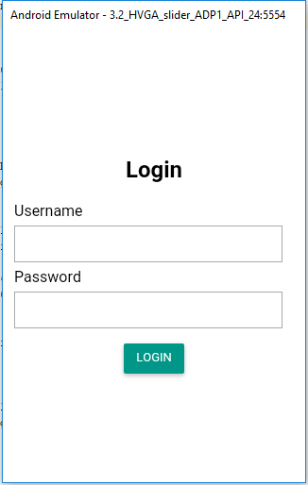

Figure 107: <Guest> Login

|  |  |
| --- | --- |
| **Step** | **Description** |
| 1 | Fill in username and password. |
| 2 | Click on “Đăng nhập” to login. |

Table 31: <Guest> Login

#### View list Feedbacks

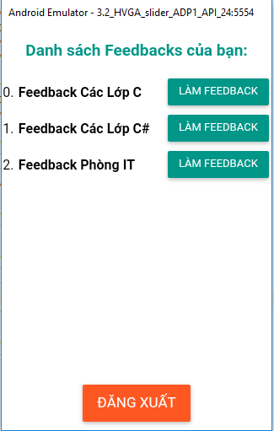

Figure 108: <All users> View list feedbacks

|  |  |
| --- | --- |
| **Step** | **Description** |
| 1 | Click on “ Làm Feedback“ to conduct this feedback. |

Table 32: <All users> View list feedbacks

#### Conduct Feedback on mobile

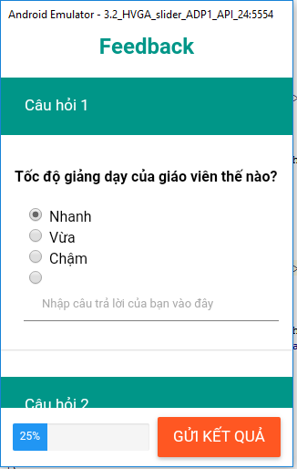

Figure 109: <All users> Conduct feedback on mobile

|  |  |
| --- | --- |
| **Step** | **Description** |
| 1 | Answer all required question. |
| 2 | Click on “Gửi kết quả “ to submit your answers. |

Table 34: <All users> Conduct feedback on mobile